**UNIVERSITY OF CEBU**

**Program Research Coordinator**

**STANDARD TEMPLATE NUMBER**

**RESEARCH STYLE GUIDELINES**

1. All written outputs must be printed on short bond papers.

2. Use Times New Roman or Arial as font style, size 14, and double-spacing for all entries, except abstract.

3. Margins of the bond paper are 1.5" left, and 1.0 inch for the top, bottom and right margins.

4. Pagination should be on the upper right hand corner of the page. No page number should on appear on the 1st page.

5. Title contains the following:

* Independent and dependent variables.
* Output can be included; separate this with a colon mark (optional).
* Bold letters and capitalized.
* Written like an inverted pyramid.
* No waste words (such as A, An, The, Basis for).
* Reflects the name of the researcher/researchers and the month and year of oral defense.

6. Approval Sheet.

* For undergraduate and graduate thesis, approval sheet duly signed by the Panel of Examiners, Program Research Coordinator, Campus Research Coordinator and Dean.

7. DEDICATION

8. ACKNOWLEDGEMENT

9. Abstract contains the following:

* Introduction
* The Problem (general and specific questions).
* Research Methodology
* Findings
* Conclusion
* Should be stated in simple past tense and third person.

10. Table of Contents.

* List Down content and page in Arabic numbers.
* Acknowledgment and Abstract in Roman numbers.
* Separate sheet for List of tables and figures.

**11. REVIEW OF RELATED LITERATURE** An organized collection of literature and studies which are outlined in the key concepts.

* The key concepts in the statement of the problem is used in the search for literature and studies.
* The key concepts provide focus and direction for the theoretical framework.

**12. Introduction**

* Overview of RRL

**13. Related Readings**

* Legal basis of the study
* Direct/indirect implications to the government thrusts

**14. Related Literature (foreign and local)**

* Sources are taken from the books, journals, magazines, online database

**15. Related Studies (foreign and local)**

* Published and unpublished research studies

**16. Synthesis and Justification**

* Justification of the present study
* Bearing of related studies upon the present study
* Differences of the present study

**17. Theoretical Framework**

* It defines the relationship of all the variables (key concepts)

**18 Conceptual Framework**

A conceptual framework represents the researcher’s synthesis of literature on how to explain a phenomenon. It maps out the actions required in the course of the study given his previous knowledge of other researchers’ point of view and his observations on the subject of research.

19. Statement of the Problem (for quantitative studies) or Objectives of the Study (for experimental studies and qualitative studies).

* State the main and specific problems.
* State the possibility for significant difference and/ or significant relationship among variables.

20. HYPHOTHESIS

-Congruent with specific problems

-Variables are defines

21. Significance of the Study explains who will be the beneficiaries of the study and how they will benefit/gain.

**22. Scope and Limitations**

23. Research Methodology starts with the Research Design which explains the type of design used in relation to the main problem. Show the figure the Flow of the Study (Input-Process-Output).

24. Research Setting describes the setting of the study.

25. **Respondents of the Study**

26. Research Subjects/Respondents/Informants

* Describes the total population, sampling method used, sampling size determination, and characteristics of the sample.
* Use the term research subjects if it is an experimental study.
* Use the term research respondents if they are answering a tool.
* Use the term research informants if they are interviewed.
* Use the term research participants if there are subjects and respondents in the study.

27. Research Instrument describes the tool/questionnaire/interview guide utilized.

28 . Research Procedures include the Gathering of Data and Treatment of Data.

* For the Gathering of Data, discuss step by step how the data was gathered starting from the approval of the study by the institution until the retrieval of the instrument from respondents.
* For the Treatment of Data, enumerate and describe the statistical tools used. No need to show the formula.
* State the data was manually computed or has used statistical software.
* For qualitative data, describe how the answers of the informants during the interview were collapsed into themes.

**29. Statistical Treatment**

30. Definition of Terms.

* Alphabetically arranged.
* Operationally defined or how terms were used in the study.
* Taken from the title, main problem and specific problems.

31. Presentation, Interpretation and Analysis of the Study contains:

* Detailed findings consistent with the specific problems.
* Findings should have implications lifted from the theoretical background. Include the parenthetical citation.
* Table should precede the description of the table.
* Do not cut tables.
* Sequence of tables is congruent to the sequence of the specific problems.
* No graphs and pictures.

32. Summary, Findings, Conclusion and Recommendations.

* For the summary, copy the main and specific problems. Explain the methodology in 1-2 paragraphs.
* Findings show the most dominant information per sub-problem.
* Conclusion answers the main problem.
* Recommendations are made by the researcher based on findings of the study.

33. Output of the Study.

* Placed one page after the recommendations.
* Can be an action plan or those that can be immediately implemented such as seminars, brochures and manuals.

34. References.

* Absolutely no internet sources.
* List down alphabetically with the following sub-headings:
  + - Books
    - Journals
    - Unpublished Theses and Dissertations
    - Other sources
  + Correct format.
  + Copyright from 2000 to present.
  + At least 30 sources from books, journals, theses, dissertations and other sources.
  + Consistent use of APA (American Psychology Association) format.

35. Appendices.

* + A for transmittal letters (to persons and institutions).
  + B for survey Questionnaire (Original).
  + C for Survey Questionnaire (Modified).

36. Curriculum Vitae.

* Contains the educational attainment (highlights highest educational attainment).
* Work experience if applicable.
* Personal data of the researcher.
* With 2x2 picture on the right upper hand corner; may be scanned.
* Contact information like email address, home address and mobile numbers.

37. Consultation Hours:

38. email your thesis softcopy to jlbantula@up.edu.ph

**APA FORMAT/STYLE** APA (**American Psychological Association)**

**www.apa.org**

**Title page**

**APPROVAL SHEET**

**Dedication**

**Acknowledgment**

**Abstract**

**Table of Contents**

**List of Tables**

**List of Figures**

**Chapter 1: THE PROBLEM AND A REVIEW OF RELATED LITERATURE**

**Introduction**

**Review of Related Literature**

**Related Readings**

**Related Literature**

**Related Studies**

**Synthesis and Justification**

**Theoretical Framework**

**Conceptual Framework**

**Statement of the Problem (General and Specific)**

**Hypothesis**

**Significance of the Study**

**Scope and Limitations**

**Chapter 2: METHOD**

**Methodology**

**Research Design**

**Research Setting**

**Respondents of the Study**

**Data Gathering Procedures**

**Data Gathering Instruments**

**Statistical Treatment**

**Definition of Terms**

**Chapter 3: PRESENTATION, ANALYSIS AND INTERPRETATION OF THE DATA**

**Chapter 4: SUMMARY, CONCLUSIONS, AND RECOMMENDATIONS**

**Summary of Findings**

**Conclusions**

**Recommendations**

**References**

**Appendices**

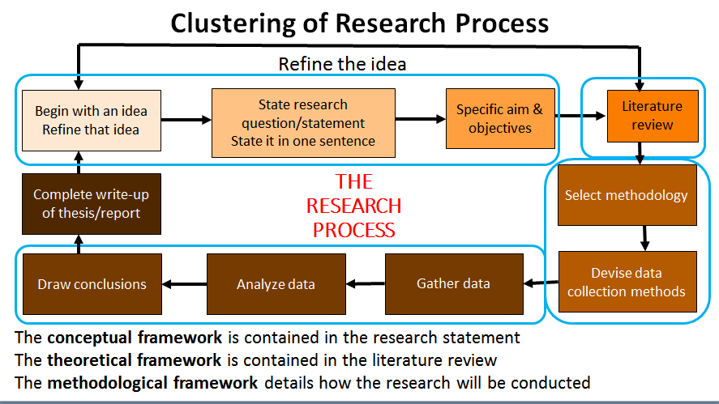

**Statement of the Problem** – is an intellectual stimulus that calls for an organized response in the form of scientific inquiry and should express a relationship between two or more variables.

**Two Parts of the Statement of the Problem**

1. **General/Main Objective -** provides the focus of research (Declarative form)
2. **Specific Objective** – statements that will address the realization of the research objective (Interrogative form)

**Start Specific Questions/Objectives with Verbs (Bloom’s Taxonomy)**

|  |  |
| --- | --- |
| **Level** | **Appropriate Verb for each level** |
| **Knowledge** | Define Memorize List Recall Recognize Repeat Related Record Name Identify Acquire Underline Label State Relate Order |
| **Comprehension** | Restate Discuss Describe Identify Locate Report Explain Express Recognize Review Transform Represent Select Tell Indicate |
| **Application** | Translate Interpret Apply Practice Illustrate Operate Explain Demonstrate Dramatize Sketch Employ Schedule Use Sequence Prepare Predict Generalize Implement Solve Complete |
| **Analysis** | Distinguish Differentiate Appraise Analyze Calculate Criticize Estimate Discover Compare Contrast Examine Test Experiment Investigate  Question Diagram Debate Classify Categorize Determine Inventory |
| **Synthesis** | Compose Plan Propose Design Assemble Create Formulate Organize Manage Construct Argue Conclude Integrate Theorize Specify Derive |
| **Evaluation** | Judge Appraise Measure Assess Value Estimate Choose Compute Evaluate Revise Score Rank Check Defend Verify Justify Rate Support Weigh |

Statement of the Problem:

The main objective of this research is create a cost predictive mathematical model for residential projects through Multiple Linear Regression Analysis associated with Exploratory Factor Item-analytic approach to determine the cost-influencing factors.

Specifically the study aimed to answer the following:

1. Determine the most frequently encountered cost influencing conditions and issues by undertaking expert consultation and critical review on established construction project management theories.
2. Develop and administer the Cost-influencing Factors Assessment Questionnaire (CFAQ) to measure the extent to which the obtained conditions and issues affect a building project cost.
3. Utilize Factor Analysis to extract the latent underlying cost-influencing factors and to develop and validate the Project Cost Assessment Instrument (PCAI).
4. Design a regression mathematical model to delineate the relationship between the extracted factors and residential project cost using the developed instrument.
5. Evaluate the effectiveness of the developed mathematical model by conducting residential project assessment in Davao City.

**Jay Cabunas**

**MS Civil Engineering**

The main objective of this research is to design a Knowledge Management System (KMS) for private construction companies in the form of Data Flow Diagrams (DFDs) considering data classification under use, type and flow order to improve process sustainability through document-based solution to construction delays.

Specifically, the study will address the following:

1. Classify all necessary data and delay factors that play a vital role in the progress of the phases of a construction project.
2. Categorize data considering their use, type and flow order in a project and delay factors according to contributors.
3. Identify the most prominent delay factors in three (3) selected companies and most effective mitigation processes through a survey using Likert Scale Analyze gathered data from the sample population using ANOVA test to identify significant differences.
4. Design a Knowledge Management System (KMS) in the form of Data Flow Diagrams for all construction data considering the most common delay factors and mitigation process. Evaluate the impact of KMS-DFDs in mitigation construction delays.
5. Evaluate the effectiveness and process sustainability of the knowledge management system in the form of data flow diagram.

**Roderick Macariola**

**MS Civil Engineering**

The main objective of this research study is to determine the compressive and flexural strength of recycled concrete aggregates (RCA) with rice husk ash (RHA) as admixture for concrete pavements.

Specifically, the study will address the following:

1. Evaluate the responses of the different Construction Project Managers in adapting RCA as replacement in natural aggregates in concrete production using survey questionnaires.
2. Measure the workability of RCA concrete added with RHA using double mixing method.
3. Determine the variability of compressive and flexural strength of RCA added with RHA under high rate of loading in 7, 14 and 28 days curing.
4. Compare the compressive and flexural strength of RCA added with RHA to normal concrete aggregates under high loading rates.
5. Investigate the physical behavior of crack in the RCA concrete added with RHA in its 28th day test.
6. Estimate the ratio of RCA and RHA that will give the best result for compressive and flexural strength.

**Statement of the Problem:**

The main objective of this research study is to design and fabricate and robot, and test it for visual duct inspection and for air properties measurement of air-conditioning duct systems.

Specifically, the study will address the following:

1. Design an duct inspection robot for visual recognition of duct accumulation, rust, molds, holes and cracks in air-conditioning duct systems.
2. Identify the sensors and transducers necessary to measure air properties in air-conditioning duct systems such as a) dry-bulb temperature, b) air pressure, c) relative humidity, d) velocity, e) air flowrate, f) carbon monoxide concentration and g) carbon dioxide concentration.
3. Fabricate the inspection robot using machine shop techniques and 3-D printing technology.
4. Develop a protocol on how the operator can control the robot to perform a visual inspection in air-conditioning duct systems.
5. Evaluate the effectivity on the robot in visual inspections and in air properties measurement in air-conditioning duct systems using standard tests.

**Jerome D. Lopena**

**MS in Mechanical Engineering**

**The purpose of a Literature Review**

* Understand and summarize the major ideas on a subject,
* Show an awareness of the scope of research that has already been conducted on a topic
* Identify new and emerging knowledge in an area, and
* Highlight gaps in the research where new research activity may be warranted.

**REVIEW OF RELATED LITERATURE**

An organized collection of literature and studies which are outlined in the key concepts.

* The key concepts in the statement of the problem is used in the search for literature and studies.
* The key concepts provide focus and direction for the theoretical framework.

**Introduction**

* Overview of RRL

**Related Readings**

* Legal basis of the study
* Direct/indirect implications to the government thrusts

**Related Literature (foreign and local)**

* Sources are taken from the books, journals, magazines, online database

**Related Studies (foreign and local)**

* Published and unpublished research studies

**Synthesis and Justification**

* Justification of the present study
* Bearing of related studies upon the present study
* Differences of the present study

**Theoretical Framework**

* It defines the relationship of all the variables (key concepts)

**For Tables, label it this way:**

|  |  |  |  |  |
| --- | --- | --- | --- | --- |
| **Table No.** | Title |  |  |  |
|  | **Label** | | **Label** | |
|  | Data |  | Data |  |
|  | Data |  | Data |  |

**For graphs, figures, illustrations:**

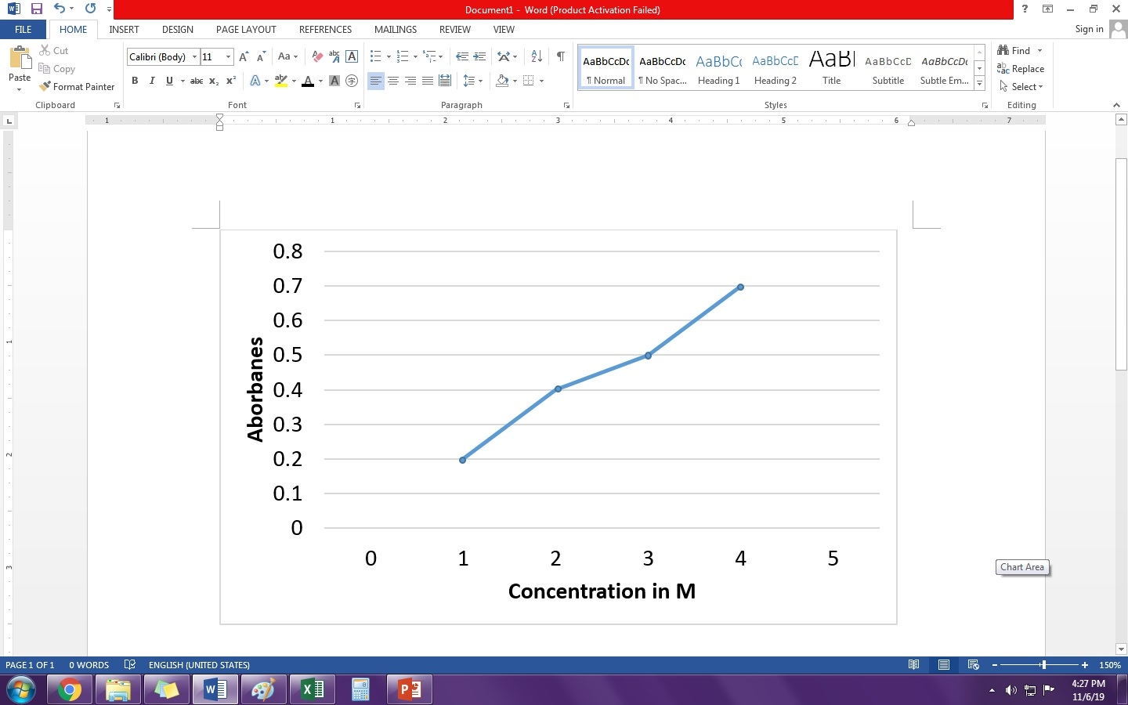

**Figure No.** Title

**For Equations:**

Number the equations in this matter:

**x + y = 12 (1.1)**

The first number denotes the chapter and the second number denotes the number of equation in that chapter. The equation number must be right justified and must be written in Times New Roman 12 bold font style.

**For illustrations with sources:**

The source of the photo or illustration must be given in this matter:

Source: Author, Year (must be aligned with the label)

**Definition of Conceptual Framework**

A conceptual framework represents the researcher’s synthesis of literature on how to explain a phenomenon. It maps out the actions required in the course of the study given his previous knowledge of other researchers’ point of view and his observations on the subject of research.

<https://simplyeducate.me/conceptual-framework-handbook/>

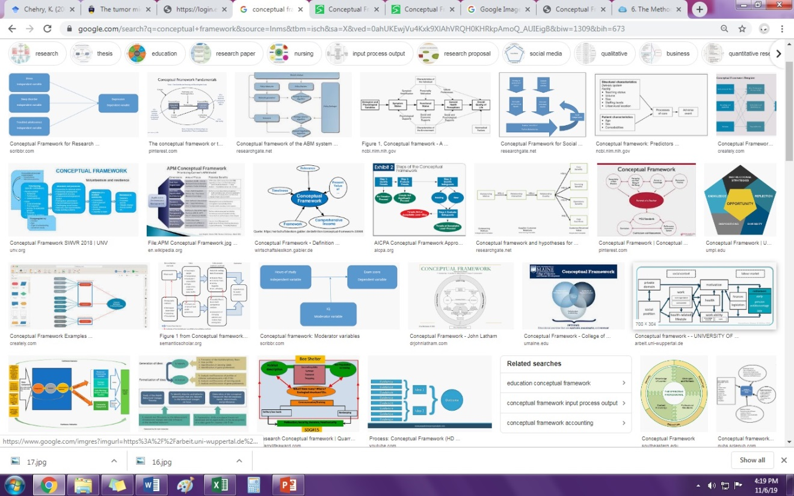

**The methodological framework emerges from the conceptual framework**

“The methodology section of a research paper answers two main questions: How was the data collected or generated? And how was it analyzed?”

<https://libguides.usc.edu/writingguide/methodology>