**SalesForce**

**Definition:**

Salesforce can be thought of as CRM tool (*Customer Relationship management tool*) in the cloud which can be used to work from anywhere using a web browser in tablet smartphone or a laptop.

CRM functionality is at the core of Salesforce.

You can manage customers’ accounts and sales leads without any customizations.

Salesforce allows us to customize the CRM system and make the system work for a unique business.

**Architecture:**

Salesforce is a cloud plateform, salesdata is in the cloud called multitenant cloud.

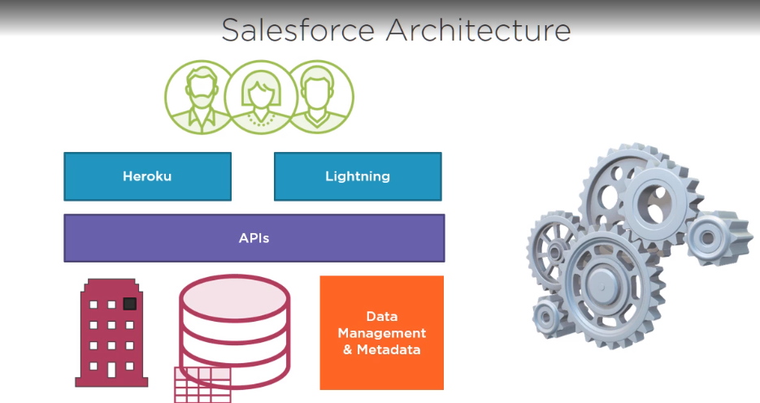

* Each organization or org has a dedicated space in the Salesforce cloud which means each org date is separate from others org data.
* Data Management and Metadata: Salesforce include data management features for your data and also to store meta data which allows Salesforce to understand data at a deeper level (like data types and how data are related) and helps to build application
* Sales force offers capabilities of API, using the API data and meta-data can be retrieved, also update or create new record of data.
* Lastly we have the user interface, many options are there for creating UI on top of Salesforce data, one option is **heroku** (hosting platform for applications), you can also use lightening which allows us to focus on application logic and workflows while Salesforce takes care of layout and look and feel of application.  
  An application can be made available to other org through app exchange.

**Sandbox**

Sandbox is an isolated copy of org metadata that can be used for experiments and developments.