**NEXUS**

<https://devopscube.com/how-to-install-latest-sonatype-nexus-3-on-linux/>

To download nexus use the below url.

<http://download.sonatype.com/nexus/3/nexus-3.7.1-02-unix.tar.gz>

To check latest release of nexus please visit the page

<https://help.sonatype.com/repomanager3/download/download-archives---repository-manager-3>

**Pre-req**

Install java.

*yum install java-1.8.0-openjdk.x86_64*

create a user by name nexus

adduser nexus

passwd nexus

Downloading and configuring nexus.

wget <https://sonatype-download.global.ssl.fastly.net/nexus/3/nexus-3.7.1-02-unix.tar.gz>

tar <downloaded file name>

mv <downloaded file name> nexus

Inside nexus folder go to bin folder and edit nexus.rc to add as below

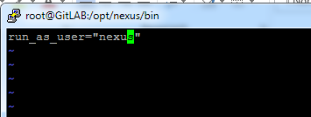

Next, we need to edit the nexus.vmoptions to configure where the runtime files will be stored.

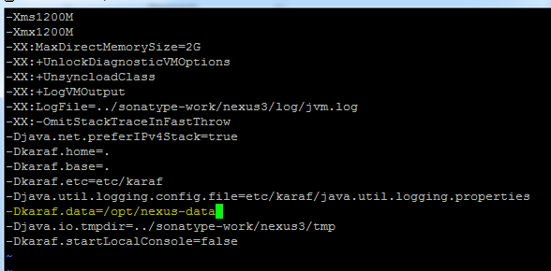

In the above screen the “-Dkaraf.data” is given a path where the directory “nexus-data” will store the dashboard during display.

Create the directory from the command line and set permission for the nexus user.

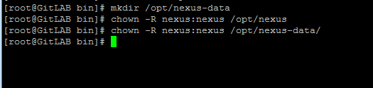

And also change the ownership to nexus user for sonatype-work folder which is present under **/opt/sonatype-work**

**Chown –R nexus:nexus /opt/sonatype-work**

Add the service to start during different run level and also create a soft link to init.d folder.

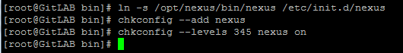

**Theory on nexus.**

Blob store.

A blob store is the internal storage mechanism for the binary parts of components and their assets.

**Repositories.**

Storing of binaries and metadata in defined folder structure so that it can be used by build tools like ant maven to retrieve its binaries.

**Types of repositories:**

* **Proxy repository**: this type is used when your project should be accessible publically.
* **Hosted repository:** used when project is not public but used by other in org
* **Repository groups**: used when we have multiple repo and can be accessed from single url.

**Users**

Nexus allows us to create users and assign roles to the created users therefore when the users logs in will see only the privileges assigned to that particular user.   
Explore more from the nexus console.

**Anonymous:**

This feature allows unauthenticated users to view and have read access to nexus.

Can be disabled by unchecking the box.

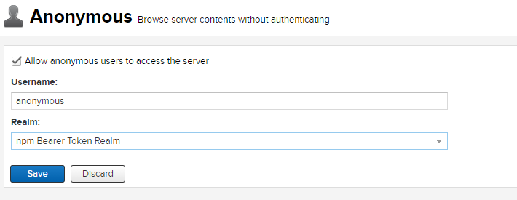

Username & Realm: This combination provides the ability to bring in users from other services and thereby have the permission of that user to the anonymous user.

Example:  you might have a guest account defined in your LDAP system and desire to use that user and the permissions it has for anonymous access