**JIRA GIT INTEGRATION**

Git can be integrated with Jira with the help of plugin “Git integration” (PAID)

**Features:**

* Integrate source code repository into the jira dashboard(gitlab, guthub, bit bucket etc )
* View the commits on the repository.
* Compare between two branches.
* View the issues logged in the repository.

**Installation:**

Step1 - Installing the plugin requires to login to jira as admin.

Step 2 – Settings tab and select add-on

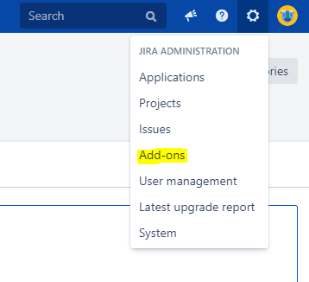

Step 3 – find new add-ons on the left.

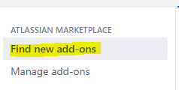

Step 4- Search for “git integration” and install.



**Confirmation of installation.**

After installing the plugin Dashboard should have GIT on top pane.



**Integration of Repository:**

To integrate repository select the Git tab and from drop down “manage repositories”

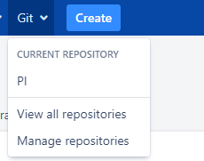

Select “connect to git repository.”



And add the repo as shown below.

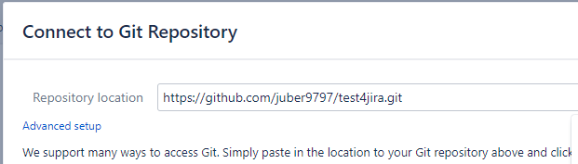

Click next.

Then you can restrict project accessing by adding projects or leave default.

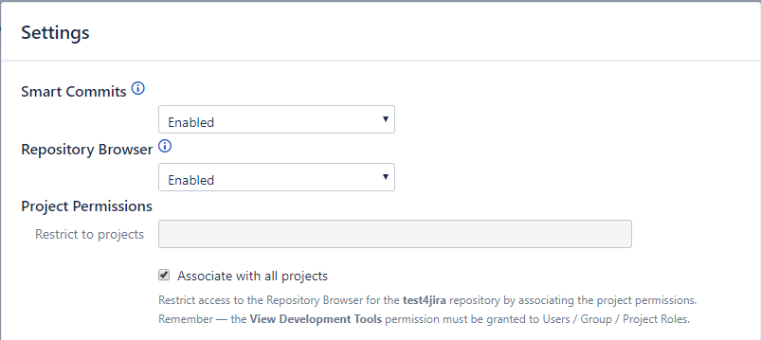

Similar ways as many repo can be added.

**View repositories, Commits, changes and Compare**

**To view list of repo, GIT -> View all repositories.**

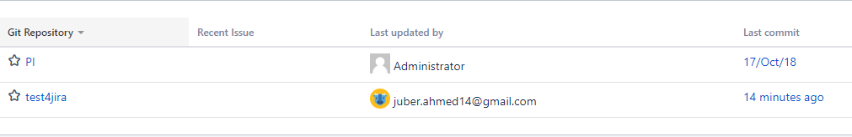

**Commit changes.**

Select the repo to view commits and changes.

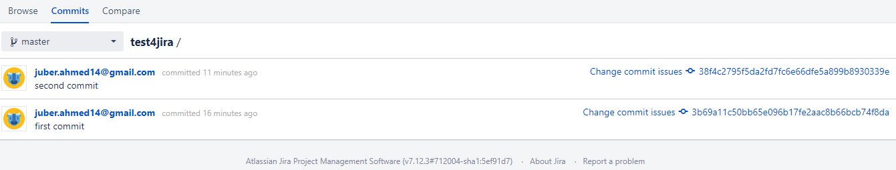

Click the “change commit id” on left it will show added, modified, deleted with green, yellow and red as shown below.

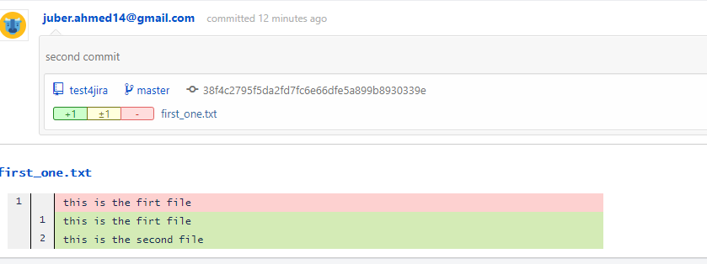

**Compare branches**

Select the repository and select the branches (example here dev and master) to see what changes are made at branch level.

Example if files are added or files are modified.

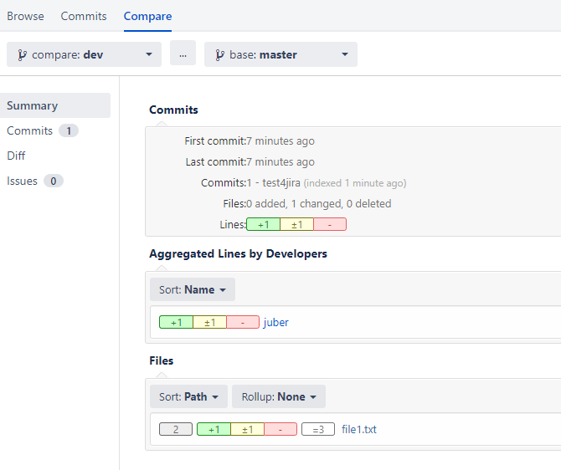

Select the diff button to check the differences.

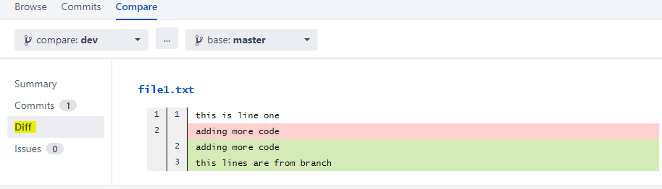

**Pricing for the plugin.**

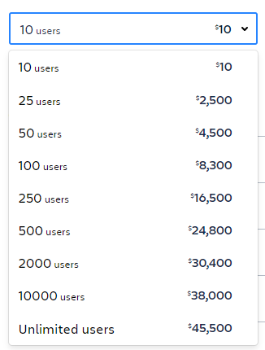

**If maintenance is included**

