**Group = Healthy**

|  |  |  |  |  |  |  |
| --- | --- | --- | --- | --- | --- | --- |
| **Case Processing Summarya** | | | | | | |
|  | Cases | | | | | |
| Valid | | Missing | | Total | |
| N | Percent | N | Percent | N | Percent |
| SDNN | 110 | 100.0% | 0 | 0.0% | 110 | 100.0% |
| a. Group = Healthy | | | | | | |

|  |  |  |  |  |
| --- | --- | --- | --- | --- |
| **Descriptivesa** | | | | |
|  | | | Statistic | Std. Error |
| SDNN | Mean | | 78.804881 | 2.2994723 |
| 95% Confidence Interval for Mean | Lower Bound | 74.247402 |  |
| Upper Bound | 83.362360 |  |
| 5% Trimmed Mean | | 77.417167 |  |
| Median | | 76.755050 |  |
| Variance | | 581.633 |  |
| Std. Deviation | | 24.1170691 |  |
| Minimum | | 34.6999 |  |
| Maximum | | 163.1670 |  |
| Range | | 128.4671 |  |
| Interquartile Range | | 30.4712 |  |
| Skewness | | .917 | .230 |
| Kurtosis | | 1.381 | .457 |
| a. Group = Healthy | | | | |

|  |  |  |  |  |  |  |
| --- | --- | --- | --- | --- | --- | --- |
| **Tests of Normalitya** | | | | | | |
|  | Kolmogorov-Smirnovb | | | Shapiro-Wilk | | |
| Statistic | df | Sig. | Statistic | df | Sig. |
| SDNN | .115 | 110 | .001 | .950 | 110 | .000 |
| a. Group = Healthy | | | | | | |
| b. Lilliefors Significance Correction | | | | | | |

**SDNN**

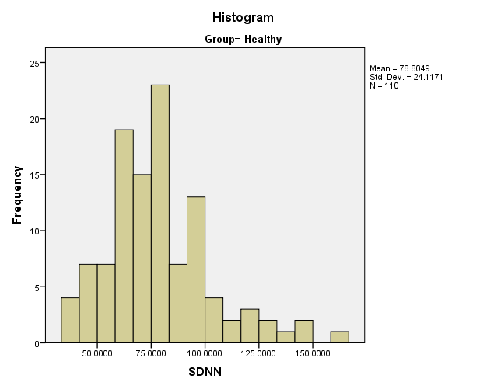

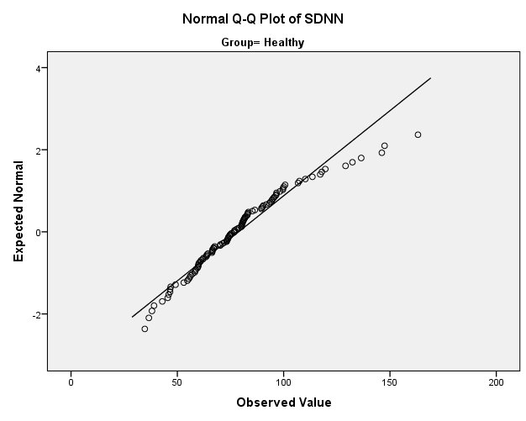

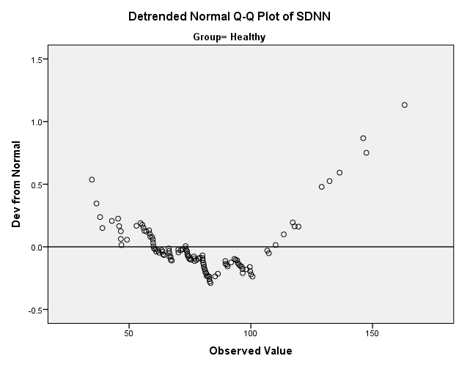

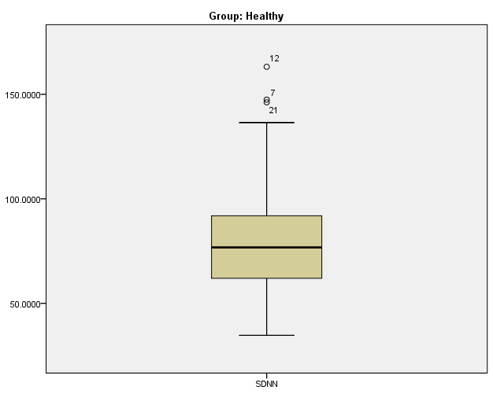

**Group = Apnea**

|  |  |  |  |  |  |  |
| --- | --- | --- | --- | --- | --- | --- |
| **Case Processing Summarya** | | | | | | |
|  | Cases | | | | | |
| Valid | | Missing | | Total | |
| N | Percent | N | Percent | N | Percent |
| SDNN | 110 | 100.0% | 0 | 0.0% | 110 | 100.0% |
| a. Group = Apnea | | | | | | |

|  |  |  |  |  |
| --- | --- | --- | --- | --- |
| **Descriptivesa** | | | | |
|  | | | Statistic | Std. Error |
| SDNN | Mean | | 82.510823 | 2.4586825 |
| 95% Confidence Interval for Mean | Lower Bound | 77.637794 |  |
| Upper Bound | 87.383851 |  |
| 5% Trimmed Mean | | 80.739109 |  |
| Median | | 77.328300 |  |
| Variance | | 664.963 |  |
| Std. Deviation | | 25.7868793 |  |
| Minimum | | 16.3806 |  |
| Maximum | | 185.6560 |  |
| Range | | 169.2754 |  |
| Interquartile Range | | 29.8668 |  |
| Skewness | | 1.238 | .230 |
| Kurtosis | | 3.219 | .457 |
| a. Group = Apnea | | | | |

|  |  |  |  |  |  |  |
| --- | --- | --- | --- | --- | --- | --- |
| **Tests of Normalitya** | | | | | | |
|  | Kolmogorov-Smirnovb | | | Shapiro-Wilk | | |
| Statistic | df | Sig. | Statistic | df | Sig. |
| SDNN | .109 | 110 | .003 | .921 | 110 | .000 |
| a. Group = Apnea | | | | | | |
| b. Lilliefors Significance Correction | | | | | | |

**SDNN**

