**Jhuvie Jhane Globio**

**INF242**

**ACT2(Multiple Inheritance)**

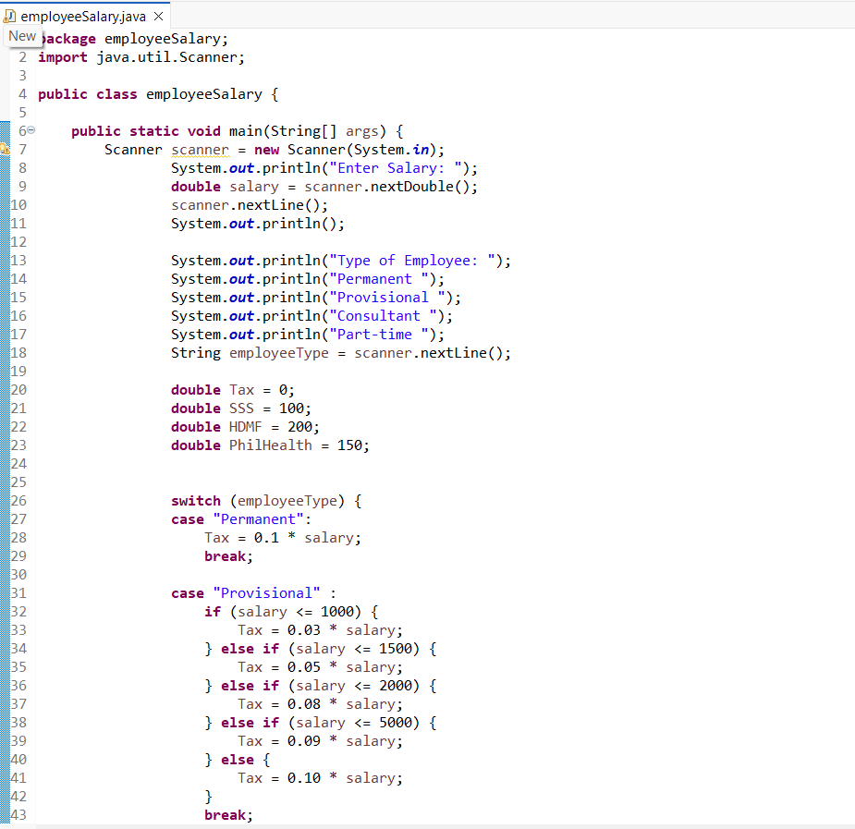Input:

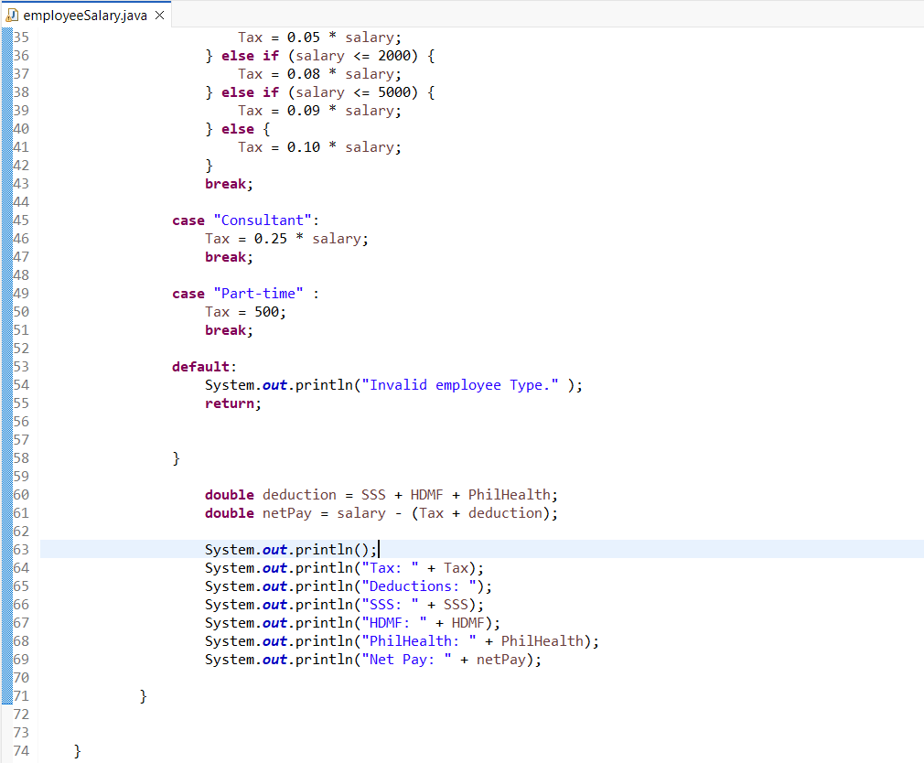Output:

