Jubilee Marie Tantoy

Gabriel Angelo Guerrero

2 ECE D

**Machine Problem No. 3 – MATLAB**

CODE

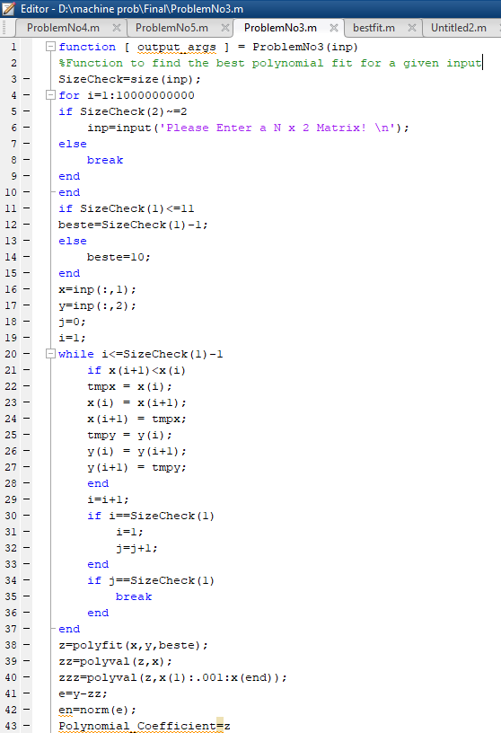

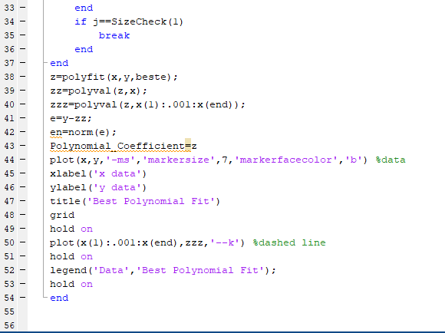

Trial : (5x2) matrix

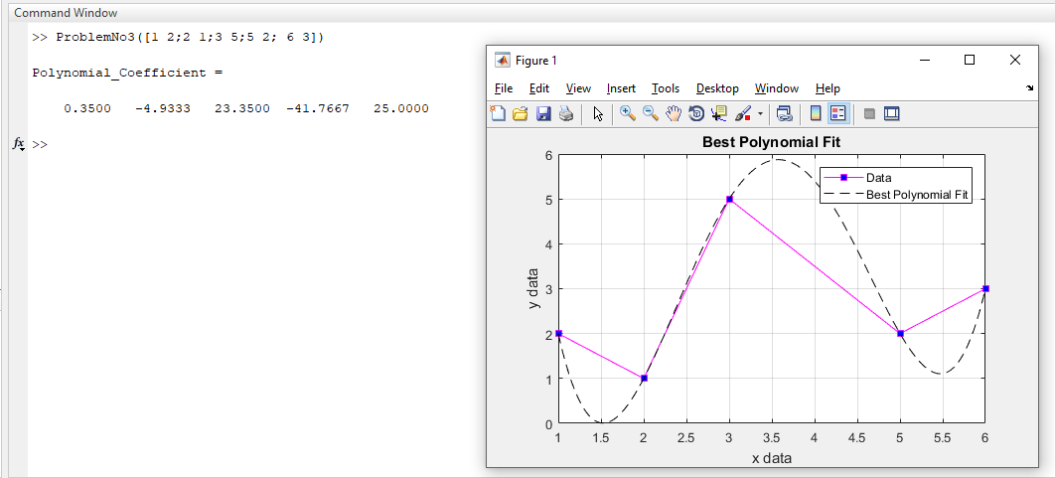

Trial : (9x2) matrix

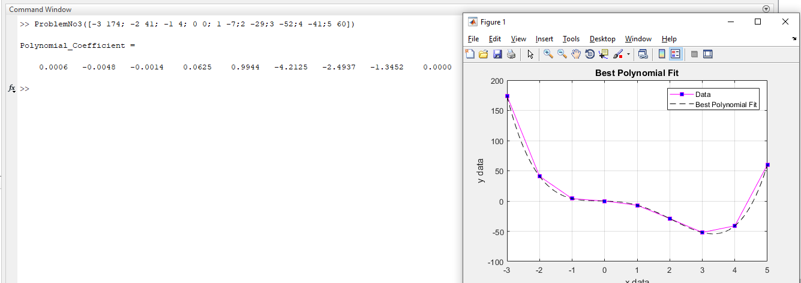

Trial 3: Input matrix not n x 2 matrix

