Jubilee Marie Tantoy

Gabriel Angelo Guerrero

2 ECE D

**Machine Problem No. 4 – MATLAB**

CODE

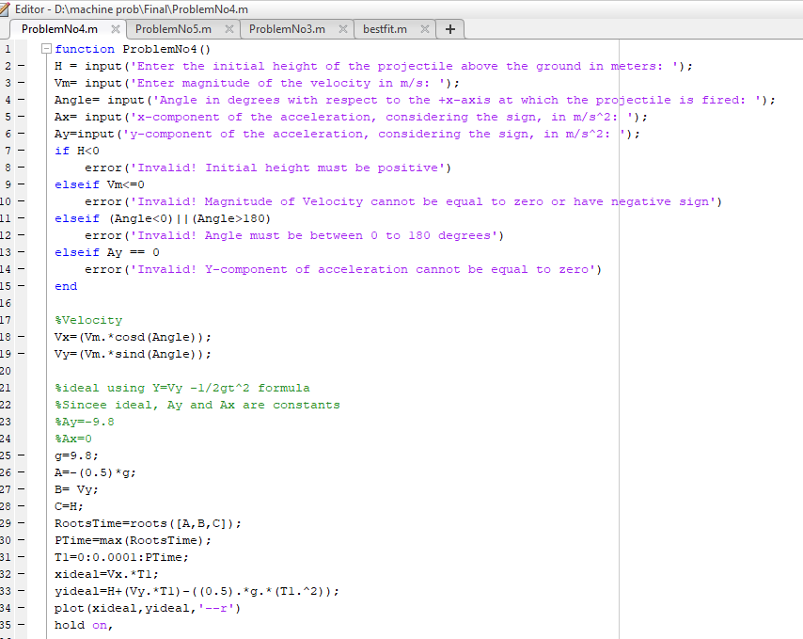

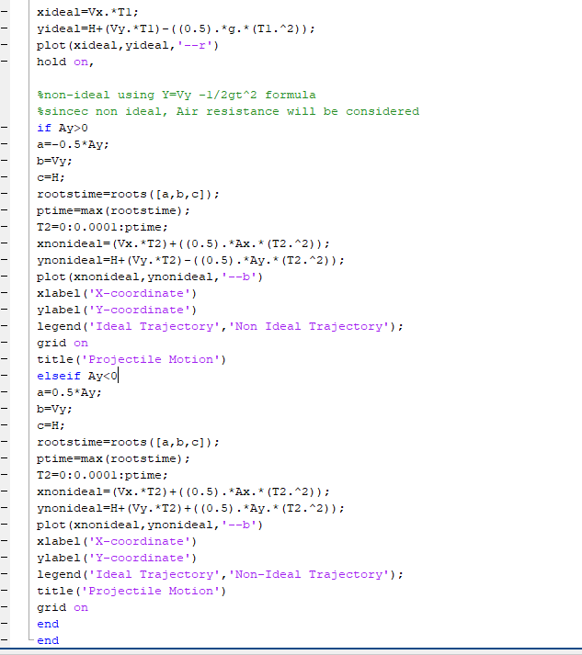

Trial No. 1 (with correct values)

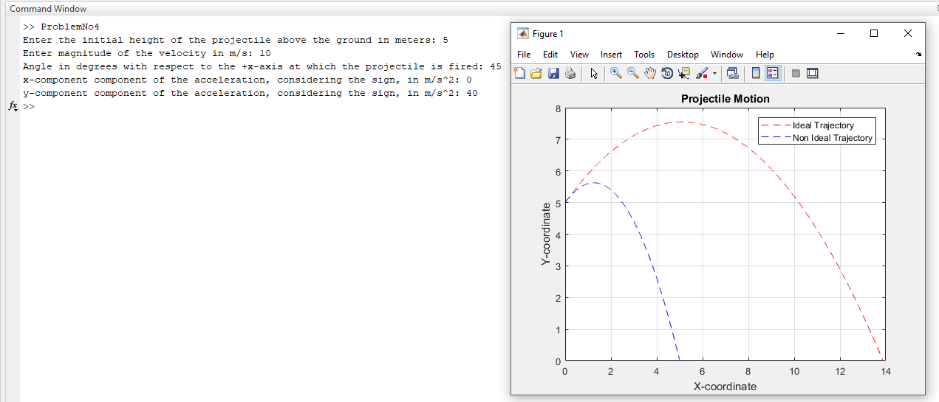

Trial No. 2 ( Negative Value of Velocity) 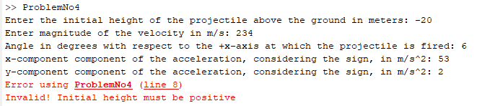

Trial No.3 (Negative Value of Height)

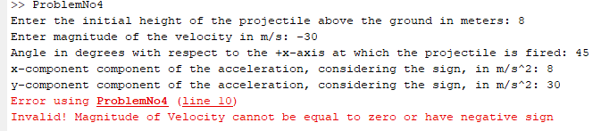

Trial No.4 (Negative Value of Angle)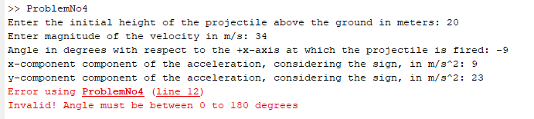

Trial No.5(More than 180 Degrees of Angle)

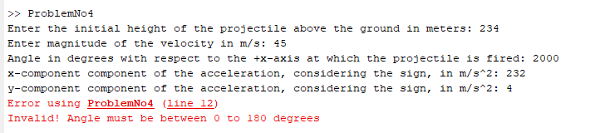

Trial No.6(Y- component of acceleration equals to 0)

