Jubilee Marie Tantoy

Gabriel Angelo Guerrero

2 ECE D

**Machine Problem No. 5 – MATLAB**

CODE

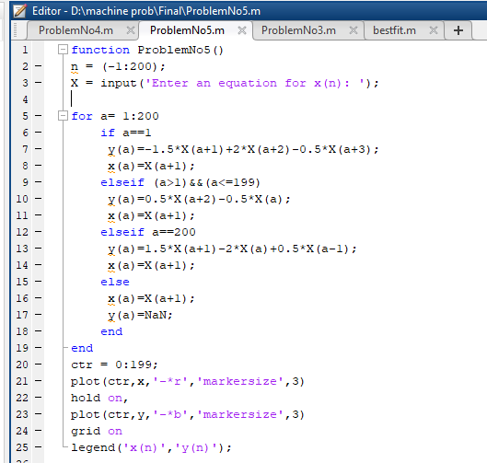

Trial 1 ( equation is sin(((3*pi)/100)*n) )

