Jubilee Marie Tantoy

Gabriel Angelo Guerrero

2 ECE D

**Machine Problem No. 5 – PYTHON**

CODE

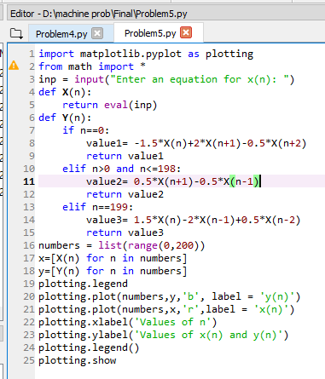

Trial 1 : input equation = sin(((3*pi)/100)*n)

