Jubilee Marie Tantoy

Gabriel Angelo Guerrero

2 ECE D

**Machine Problem No. 4 – PYTHON**

**CODE**

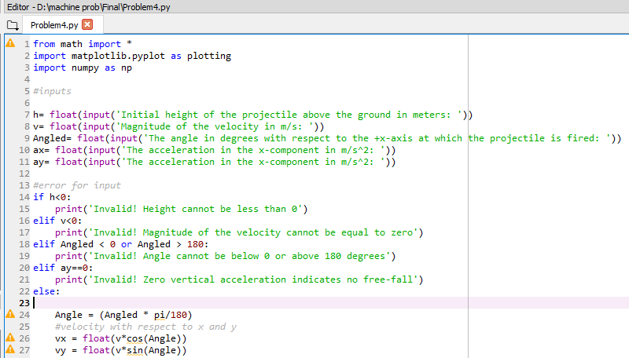

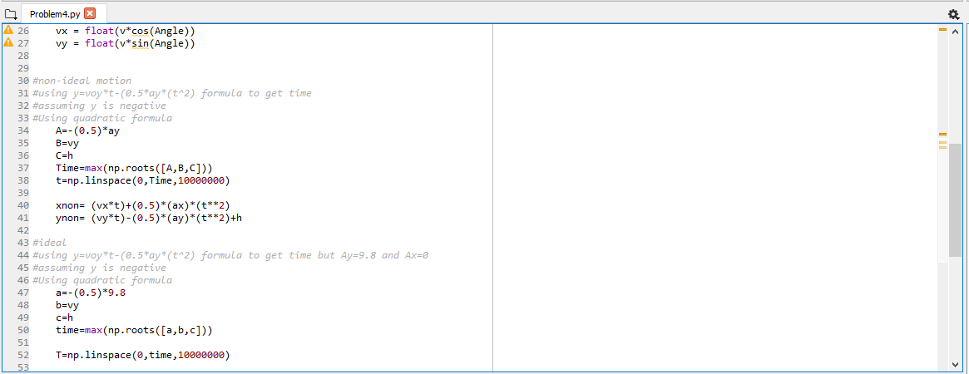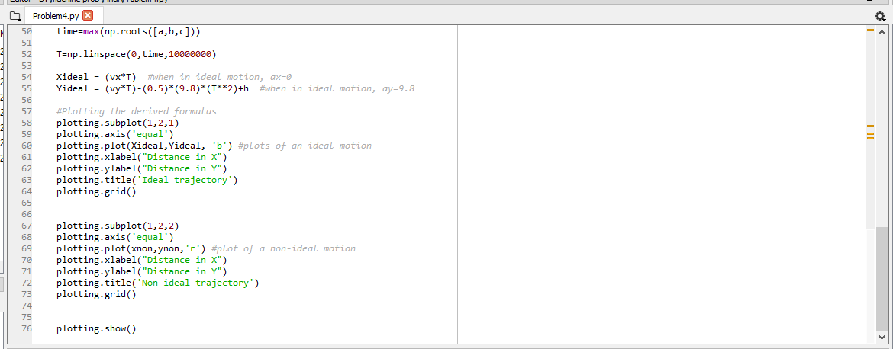

**Trial 1 (correct Values)**

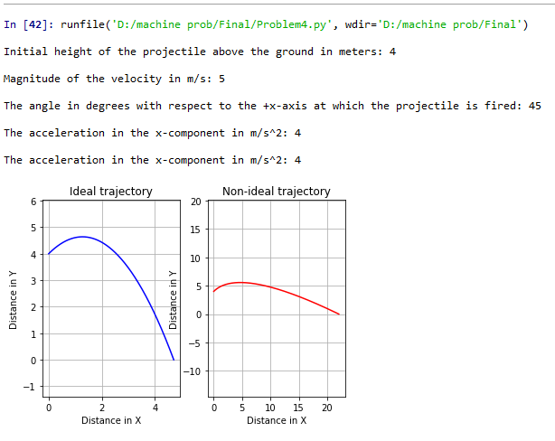

**Trial 2 (Height less than 0)**

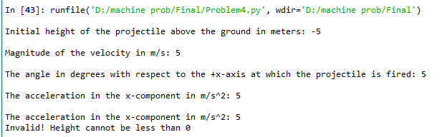

Trial 3 (Magnitude less than 0)

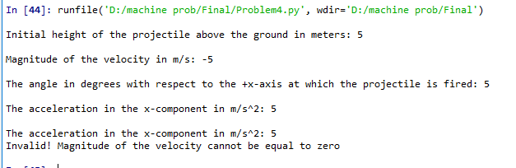

**Trial 4 (Angle greater than 180 or less than 0)**

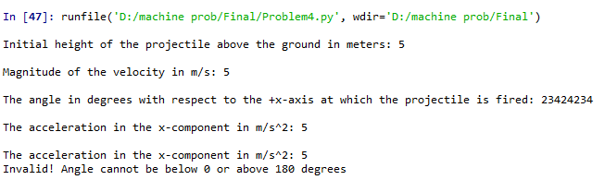

**Trial 5(Acceleration in y = 0)**

