Team 1 Group Project

Links
Application Demo Video -> https://www.youtube.com/watch?v=xrrUyPRfZac&feature=youtu.be
VM Download Link -> https://gatech.box.com/s/jyzyzl1yhweevlhy1jdyoc42byval7wr

Application Requirements
Java version 1.8+
Any modern web browser capable of HTML5 and ES6 JavaScript

Application External Dependencies
jQuery (JavaScript library) - https://jquery.com/
Spark (Java Micro Webserver) - http://sparkjava.com/
Simple Logging Facade for Java - https://www.slf4j.org/

Accessing the VM
The VM being used is the official course VM
Login to VM with password cs6310
Git repo for application with latest code is here -> ~/git/cs6310

Description of folders within repo
app – This is the actual project folder structured as a maven ready folder.
app/src – All source code (java and html/js/css) for the project
test – All provided test files
test/probabilities – All provided passenger distribution files
test/20 Step Solutions – Solutions of twenty step simulation with each test file

To Run the application
This is a two step process – Launch the Java app and then access UI on browser
To start the Java application, open a terminal and change directory
cd ~/git/cs6310/app/
Issue following command for Mac/Unix
Note that for Windows systems, use semicolon instead of colon and back slash instead of forward slash
To launch with no input files specified
java -cp "./target/classes:./target/classes/lib/*" SimulationService
To launch with a setup file and passenger probability file specified
java -cp "./target/classes:./target/classes/lib/*" SimulationService <setup file> <passenger probability file>
Server will start running. Do not close the window
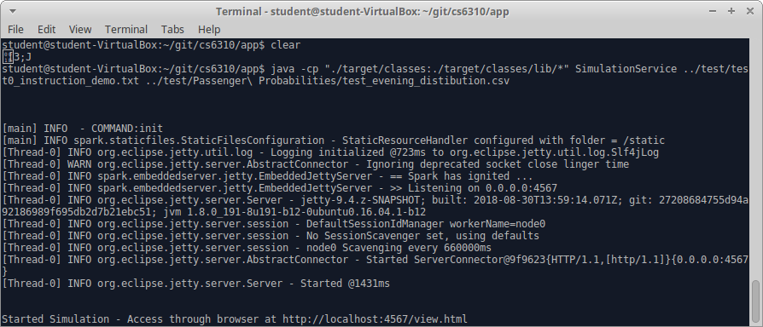
Open a browser and access below URL to access the application UI
http://localhost:4567/view.html

To load (or re-run) application with another set of input files
Option 1: Use the ‘initialize from files’ button on the UI to load the new setup and passenger probability files
Option 2: shut down the Java console app and re-run with new set of input files as argument. Then launch browser and navigate to http://localhost:4567/view.html

To Build application from source (compile)
Always make source code changes (java or html/js/css) only in app/src folder.
Compiled classes & everything required to run app will be created in app/target
Open a terminal and change directory
cd ~git/cs6310/app

- Build using Maven -> Execute following command
mvn clean compile
- Build using Java → Execute the following four commands
rm -f -r cs6310/app/target
mkdir -p target/classes
javac -cp "./src/main/java/resources/lib/*" -d "./target/classes" ./src/main/java/*.java

cp -R ./src/main/resources/* ./target/classes

Some notable application features

There is extensive error checking and validation built in with good feedback to the user – For example, try update bus or system changes to incorrect or alphabetic values. Or try initializing system without specifying a file. Similarly, info like number of rewinds available or features like disabling rewind button when all rewinds are exhausted are implemented.

There is extensive logging on the server console to show information related to passenger exchange etc. that is not all visible on the UI.

Application combines domain driven design with single responsibility principle. Hence the reason why Bus, Stop, Route etc. are core business entities and most of the application logic is taken away from them by SimulationEngine (Inversion of Control).

SimulationEngine is a singleton so that every web request coming in can get a hold of the same instance

The UI is truly stateless. It is just a window into the actual application engine. This de coupling of UI from application engine using a well-known protocol (http + json) allows multiple UIs to connect to the SimulationService and view or manipulate the system.

The UI has clean simple ES6 JavaScript class-based code w/o relying on any complex framework etc.

On a rewind, we restore all the state related to the bus including any capacity, passenger and route changes that may have happened.

Other interesting info
http://localhost:4567/ -> This will give a JSON representation of system state.
The application start page view.html as well as many operations makes http call to this URL to get the system state and redraw UI
http://localhost:4567/movebus -> Performs move bus event and returns data pertaining to bus that moved, stop that got affected. The “move bus “ button on the UI calls this.
We could return the entire system state data too as a result of this and have the UI repaint everything. But why do that when we know only a bus and stop changes as a result of move bus event. Hence a different minimal return data for this as opposed to the URL just above
http://localhost:4567/reset -> Resets system to the very start. This is not required for the assignment. But is a convenient way to debug/test the application
http://localhost:4567/changebus -> This is a HTTP POST method and accepts bus Id, speed, capacity, route and stop index on new route as request parameters.
It queues the proposed changes for the bus to happen at the next event for that bus
http://localhost:4567/rewind/<N> -> Rewinds system by N steps. We hardcode N to 1 since the Ui is designed to allow only a single rewind at a time. Returns data relevant to the stop and bus impacted by the rewind
http://localhost:4567/changebus -> System efficiency update end point that accepts all five k values

Bulk testing against provided test files and their solutions (Only move bus sequence logic can be validated since passenger count etc. is random)
Run SimulationTester passing folder with test files as first argument and a passenger probability file as second argument.
The results will be created in a folder named “output” in the folder passed as first argument.
This output folder can be folder diff-ed with the provided solutions folder ( ~/git/cs6310/test/20 Step Solutions ) to validate output correctness
cd ~/git/cs6310/app
java -cp ./target/classes:./target/classes/lib/* SimulationTester ../test ../test/probabilities/test_evening_distibution.csv
Now folder diff ../test/output and ../test/20 Step Solutions

