To Compile
- Using Maven ->
The directory structure is already setup for Maven and has pom.xml.
So follow standard Apache Maven install directions if not already installed,
change directory to Git\cs6310\app and run
mvn compile
Compiled classes will be in Git\cs6310\app\target\classes
- Using Java ->
Change directory to Git\cs6310\app\src\main\java
javac -cp "../resources/lib/*" *.java

Compiled classes will be created in same folder

To Run
If built using Maven, then everything we need will be in directory Git\cs6310\app\target\classes
If manually putting together, have all of this in one folder
- *.class files from compilation
- Directory Git\cs6310\app\src\main\resources\lib with all its contents
- Directory Git\cs6310\app\src\main\resources\static with all its contents
- test0_scenario.txt and test0_rider.txt
Run app as below (For unix systems, use colon instead of semicolon)
java -cp ".;lib/*" SimulationService ..\..\test\test0_scenario.txt ..\..\test\test0_rider.txt
Server will start running. Do not close the window
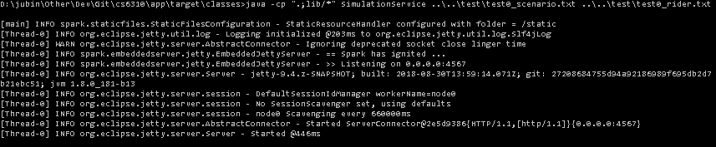

To Test
http://localhost:4567/view.html -> This will launch the UI that shows the Simulation System state
http://localhost:4567/ -> This will give a JSON representation of system state.
The UI page above makes http call to this URL to get the system state
http://localhost:4567/movebus -> Performs move bus event and returns data pertaining to bus that moved, stop that got affected. The “move bus “ button on the UI calls this.
We could return the entire system state data too as a result of this and have the UI repaint everything. But why do that when we know only a bus and stop changes as a result of move bus event. Hence a different minimal return data for this as opposed to the URL just above
http://localhost:4567/reset -> Resets system to the very start. This is not required for the assignment. But is a convenient way to debug/test the application

To Do
Server App - Implementation of rewind logic and associated data structures on server side
UI - add button and interface for bus changes, System constant changes, rewind
Server app – Add http Endpoints to accept, process and return relevant json response for bus changes, System constant changes, and rewind
UI - Make UI look nice and presentable
Testing - Lot of testing. A good start is to make the test input files in Git\cs6310\test compliant with the format for Assignment 9

