Description of folders
app – This is the actual project structured as a maven folder.
app/src - source code
test – All provided test files and solutions

To Run the application
Open a terminal and change directory
cd /home/student/git/cs6310/app/
Isssue following command based on operating system
Note that for Windows systems, use semicolon instead of colon and back slash instead of forward slash
For Mac/Unix:
java -cp "./target/classes:./target/classes/lib/*" SimulationService <path to setup file> <path to passenger distribution file>
For Windows:
java -cp ".\target\classes;lib\*" SimulationService <path to setup file> <path to passenger distribution file>

Server will start running. Do not close the window
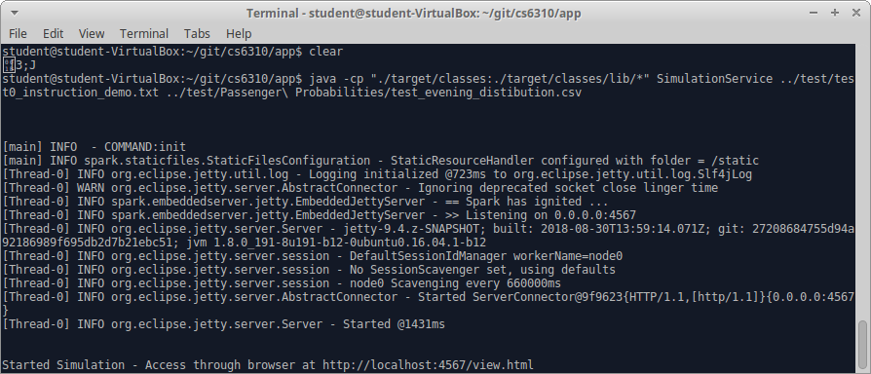

Open a browser and access below URL to access the application UI
http://localhost:4567/view.html

To Build from source (compile)
Always make source code changes (java or html/js/css) only in app/src folder.
Compiled classes & everything required to run app will be created in app/target
Open a terminal and change directory
cd /home/student/git/cs6310/app

- Build using Maven -> Execute following command
mvn clean compile
- Build using Java → Execute the following four commands
rm -f -r cs6310/app/target
mkdir -p target/classes
javac -cp "./src/main/java/resources/lib/*" -d "./target/classes" ./src/main/java/*.java

cp -R ./src/main/resources/* ./target/classes

Other related info
http://localhost:4567/ -> This will give a JSON representation of system state.
The application start page view.html as well as many operations makes http call to this URL to get the system state and redraw UI
http://localhost:4567/movebus -> Performs move bus event and returns data pertaining to bus that moved, stop that got affected. The “move bus “ button on the UI calls this.
We could return the entire system state data too as a result of this and have the UI repaint everything. But why do that when we know only a bus and stop changes as a result of move bus event. Hence a different minimal return data for this as opposed to the URL just above
http://localhost:4567/reset -> Resets system to the very start. This is not required for the assignment. But is a convenient way to debug/test the application
http://localhost:4567/changebus -> This is a HTTP POST method and accepts bus Id, speed, capacity, route and startindex as request parameters.
It queues the proposed changes for the bus to happen at the next event for that bus

To test quickly against provided test files and solution files (Only move bus logic since passenger count etc. is random)
Run SimulationTester passing folder with test files as first argument and a rider file as second argument.
The results will be written to a folder named “output” in the folder passed as first argument.
This can be folder diff-ed with the provided solutions folder ( /home/student/git/cs6310/test/20 Step Solutions ) to check output correctness
cd /home/student/git/cs6310/app
java -cp "./target/classes:./target/classes/lib/*" SimulationTester “test” “test/Passenger Probabilities/test_evening_distibution.csv”

