1.請依照下列指定的情況，利用SQL指令完成要求：

(1)針對某一個出版社，列出該出版社的書籍總被購買數量

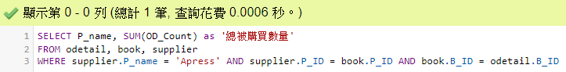

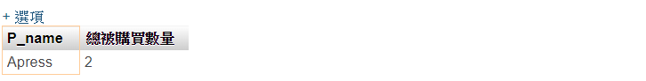

1.取得「P_name (supplier)」跟「總購買數量OD_Count(odetail)」資料

2.從odetail, book, supplier選取資料表

3.從「P_name」中找”Apress資料&串聯supplier.P_ID = book.P_ID AND book.B_ID = odetail.B_ID

/

Code:

SELECT P_name, SUM(OD_Count) as '總被購買數量'

FROM odetail, book, supplier

WHERE supplier.P_name = 'Apress' AND supplier.P_ID = book.P_ID AND book.B_ID = odetail.B_ID

(2)針對某一個出版社，列出該出版社名稱所有書籍，

並只顯示被購買數量大於2的書籍。最後以被購買數量由小到大排序。



1.取得「P_name (supplier)」跟「被購買數量OD_Count(odetail)」資料

2.從odetail, book, supplier選取資料表

3.從「supplier.P_name」中找” 'OREILLY'資料&串聯supplier.P_ID = book.P_ID AND book.B_ID = odetail.B_ID

4.設定條件為「被購買數量>2」

5.聯集第二個table…

(5~最後)重複上列動作

/

Code

SELECT P_name, B_name, SUM(OD_Count) as '被購買數量'

FROM supplier, odetail, book

WHERE supplier.P_name='OREILLY' AND book.B_name='Designing with Data' AND supplier.P_ID = book.P_ID AND book.B_ID = odetail.B_ID

HAVING 被購買數量>2

UNION

SELECT P_name, B_name, SUM(OD_Count) as '被購買數量'

FROM supplier, odetail, book

WHERE supplier.P_name='OREILLY' AND book.B_name='Programming iOS 13' AND supplier.P_ID = book.P_ID AND book.B_ID = odetail.B_ID

HAVING 被購買數量>2

UNION

SELECT P_name, B_name, SUM(OD_Count) as '被購買數量'

FROM supplier, odetail, book

WHERE supplier.P_name='OREILLY' AND book.B_name='Azure Analytics' AND supplier.P_ID = book.P_ID AND book.B_ID = odetail.B_ID

HAVING 被購買數量>2

(3)針對某一個出版社，列出該出版社名稱，以及其所有產品之被購買數量的總平均。

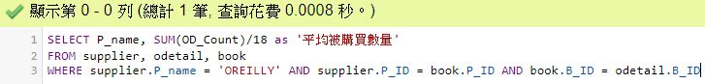



1.取得「P_name (supplier)」跟「平均被購買數量OD_Count/18筆訂單」資料

2.從odetail, book, supplier選取資料表

3.從「P_name」中找” OREILLY”資料&串聯supplier.P_ID = book.P_ID AND book.B_ID = odetail.B_ID

/

Code

SELECT P_name, SUM(OD_Count)/18 as '平均被購買數量'

FROM supplier, odetail, book

WHERE supplier.P_name = 'OREILLY' AND supplier.P_ID = book.P_ID AND book.B_ID = odetail.B_ID

(4)請列出所有會員資訊以及他們的總購買次數，並且依照次數由高到低排序。

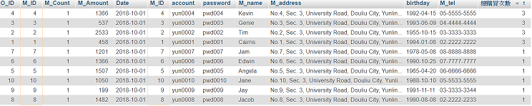

1.取得所有會員及「總購買次數」資料

2.從orderhistory,member選取資料表

3.從「orderhistory.M_ID」中找” member.M_ID”資料&設定各會員ID

4.聯集其他會員

(4~最後)重複上列動作

5.ORDER BY 總購買次數由高到低排序

/

Code:

SELECT *, COUNT(O_ID) AS '總購買次數'

FROM orderhistory,member

WHERE orderhistory.M_ID = member.M_ID AND member.M_ID = 1

UNION

SELECT *, COUNT(O_ID) AS '總購買次數'

FROM orderhistory,member

WHERE orderhistory.M_ID = member.M_ID AND member.M_ID = 2

UNION

SELECT *, COUNT(O_ID) AS '總購買次數'

FROM orderhistory,member

WHERE orderhistory.M_ID = member.M_ID AND member.M_ID = 3

UNION

SELECT *, COUNT(O_ID) AS '總購買次數'

FROM orderhistory,member

WHERE orderhistory.M_ID = member.M_ID AND member.M_ID = 4

UNION

SELECT *, COUNT(O_ID) AS '總購買次數'

FROM orderhistory,member

WHERE orderhistory.M_ID = member.M_ID AND member.M_ID = 5

UNION

SELECT *, COUNT(O_ID) AS '總購買次數'

FROM orderhistory,member

WHERE orderhistory.M_ID = member.M_ID AND member.M_ID = 6

UNION

SELECT *, COUNT(O_ID) AS '總購買次數'

FROM orderhistory,member

WHERE orderhistory.M_ID = member.M_ID AND member.M_ID = 7

UNION

SELECT *, COUNT(O_ID) AS '總購買次數'

FROM orderhistory,member

WHERE orderhistory.M_ID = member.M_ID AND member.M_ID = 8

UNION

SELECT *, COUNT(O_ID) AS '總購買次數'

FROM orderhistory,member

WHERE orderhistory.M_ID = member.M_ID AND member.M_ID = 9

UNION

SELECT *, COUNT(O_ID) AS '總購買次數'

FROM orderhistory,member

WHERE orderhistory.M_ID = member.M_ID AND member.M_ID = 10

ORDER BY 總購買次數 DESC

4.請依照下列指定的情況，利用SQL指令完成要求：

(1)請建立一視觀表(View)命名為「View_Order_Count」，顯示各出版社、其所有書籍名稱和各書籍被購買數量以及書籍的銷售總額。



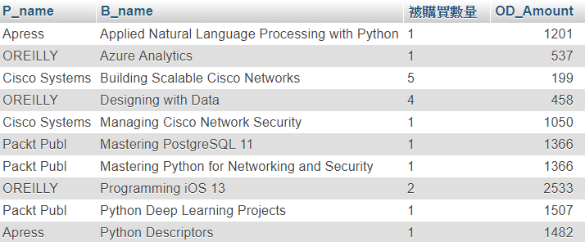

1.建立一個檢視表(VIEW)名稱為view_order_count

2.取得「P_name」「B_name」跟「被購買數量」跟「OD_Amount」資料

3.從supplier, odetail, book選取資料

4.設定條件為supplier.P_ID = book.P_ID 跟 book.B_ID = odetail.B_ID

5.將B_name設為群組

/

Code:

CREATE view view_order_count AS

SELECT P_name, B_name, SUM(OD_Count) as '被購買數量', OD_Amount

FROM supplier, odetail, book

WHERE supplier.P_ID = book.P_ID AND book.B_ID = odetail.B_ID

GROUP BY B_name

(2)將書籍” Programming iOS 12”之品名改為” Programming iOS 13”，並針對視觀表View_Order_Count查詢OREILLY出版社之所有書籍。

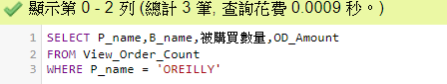

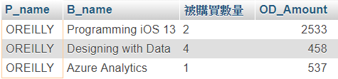

1.更新資料'Programming iOS 12'改為’Programming iOS 13'

2.取得「P_name」「B_name」跟「被購買數量」跟「OD_Amount」資料

3.從View_Order_Count選取資料

4. 設定條件為P_name = 'OREILLY'

/

Code

UPDATE book SET B_name='Programming iOS 13' WHERE B_name='Programming iOS 12';

SELECT P_name,B_name,被購買數量,OD_Amount

FROM View_Order_Count

WHERE P_name = 'OREILLY'

(3)針對視觀表View_Order_Count，查詢哪些出版社的銷售金額加總後，低於$5000，並顯示出版社名稱及總被購買次數及總金額

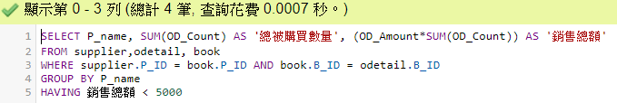

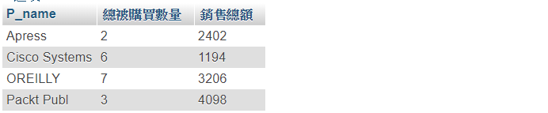

1.取得「P_name」跟「總被購買數量」跟「銷售總額」資料

2.從supplier,odetail, book選取資料

3.設定條件為supplier.P_ID = book.P_ID 跟 book.B_ID = odetail.B_ID

4.把P_name設為群組

5.將銷售總額 < 5000設為條件

/

SELECT P_name, SUM(OD_Count) AS '總被購買數量', (OD_Amount*SUM(OD_Count)) AS '銷售總額'

FROM supplier,odetail, book

WHERE supplier.P_ID = book.P_ID AND book.B_ID = odetail.B_ID

GROUP BY P_name

HAVING 銷售總額 < 5000