数据库实验一

吴文涛

091220120

wuwentao137@gmail.com

1. 创建模式

CREATE SCHEMA LAB_1;

1. 创建表格

CREATE TABLE Student (

sno INT PRIMARY KEY,

sname CHAR(8) NOT NULL,

sex CHAR(2),

deptno INT);

CREATE TABLE Course(

cno INT,

cname CHAR(20) NOT NULL,

tno INT,

credit INT,

PRIMARY KEY(cno,tno));

CREATE TABLE SC(

sno INT,

cno INT,

PRIMARY KEY(sno,cno),

grade INT);

CREATE TABLE Teacher(

tno INT PRIMARY KEY,

tname CHAR(8) NOT NULL,

deptno INT);

CREATE TABLE Dept(

deptno INT PRIMARY KEY,

dname CHAR(20) NOT NULL);

结果：

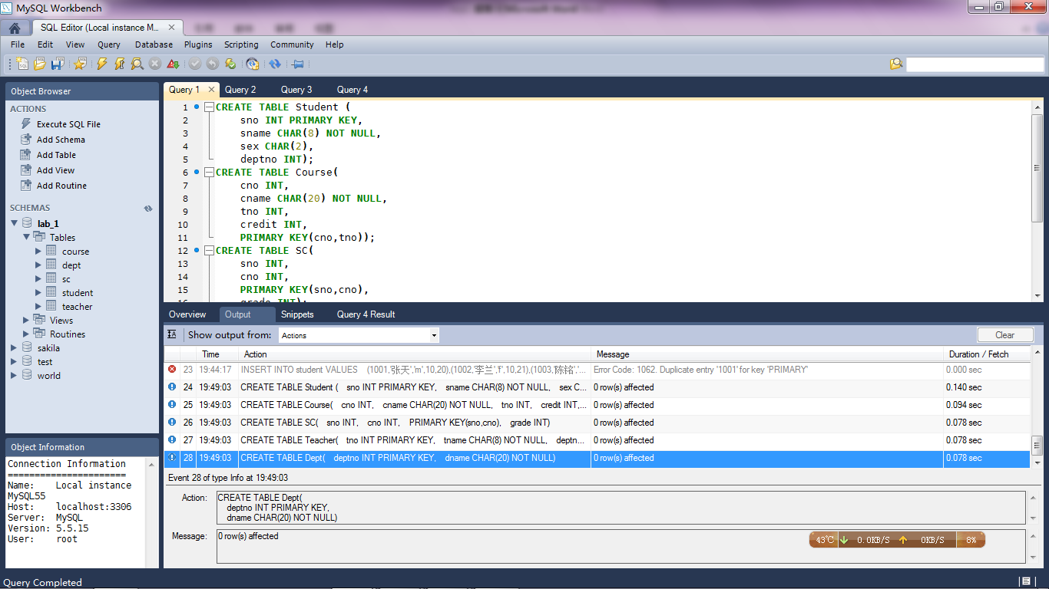

1. 在Student表中加入属性AGE（INT型）。

ALTER TABLE student ADD age INT;

1. 将Student表中的属性AGE类型改为SMALLINT型。

ALTER TABLE student MODIFY age SMALLINT;

结果：

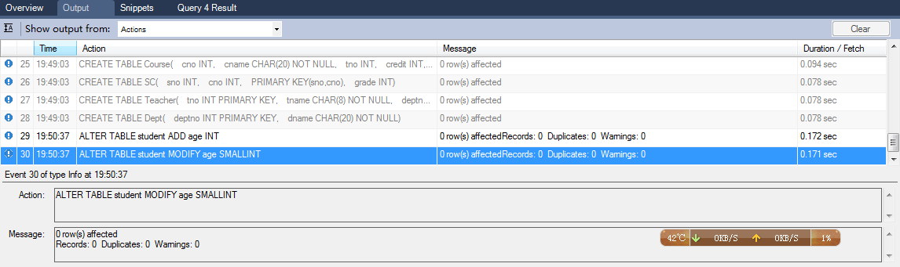

1. 插入数据

INSERT INTO student VALUES

(1001,'张天','m',10,20),(1002,'李兰','f',10,21),

(1003,'陈铭','m',10,21),(1004,'刘茜','f',20,21),

(1005,'马阳','m',20,22);

INSERT INTO course VALUES

(1,'数据结构',101,4),(2,'数据库',102,4),

(3,'离散数学',103,4),(4,'C语言程序设计',101,2);

INSERT INTO SC VALUES

(1001,1,80),(1001,2,8lab_1.courselab_1.course5),(1001,3,78),

(1002,1,78),(1002,2,82),(1002,3,86),

(1003,1,92),(1003,3,90),(1004,1,87),

(1004,4,90),(1005,1,85),(1005,4,92);

INSERT INTO teacher VALUES

(101,'张星',10),(102,'李珊',10),

(103,'赵应',10),(104,'刘田',20);

INSERT INTO dept VALUES

(10,'计算机'),(20,'信息');

1. 查询所有学生的信息。

SELECT *

FROM student;

结果

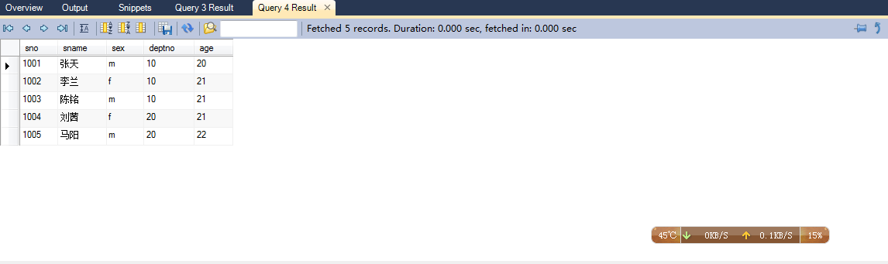

7.查询所有女生的姓名。

SELECT sname

FROM student

WHERE sex = 'f';

结果

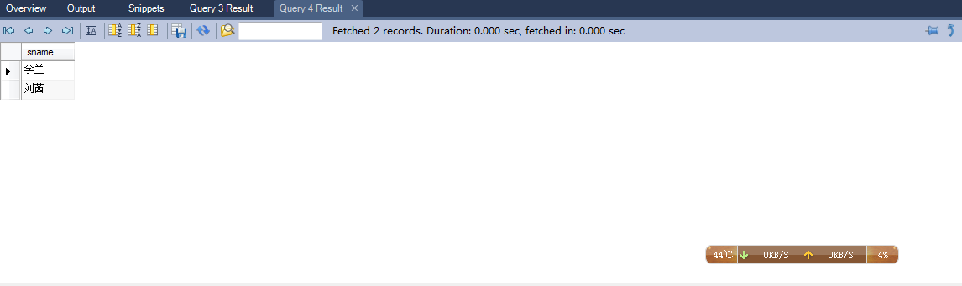

1. 查询成绩在80到89之间的所有学生的选课记录,查询结果按成绩的降序排列。

SELECT sno,cno

FROM SC

WHERE grade >= 80 and grade <= 89

ORDER BY grade DESC

结果

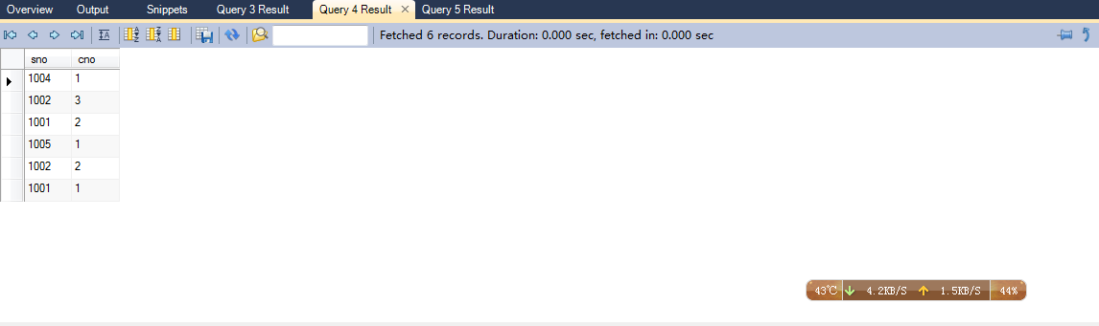

9. 查询各个系的学生人数。

SELECT COUNT(student.deptno),dept.dname

FROM student,dept

WHERE student.deptno = dept.deptno

GROUP BY student.deptno;

结果

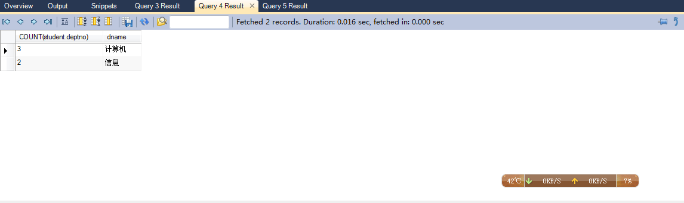

1. 查询信息系年龄在21岁以下(含21岁)的女生姓名及其年龄。

SELECT student.sname

FROM student,dept

WHERE student.deptno = dept.deptno and dept.dname = '信息'

and student.age >= 20;

结果

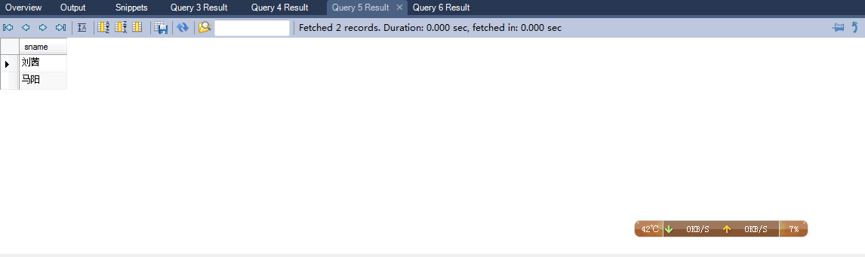

11. 查询修课总学分在10分以下的学生姓名。

SELECT student.sname

FROM student

WHERE student.sno IN

(SELECT sc.sno

FROM sc,course

WHERE sc.cno = course.cno

GROUP BY sc.sno

HAVING SUM(course.credit) <= 10);

结果

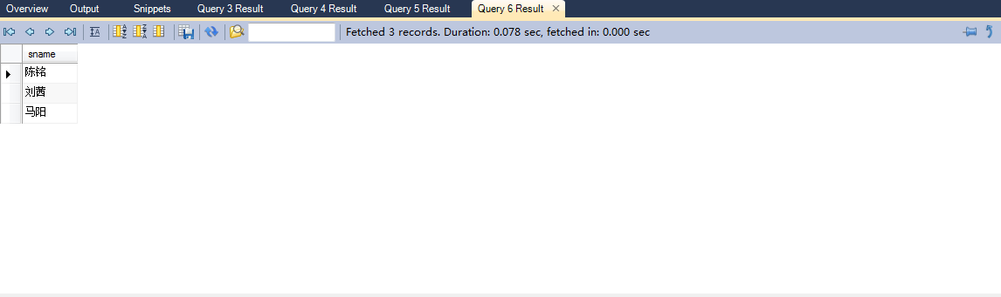

1. 查询各门课程取得最高成绩的学生姓名及其成绩。

SELECT student.sname, sc.grade

FROM student, sc

WHERE student.sno = sc.sno and

sc.grade IN(

SELECT MAX(sc2.grade)

FROM sc sc2

WHERE sc.cno = sc2.cno

GROUP BY sc2.cno);

结果

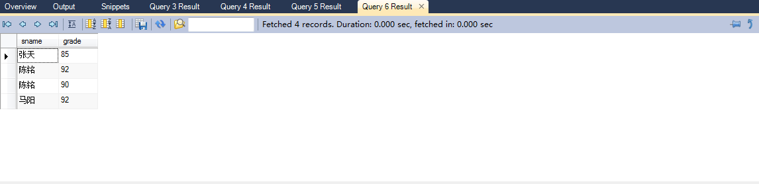

1. 查询选修了1001学生选课的全部课程的学生学号。

SELECT sno

FROM sc

WHERE NOT EXISTS

( SELECT sc2.cno

FROM sc sc2

where sc2.sno = 1001 and NOT EXISTS

(SELECT sc1.cno

FROM sc sc1

WHERE sc1.sno = sc.sno and

sc1.cno = sc2.cno))

GROUP BY sno;

结果

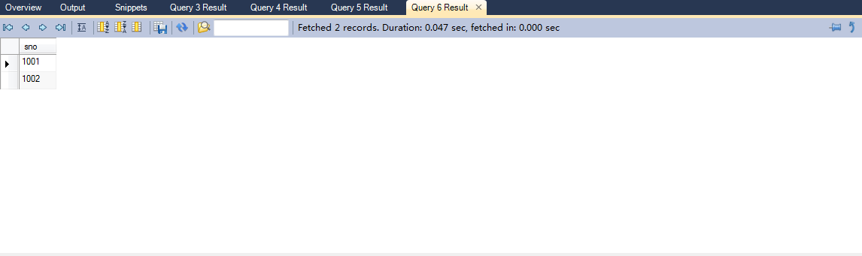

1. 查询选修了张星老师开设的全部课程的学生姓名。

SELECT student.sname

FROM student

WHERE student.sno IN

(SELECT sc.sno

FROM sc

WHERE NOT EXISTS

(SELECT sc2.cno

FROM sc sc2,teacher

WHERE sc2.cno = teacher.tno and teacher.tname = '张亮' and NOT EXISTS

(SELECT sc1.cno

FROM sc sc1

WHERE sc1.sno = sc.sno and

sc1.cno = sc2.cno))

GROUP BY sno);

结果

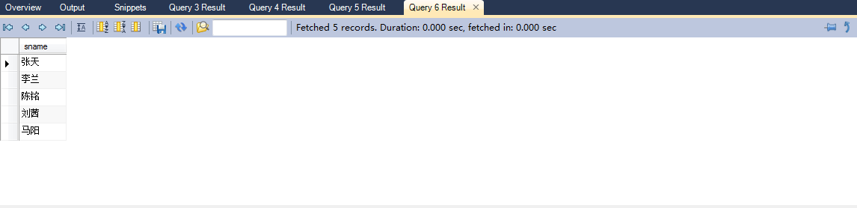

15. 将张星老师数据结构课的学生成绩全部加2分。

UPDATE sc

SET sc.grade = sc.grade + 2

WHERE sc.cno IN (SELECT course.cno

FROM course

WHERE course.cname = '数据结构');

结果

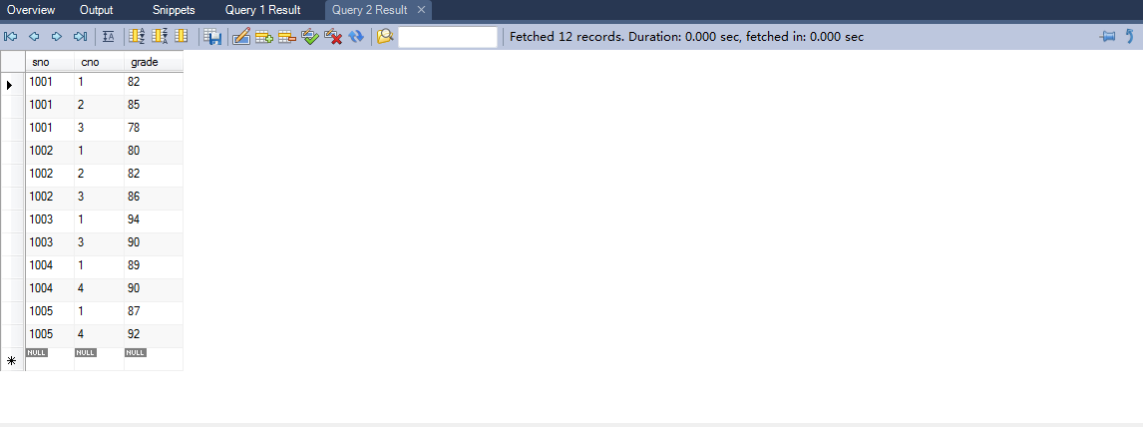

1. 删除马阳同学的所有选课记录。

DELETE

FROM sc

WHERE '马阳' =

(SELECT sname

FROM student

WHERE student.sno = sc.sno);

结果

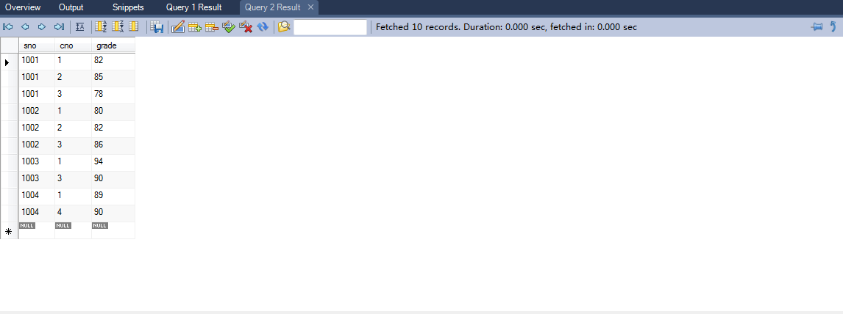

1. 建立视图

在插入数据的Student基本表上为计算机科学与技术系的学生记录建立一个视图CS_STUDENT。

CREATE VIEW CS_STUDENT (sno,sname,sex,deptno,age)

AS SELECT sno,sname,sex,deptno,age

FROM student

WHERE student.deptno IN (SELECT dept.deptno

FROM dept

WHERE dept.dname = '计算机');

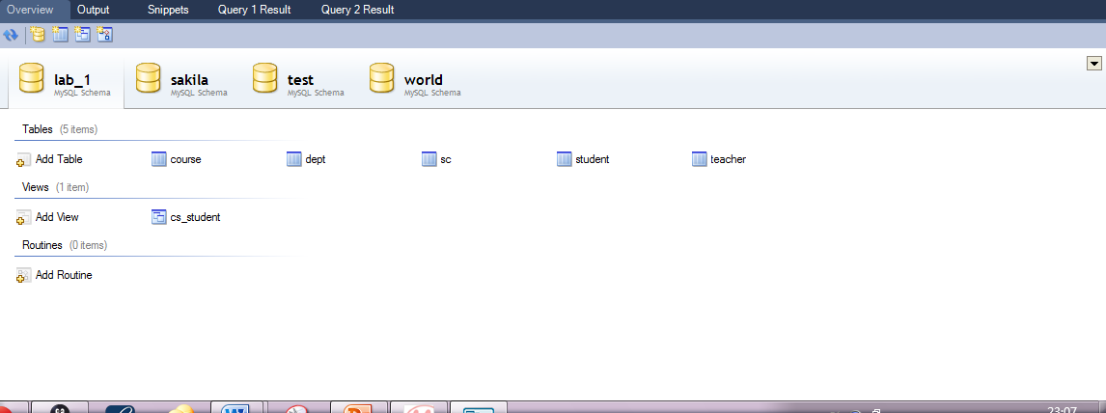

18. 删除视图

在操作结束后删除视图CS_STUDENT。

DROP VIEW CS_STUDENT

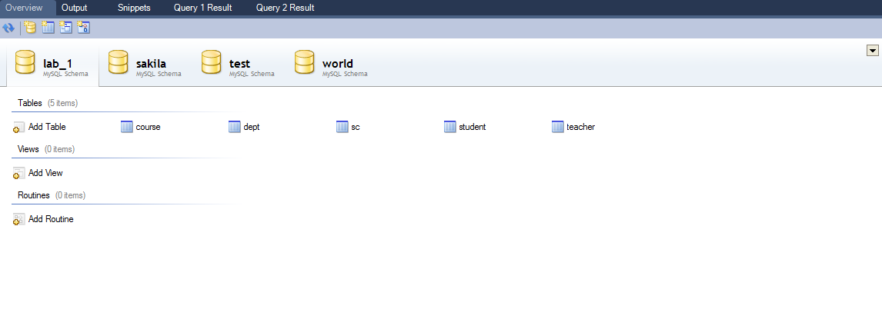

19.删除表格

DROP TABLE course;

DROP TABLE dept;

DROP TABLE sc;

DROP TABLE student;

DROP TABLE teacher;

结果：

