Team 6

Part2 Write-up

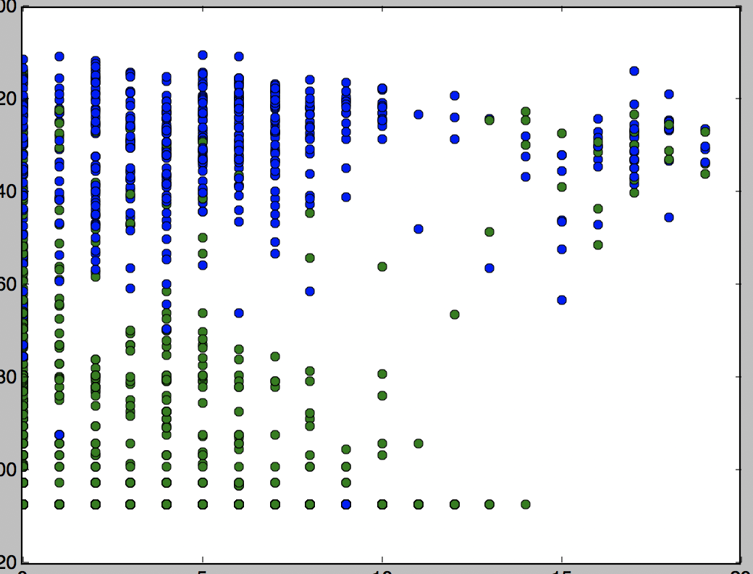

Zero CrossingX vs. entropy

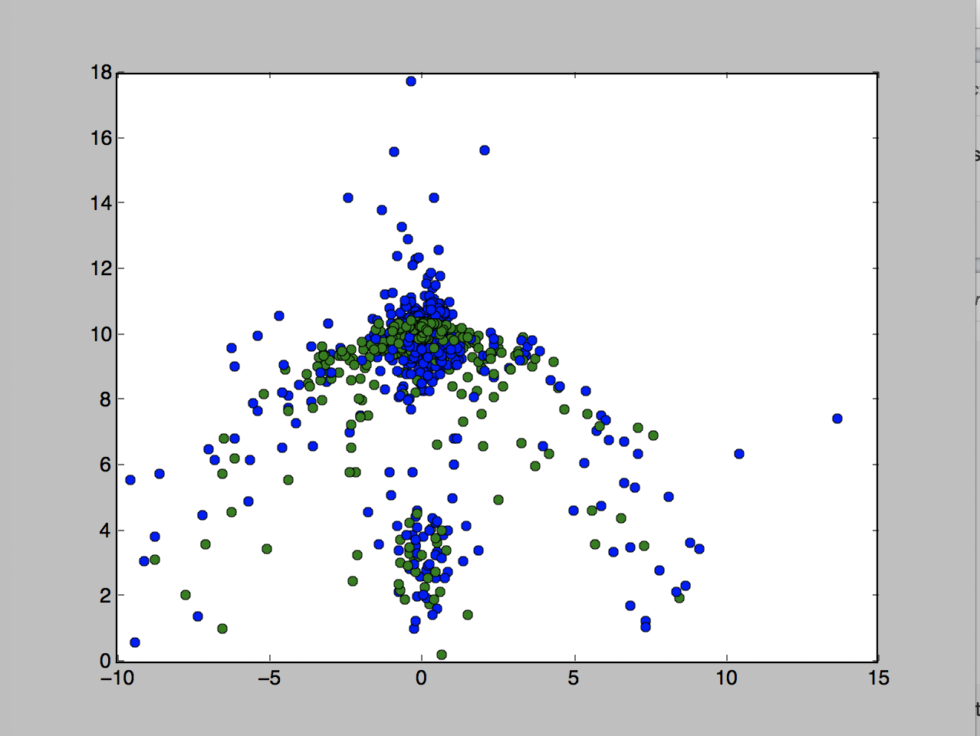

meanY vs. meanZ

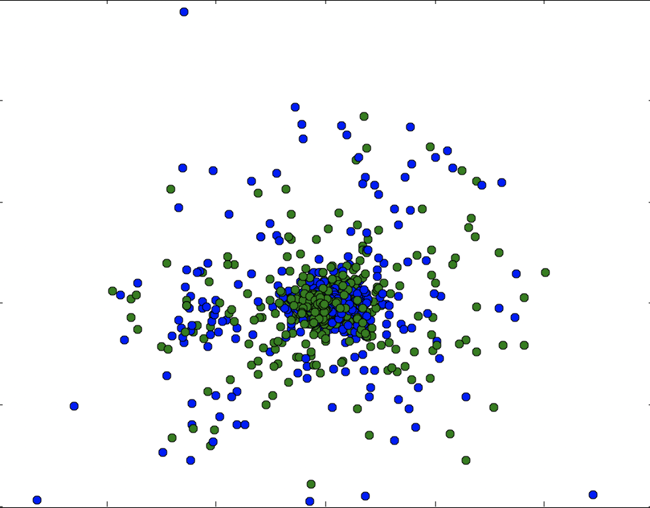

median X vs. median Y

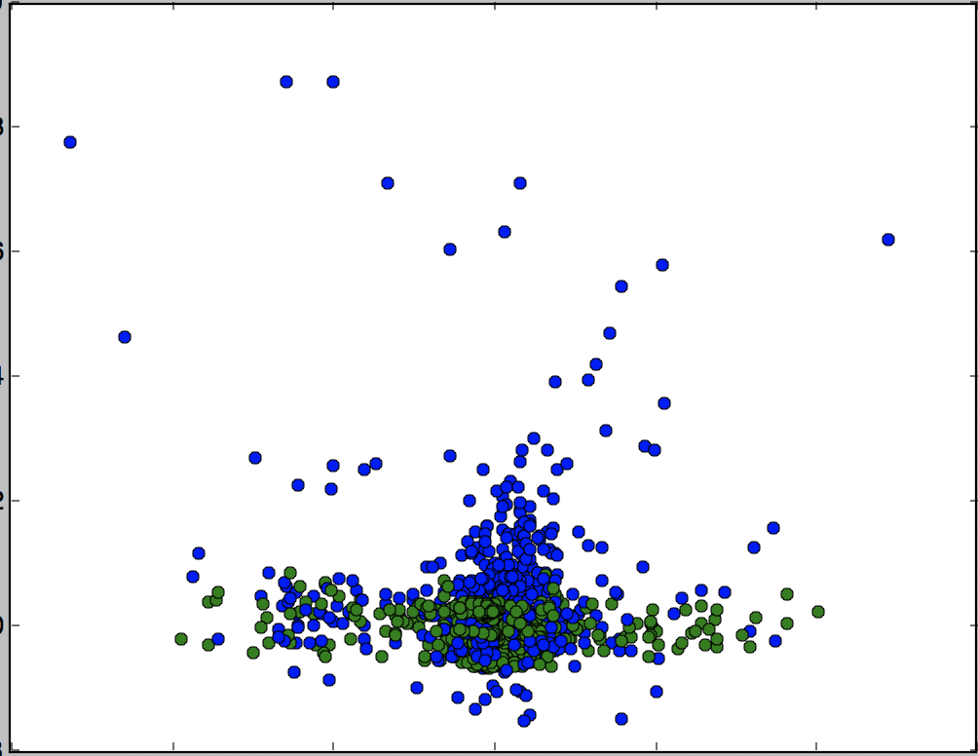

medianX vs. mean-magnitude

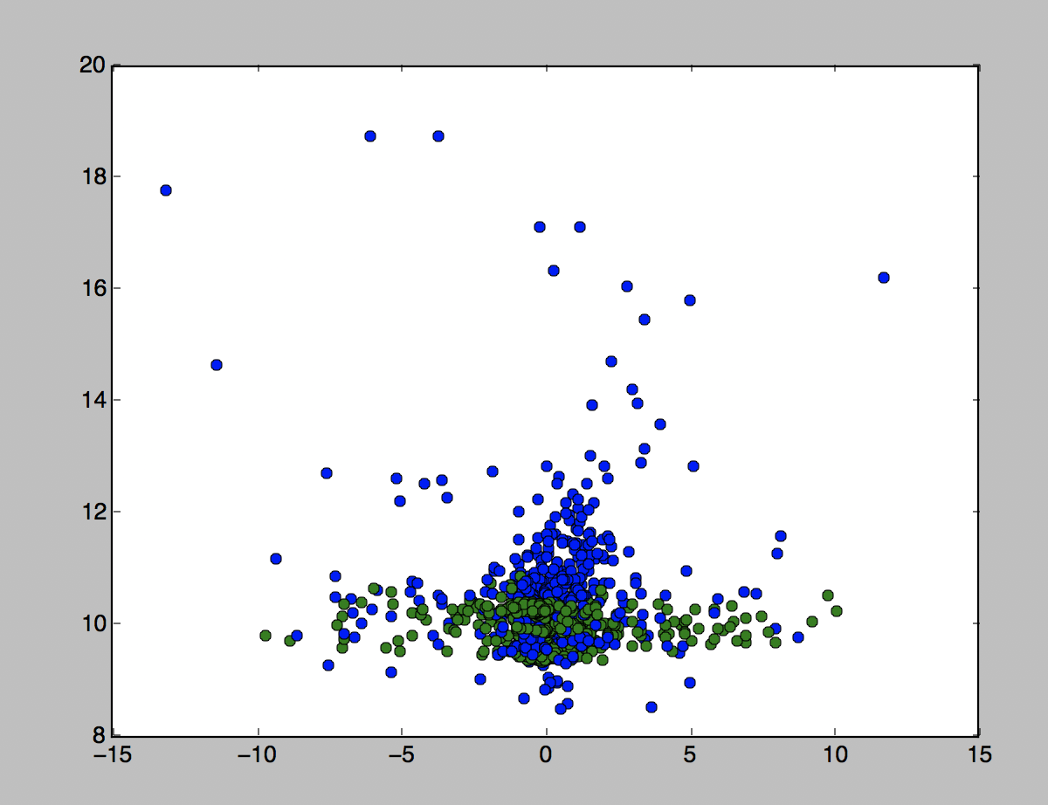

meanX vs. mean-magnitude

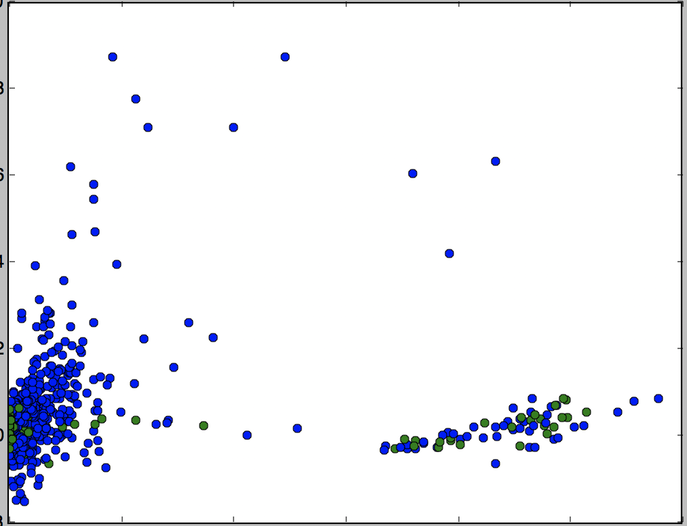

variancX vs. mean-magnitude

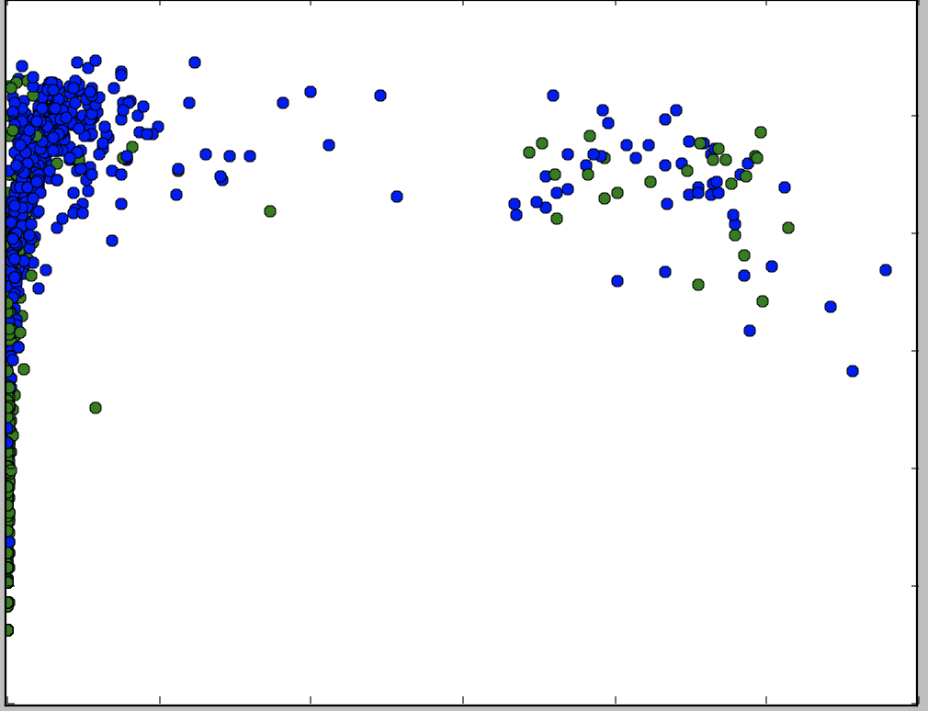

variance vs. entropy

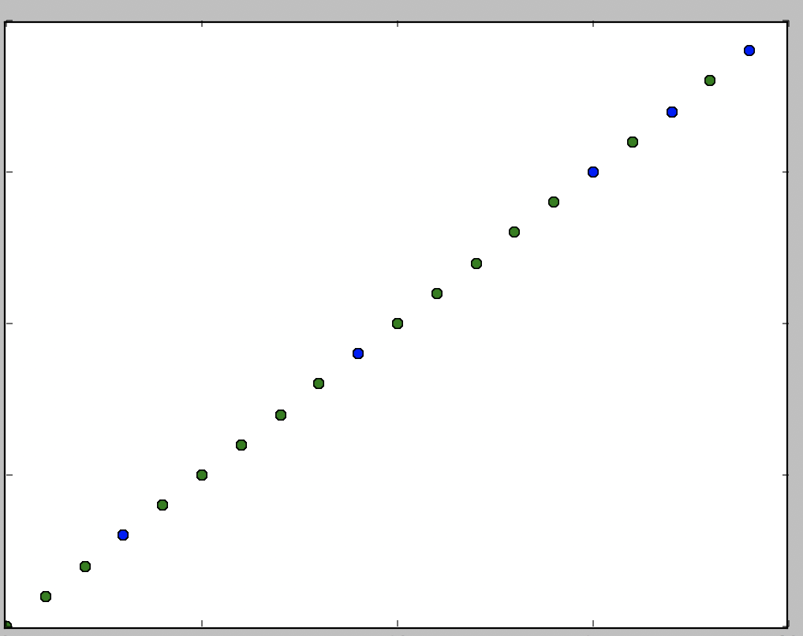

zero Crossing X vs. peakx

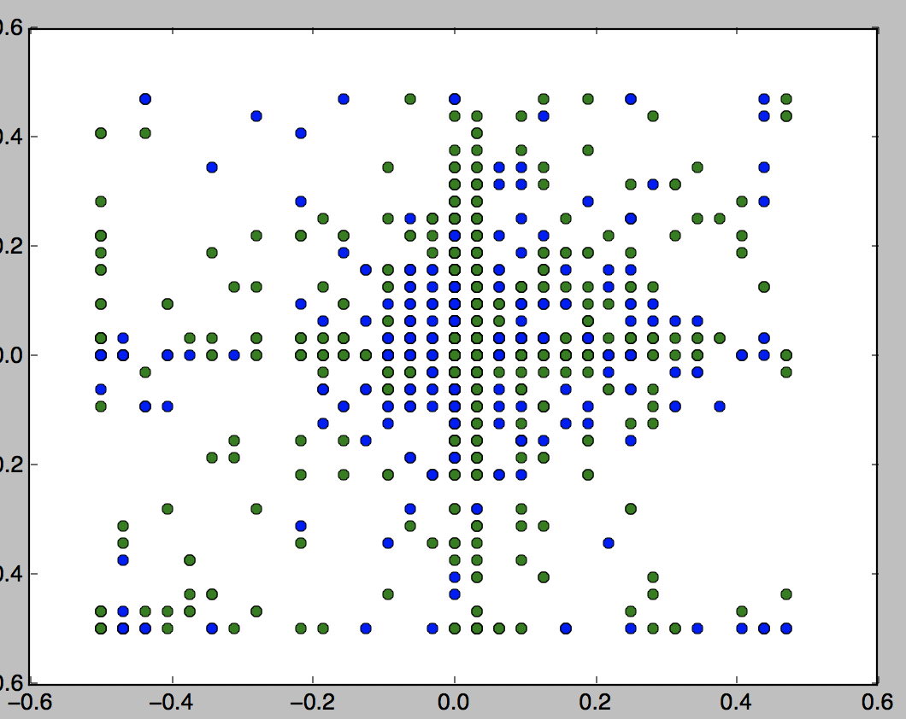

FFTX vs. FFTY

Base on the visualization, the variance vs. entropy work best, since I can differentiate most of the point on plot by putting a line at the middle between 0.0 and 0.2. The one that works poorly is FFTX vs FFTY, because all the point on the plot just scatting around the graph, no way to separate those point by using one line.