Susan the Animal Trauma Rehabilitationist

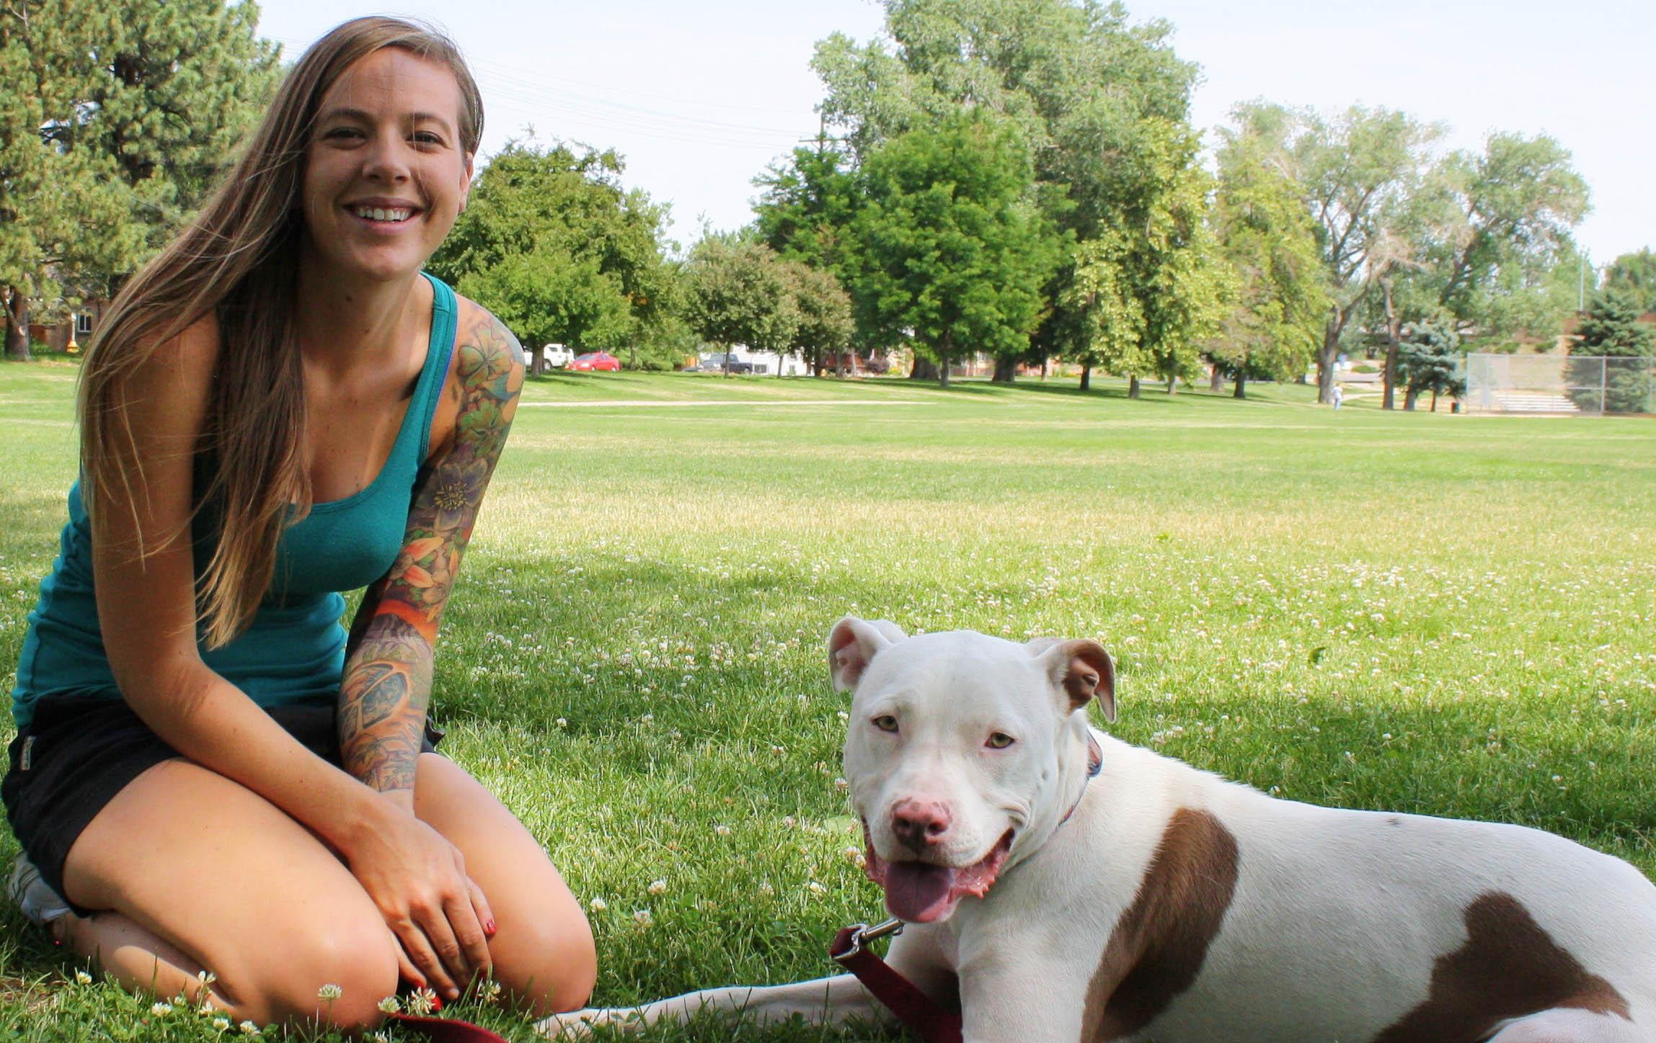

For more than 8 years, Susan has professionally worked with dogs and cats. Her love for animals motivates her every day to build harmonious relationships between animals and humans. For this reason she limits working with multiple dogs at the same time and instead specializes on working with fearful and aggressive dogs one at a time. Throughout the week she will repeat her work with the same animal multiple times. On a typical work day she will not work more than 7 hours, which includes her commutes to pick-up and drop-off the animals she works with.

Although she knows all there is to working with animals, she finds it difficult communicating with their owners. Her main troubles revolve around keeping up with client communications via email (new and old), keeping clients compliant to her training instructions, and calendarizing services.

Previously, she was an enthusiastic Mac owner that used iCal and any related Apple applications to run her operations, but after having technical issues with her machine and not having affordable technical support she decided to use more affordable tools. Currently she uses Gmail and Google Calendar, but she would like a tool that is more intuitive, centralized, and not platform exclusive so that it is easier for herself and her clients to communicate and book services. She has worked independently for many years, but she is interested in starting a co-op with several of her peers and housemates, so having a tool that would unify their communications, calendars, and payments is even more of an interest for her now.