

**Project Proposal:** Blood donation website

**Student Name Id Tasks**

|  |  |  |
| --- | --- | --- |
| **بيلسان السلمي** | 2110091 | 2 Interviews - Problem definition - Findings - Scope objective - Context diagram –  F and nf requirements - Use case analysis - Class diagram – Sequence diagram |
| **شدن المزعل** | 2114431 | 2 Interviews – Motivation – recommendations - project writing - stakeholders - f and nf requirements - Use case analysis- Class diagram - Sequence diagram |
| **جود علاقي** | 2112084 | 2 Interviews - Content - Goal - Feasibility - Context diagram - Use case- Class diagram - Sequence diagram |
| شهد المنتشري | 2111221 | 2 Interviews - Consideration - Goals - Project writing -Current situation - Use case- Class diagram - Sequence diagram |
| **رواف النجار** | 2110902 | 2 Interviews - Cost schedule -Project writing - Event list - Use case analysis- Class diagram - Sequence diagram |

*Group leader:*

*بيلسان السلمي*

*Editor:*

*جود علاقي*

*Revisor:*

*شدن المزعل*

Table of Contents

Problem Description: 5

Interview 6

Analysis summary: 14

Content 15

Motivation 15

Considerations 15

b. Goals of the Project: 15

Preliminary report 15

The problem: 15

Findings: 15

Recommendation or proposed solution: 15

Cost & schedule estimates: 16

Project Estimated Costs: 16

Project Estimated Schedule: 16

The feasibility study 17

Report writing 17

1- Problem Definition: 17

2- Scope Objectives of “new system”: 17

3- Alternative Solutions: 18

4- Cost and benefits of Alternatives: 18

5- Software impacts 18

6- Potential Changes in the Organization: 18

7- Recommended Alternative of the course of Action: 18

Project plan 19

Stockholder definition 22

The Current Situation 22

Content: 22

Motivation: 22

The Context of the Work 22

b. Business event list 23

Non-Functional Requirements: 24

Functional and non-functional requirements: 24

Functional Requirements: 24

Use case diagram: 25

Sequence diagram: 36

Class Diagram: 39

# Problem Description:

Millions of people are encouraged to donate blood each year. Blood donation is a noble humanitarian act, as it saves the lives of thousands of patients in need. 1 in 10 hospitalized patients requires blood transfusions, especially those with malignant or acute illnesses and those who have suffered significant blood loss due to a major accident. Most cases of patients who need blood are time sensitive. Our vision is to create a system that will connect the donor to the recipient in the fastest way possible. By organizing them according to compatibility and proximity. Thus, assuring that every patient is receiving the help they need without avoidable delays.

|  |  |  |
| --- | --- | --- |
| Interview**er** | **Interviewee** | **The Interview** |
| *Shadan Almuzil* | *Wajd Alhazmi,*  *Medical student*  *7/9/2022* | -Have you donated blood before? She has never donated blood before.  ***- Do you think the donor’s age should be 18-65 years old?***  Yes, the donor's age should be from 18-65.  **-**What do you think the hemoglobin percentage should be?  The percentage of hemoglobin in the blood for men should be from 15-16 G, and for women from 13-14 G. -Does donating blood help reduce iron in the blood? Donating blood may help reduce the percentage of iron in the blood. -Are those who donate blood once a year less likely to get leukemia and circulatory diseases? Donating blood once a year may help reduce the incidence of leukemia and circulatory diseases. |
| *Farah Almufda, student*  *8/9/2022* | -Have you donated blood before? She has donated blood before.  ***-Do you think the donor’s age should be 18-65 years old?*** She believes that the donor's age should range from 18 to 65. -What do you think the hemoglobin percentage should be? She does not know what the percentage of hemoglobin in the blood should be. -Does donating blood help reduce iron in the blood? She believes that donating blood may help reduce the percentage of iron in the blood. -Are those who donate blood once a year less likely to get leukemia and circulatory diseases? She does not know if donating blood once a year may help reduce the incidence of leukemia and circulatory diseases |
| *Bylsan Alsulami* | *Remas Mohmed, Doctor*  *9/9/2022* | -What’s your specialty? General doctor. -where do you work? King Abdullah hospital. - In your opinion, what’s the significance of donating blood? Blood donation is very important, it could save lives, and, in our hospitals, we always lack blood, I think people don’t realize how important it is. - Have you seen specialized websites for blood donations in Saudi Arabia? No, but I have seen a foreign website. - What do you think about the feature of putting patients according to their location? This feature is very important because some donors are willing to come and donate until they discover that the patient is in another region. - What type of patient information is needed on the website? We need to know the patient's age, weight, and blood type.  ***-*** ***What do you think about the feature of sending a message to the blood donor including instructions on what to do before and after donation?***  It would be a great feature to save time. |
| *Afaff basfar,*  *Nurse*  *10/9/2022* | -What’s your specialty? Nurse -where do you work? *King Abdullah hospital* - In your opinion, what is the significance of donating blood? Blood is essential to help patients survive surgeries, cancer treatment, chronic illnesses, and traumatic injuries. - Have you seen specialized websites for blood donations in Saudi Arabia? No, but I think we need one. - What do you think about the feature of putting patients according to their location? This feature would be very helpful to save time. - What type of patient information is needed on the website? We need to know the patient's age, weight, and blood type. - What do you think about the feature of sending a message to the blood donor including instructions on what to do before and after donation? That would be a great feature because some donors would come not being aware of the instructors |
| *Shahad Almontasheri* | *Amal Ahmed,*  *Nurse*  *8\9\2022* | -How is the safety of the transfused blood ensured for the patient? Identify the patient properly.  Two Nurses check the patient’s identification at the bedside.  At least 2 licensed nurses check the label of the blood transfusion. Check the following:  * Serial number  * Blood component  * Blood type  * Rh factor  * Expiration date  * Screening test  Monitor vital signs.  Observe for potential complications. -What are the tests performed on the donor? -compatibility tests between the transfused blood units and the patient’s blood, to ensure the safety and effectiveness of the blood.  - Conducting accurate tests and analyses of each blood unit to identify the group and ensure that it’s free of communicable diseases such as Hepatitis B and C. -If there is a blood donation process website, how do you expect it to help you as nurses? Get the required blood types faster and more orderly. -What methods do you use to find donors easily? Social Media- Advertisements. -How long does it take for a donor to donate again? The shortest allowed period is eight weeks between two donations and donation frequency may not exceed five times per year. |
| *Shahad Almontasheri* | *Anwar Mohammed, Medical laboratory specialist*  *10\9\2022* | -How is the safety of the transfused blood ensured for the patient? Safe transfusion requires a final patient identity  Check, at the patient's bedside before blood administration. This is vital to ensure the right blood is given to the right patient. Two clinicians must independently complete the patient and blood product identification by checking the bedside. -What are the tests performed on the donor? Hepatitis B surface antigen (HBsAg) Hepatitis C virus antibody (anti-HCV)/ antigen HIV-1 and HIV-2 antibody (anti-HIV-1 and anti-. HIV-2) antigen (HIV-1 and HIV-2 Ag) Serologic test for syphilis (HCV Ag) Nucleic acid amplification testing (NAT) for HIV-1, HCV, and HBV if available. -If there is a blood donation process website, how do you expect it to help you as nurses Organizing the blood donation process and facilitating obtaining the required blood type. -What methods do you use to find donors easily? Government platforms - advertisements - social media  ***-How long does it take for a donor to donate again?***  The plasma from your donation is replaced within about 24 hours. Red cells need about four to six weeks for complete replacement. That's why at least eight weeks are required between whole blood. |

|  |  |  |
| --- | --- | --- |
| *Joud Alaki* | *Dr. Salwa Hindawi,*  *Blood Bank Lab manager, King Abdulaziz Hospital*  *11/9/2022* | -What problems do you face with the management of blood transfusions? 1- Lack of resources, like trained staff and Budget.  2- Unavailability of regular volunteer blood donors.  3-Sometimes, shortage of blood groups during vacation time and Eid holidays.  -In emergencies when there is a special case of a specific blood type, how do you manage it?  Inventory management is the answer, as we should have a certain number of each blood group all the time. And in case of a shortage, we have a list of volunteer donors whom we can contact to help us. -What information do you log in when handling blood transfusion requests? **From the clinical side:**  Patient information: name, age, hospital record number, diagnosis, the reason for transfusion, type, and the number of blood components needed.  Laboratory investigations: Hb level, platelets, PT & PTT.  The physician’s name and signature.  The Department’s name.  **From the blood bank side:**  Blood group & antibody screening results of patients and donors.  Compatibility testing: cross-matching.  Type of component, volume & numbers.  The name & signature of the staff who did the work -When there's a blood shortage and blood banks can't provide that much blood, how do you handle that? We may contact other hospitals and call a list of donors to come donate. We also release reserved blood from elective surgical cases to deal with emergencies.  -How do you prioritize who gets the blood transfusion, is there a list and is it easily accessed?  In the case of elective surgical operation, we have a list called Maximum Surgical ordering schedule (MSOS). This includes all surgical operations done in the hospital, which operations we must prepare blood for, and which we don’t. This list we have is easily accessed by the staff working in the blood bank.  We also have a clear policy and guidelines which guides who should get a blood transfusion in every case. |
| *Dr. Eman Kasim,*  *Blook bank lab manager,*  *Dr. Erfan and Bagedo General Hospital*  *9/9/2022* | -How do you avoid blood shortages? 1-Motivating people to donate blood, through social media and accessible and comfortable blood donation centers.  2-Implementing effective strategies to convert voluntary non-remunerated donors into regular donors.  3-Organizing a mobile blood drive.  4-Improving the capacity of blood banks to produce maximum blood products.  5-Developing an evidence-based emergency blood management plan. -What are the causes of blood transfusion complications? Complications of blood transfusion are rare but can be life-threatening. Since 2005, it has been a legal requirement that all serious adverse reactions regarding the safety or quality of blood are reported. Most reported complications are caused by transfusion of mismatched blood products and are avoidable through clinical vigilance.  Massive blood transfusion. - How do you prioritize who gets the blood transfusion, is there a list and is it easily accessed? The priority for blood transfusion is determined based on the patient’s clinical diagnosis and current situation. In emergency cases, the blood transfusion will be decided by the charge physician according to the clinical guideline and the hospital policy. Every hospital has a blood transfusion policy and procedures. - How do you handle blood shortages? A stock of negative O blood group (universal donor), must be kept and monitored for emergencies.  Prioritizing critical cases.  Internal hospital calls/ text messages to hospital workers and visitors inviting them to donate.  Every Blood bank has a list of regular donors, they are called for donation by the blood bank coordinator according to the needed blood group. If the need for blood continues more, arrangements for transferring the patients to  governmental or other care facilities. -What information do you log in when handling blood transfusion requests? Filling a blood transfusion request form with the following information:  Patient details e.g., Surname, first name, gender, and patient identification number.  Reason for transfusion  “High Risk” sticker if appropriate.  Transfusion history  Location  Name and surname of the person authorizing the request. |

|  |  |  |
| --- | --- | --- |
| *Rawaf Bader* | *Asmaa Marwan Osta*  *Medical laboratory student*  *9/9/2022* | - What quick action do hospitals take when they don't have the blood type they need***?*** I have no idea about the hospital procedures in this case.  - Is it often difficult to find donors?Sometimes it is difficult to find a patient's blood type and it is not available, and the patient needs a lot of blood in his case, and we resort to social networking sites to solve this problem.  ***-*** What is the benefit of having an application or website where blood donors are registered?The benefit is high, for the donor and the patient, because the application can help the patient in giving him instructions and some motivation, and if there is a need for a particular blood type, donors will be alerted through the application as soon as possible.  ***-*** What is the important information that should be known about the patient before blood is drawn or donated?We need personal information, his name and age, identification number, and when the last time he donated his blood and some other medical information.  ***-*** What type of blood is it difficult to find a lot of donors? it is difficult to find rare blood types (-A, AB) |
| *Dr:Mohammed F alahmadi*  *Medical*  *laboratory specialist*  *9/9/2022* | - What quick action do hospitals take when they don't have the blood type they need?I have never had this kind of case in the hospital before, but I asked this question before to one of the doctors, and he answered me that I can give him a blood type that is close to the patient’s blood type.  - Is it often difficult to find donors?No, there is no difficulty in finding donors. If a critical situation occurs, we can announce it on social media, and donors can be obtained.  ***-*** What is the benefit of having an application or website where blood donors are registered?The benefit is very great because people can be reminded to donate by registering them in it, and it can motivate donors through motivational messages in the application.  - What is the important information that should be known about the patient before blood is drawn or donated? We need his name and ID number, some medical questions (have you taken some medications, have you been outside the Kingdom in the last 12 months?), pressure, weight, and hemoglobin percentage are also taken. - What type of blood is it difficult to find a lot of donors? The rare blood type (A-, AB-) |

|  |  |  |
| --- | --- | --- |
| **Interviewer** | **Interviewee** | **Analyst Comment** |
| *Bylsan Alsulami* | *Remas Mohamed, Doctor*  *9\9\2022*  *Affaf basfar, Nurse*  *10/9/2022* | There is not enough awareness of the importance of donating blood and its benefits for society. In addition to that, there is a lack of blood in hospitals*,* there are obstacles facing the hospitals when the donors came to donate. So, we will provide a list of questions before registering, some people do not know instructions after donating blood, so we will provide a service that includes sending a message to the donor. |
| *Shadan Almuzil* | *Wajd Alhazmi,* *Medical student*  *7/9/2022*  *Farah Almufda, student*  *8/9/2022* | From the questionnaire I did, I found out that the percentage of blood donors varies, there is a large number of people who have donated blood, but it is dominated by people who have not donated before. I also discovered that few people know about the importance of blood donation, and most believe that it is a voluntary medical procedure, and some people do not have complete knowledge about the conditions of blood donation, so we will provide a service to help donors whether the conditions apply to them or not. |
| *Shahad Almontasheri* | Amal Ahmed, nurse  8\9\2022  Anwar Mohammed, Medical laboratory specialist  10\9\2022 | Some hospitals have trouble finding donors, and some donors struggle to find enough information to donate. Therefore, we will endeavor to reduce the communication gap between donors and blood banks so that the blood donation process becomes easier. |
| *Joud Alaki* | *Dr. Salwa Hindawi,*  *Blood Bank Lab manager*  *11/9/2022*  *Dr. Eman Kasim,*  *Blook bank lab manager*  *9/9/2022* | It is vital to have a foolproof policy and guidelines when it comes to blood bank management. One of the most important parts of managing blook banks is the avoidance of blood shortages.  When filling out a blood transfusion request form, all information should be provided for the maximum and fastest result.  In case of blood shortages, hospital staff and regular donors are asked to donate. Fellow hospitals are also contacted to help. |
| Rawaf Bader | *Asmaa Marwan Osta*  *Medical laboratory student*  Dr:Mohammed F alahmadi  Medical laboratory specialist  *9/9/2022* | Social media is often used when the patient's required blood type is not found. The application can facilitate the specialist, patient or donor to easily access his personal information so that his information is preserved and safe. The application can also help in obtaining people who carry rare types faster. |

# Analysis summary:

There is not enough awareness of the importance of donating blood and its benefits for society, the percentage of blood donors varies, there is many people who have donated blood, but it is dominated by people who have not donated before, so hospitals face many obstacles such as blood shortage and the misconceptions of what to do before and after donating blood.

So, our blood donation website will solve the problem, The user will be able to register as donator or patient. If they are a donor, then before creating the account they will answer a list of questions related to their ability to donate. If they do not fit the criteria, they will receive a message that they will not be able to donate, when a donor is required, all donors in the same area will be contacted to inform them.

# Content

What triggered this project was the ability to create a better and more progressive way of handling blood bank management systems. And that's by creating a unified regional database system for blood bank processes and data. Thus, speeding up blood transfusion/donation processes and helping patients without delays. In emergencies and blood shortages, our system will scan through the database, to find a nearby hospital or healthcare facility that has the needed blood and notify them of the blood request. The system will also send notifications to hospital staff and consistent donors to donate.

# Motivation

The low blood retention rate and the shortage of long-term blood donors are global problems, as this problem has been described as an urgent problem that needs to be solved. The purpose of the study is to realize a large application that brings voluntary blood donors and those who need blood to a common platform. It aims to encourage people to donate blood. This project is aimed at serving people who are looking for donors who are ready to donate blood and also provide it in the required time frame. The blood donation application tries to help the patients who want blood. It is an effort to connect people who need blood with those who want to donate blood. The application explores finding blood donors using the blood group and the address they filled out during registration.

# Considerations

Delaying donating blood hampers, the medical staff in hospitals and causes health problems for patients, because some patients urgently need to donate blood.

## b. Goals of the Project:

Organizing blood donation operations and raising awareness of the importance of donating

# Preliminary report

## The problem:

Blood transfusion saves lives and improves health, but many patients in need of transfusion lack timely access to safe blood. Blood supply should be an integral part of every country's national health care policy and infrastructure.

The problem is that there is no website that gathers all the donors and the patients who need blood donations, and it is hard to reach them, even though a good system can help donors save patients' lives.

Our system will help to gather all the donors in one place. And put them according to their location which will make it easier for the patients to find them

## Findings:

The current system has many problems such as wasting the donor and the patient time, hospitals cannot show their need for blood to donors in the same region, and the use of paperwork may cause the documents to be prone to damage or loss.

## Recommendation or proposed solution:

Our vision is to develop a system that brings donors together so they can be easily reached. So, the website has many functions that refer to the importance of donating blood and its benefits for society and help patients and hospitals that have a deficiency of blood, also the website makes all of donors and patients share their information periodically.

## Cost & schedule estimates:

### Project Estimated Costs:

|  |  |
| --- | --- |
| Resources | Estimated cost |
| Specification | 100 SR |
| Design | 350 RS |
| Snacks and water | 1200 RS |
| Development | 200 RS |
| Testing | 100 RS |
| Desks | 15,000 RS |
| Computers | 150,000 RS |
| Chairs | 80,000 RS |
| Salary of employees | 50,000 RS |
| Device Battery | 1500 RS |
| Electricity | 60,000 RS |

Total: 358,450

### Project Estimated Schedule:

|  |  |  |  |
| --- | --- | --- | --- |
| Tasks | Estimated duration | Start date | End date |
| Planning | 6 days | 1/10/2022 | 6/10/2022 |
| Gathering requirements | 5 days | 7/10/2022 | 12/10/2022 |
| Analysis | 10 days | 13/10/2022 | 23/10/2022 |
| Determining features | 10 days | 24/10/2022 | 3/11/2022 |
| Design | 5 days | 4/11/2022 | 9/11/2022 |
| implementing | 15 days | 10/11/2022 | 25/11/2022 |
| Testing | 3 days | 26/11/2022 | 29/11/2022 |
|  |  |  |  |
|  |  |  |  |
|  |  |  |  |

# The feasibility study

The solution we are trying to reach by creating a regionally unified blood bank database is to better handle emergencies. By matching the donor’s blood to the recipient directly and in blood shortages, automatically sending a message to regular donors and hospital staff encouraging them to donate.

The system would help many people to get blood transfusions quickly and help manage the database so that everything is in one place. In emergencies, delayed blood transfusions can be life-threatening. With the system, we hope to connect blood to the recipient in the fastest way possible. The hospital staff would be able to put in a blood request to other health facilities and once a response is given, the system will notify them. That helps the staff focus on other work rather than constantly following up for a response.

By creating such software, a lot of work, manpower, and money come to play.

The system has to comply with the law and regulations of the country regarding electronic health records (EHR). The safety and privacy of the data also have to be insured, since we are dealing with sensitive information. This means software maintenance and constant security improvement to combat new malware.

Also, the trouble of appealing to blood banks and hospitals to join this database for more regional data coverage. All of this, hiring a legal team, software developers, cyber security specialists, and trips to blood banks in hospitals to follow up, costs a lot of time money, and effort.

The best option is to go all out, but with budget constraints. Starting gradually would be suggested. Starting with managing one blood blank and then expanding accordingly.

# Report writing

## 1- Problem Definition:

Each year, millions of people are asked to donate blood, while many patients die waiting to donate blood and waiting for someone to donate blood. Many of them cannot find anyone to donate blood. In fact, 1 in 10 of his hospitalized patients needs a blood transfusion, especially those with cancer or other serious and incurable diseases, those who have had a serious accident and have lost a lot of blood, and many patients receive blood transfusions. An important procedure of blood transfusion, many serious diseases are treated with blood components. Also, transfusion of blood from a healthy person to a poor patient is a voluntary medical act known as blood donation. Blood transfusions are usually done in hospitals, outpatient clinics, or clinics. This procedure usually takes between 1 and 4 hours, depending on the part of the body receiving the blood and the amount of blood required. The blood also undergoes many tests to make sure there are no diseases or infections that could affect the patient.

## 

## 2- Scope Objectives of “new system”:

The goal of the blood donor system website is that allows donors, patients, and hospitals to gather in one place. The donor can save patients' lives through the website. when the donor registers the system will provide a list of questions after register web application checks the answered questions to make sure if the donor is qualified. The hospitals and patients can register on the website to use some features that are specific to them. The website will save time for hospitals and patients rather than call a blood bank to ask them if they have enough bloodstock. Also, they can post an announcement on the website.

## 3- Alternative Solutions:

The alternative solution for our website is to carry out blood donation campaigns in some shopping centers, universities, and etc.

These campaigns aim to raise awareness of the importance of donating blood and its benefits, spread the culture of donating blood, as well as showing its health effects to all groups in society.

## 4- Cost and benefits of Alternatives:

|  |  |  |
| --- | --- | --- |
| PHASE | COST | TIME |
| Campaigns | 5,500 SR | 2 months |
| Salary | 45,000 SR | - |
| Rent | 120,000 SR | 1 year |
| Tools | 100,000SR | 3 weeks |
| Posters | 6,600 SR | 8 days |
| Advertising | 250,000 SR | 2 months |
| Nurses | 65,000 SR | 2 weeks |

## 5- Software impacts

Reminder of the importance and benefits of donating blood - Sending messages to the donor that include instructions before and after the donation process.

## 6- Potential Changes in the Organization:

In general, there is no website that collects all donors and patients who need to donate blood, and they are difficult to contact. Because of this, our program will help her get all her donors in one place. And arranging them according to their location and makes it easier for the patient to find and also helps save donor and patient time. Perform patient transfusions quickly and easily.

## 7- Recommended Alternative of the course of Action:

A website is more sufficient alternative than to curry out blood donation campaigns

# Project plan

صورة تحتوي على منضدة

تم إنشاء الوصف تلقائياًصورة تحتوي على منضدة

تم إنشاء الوصف تلقائياً

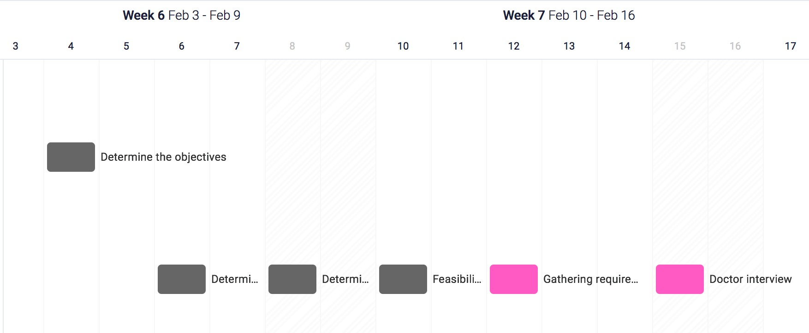

صورة تحتوي على منضدة

تم إنشاء الوصف تلقائياً

صورة تحتوي على منضدة

تم إنشاء الوصف تلقائياً

صورة تحتوي على منضدة

تم إنشاء الوصف تلقائياً

صورة تحتوي على نص, وسيلة, لقطة شاشة, أجهزة المطبخ

تم إنشاء الوصف تلقائياًصورة تحتوي على منضدة

تم إنشاء الوصف تلقائياً

# Stockholder definition

a. The Client

The person or organization that will invest in this program is the Ministry of Health

b. The Customer

Often it will be people who need blood or who want to donate blood. Also, hospitals, blood banks, and the Ministry of Health.

c. Other Stakeholder

Often, they will be hospitals, our program will help hospitals to overcome many crises that need blood.

## The Current Situation

### Content:

We want to change how things are done currently to optimize efficiency. By digitalizing interactions regarding blood donations. Instead of hospitals contacting each health care facility for blood requests, they would simply post a blood request on the application. And each health care facility within the same proximity would be notified. Also, people who are interested to donate can also view the blood request, if they’re within the same proximity.

### Motivation:

The motivation for creating such software is, to make things easier for hospitals especially in emergent situations. Our goal is to help save lives by making blood donating /receiving processes faster, since hospitals face life/death situation regarding patients’ loss of blood.

The effects of proposed changes:

* ‏Reducing the communication gap between donors and blood banks so that blood donation processes become easier
* Easy to access instructions of post donation
* Encouraging regular donors to donate in blood shortages, which will help in containing the problem

The best alternatives is to allow hospitals to post blood requests, that would be sent to every health care facility withing the same proximity.

## The Context of the Work

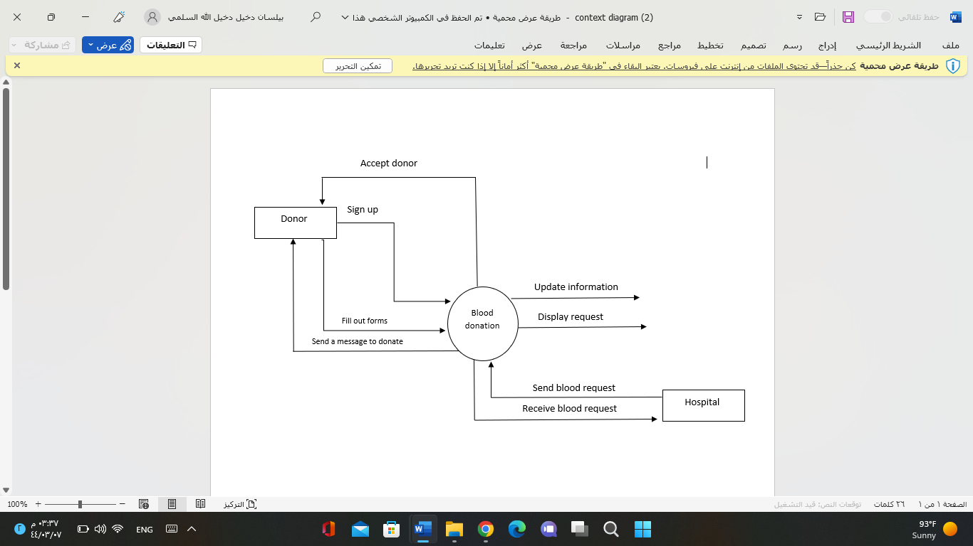a. Context diagram

### b. Business event list

|  |  |  |
| --- | --- | --- |
| **Event Name** | **Input and Output** | **Summary** |
|  |  |  |
| 1. Sign up | Sign up (in) | The user will enter their information |
| 2. Fill out forms | Fill out forms (in) | The donor will answer a question provided by the website |
| 3. Post announcement  (Send blood request) | Post announcement (out) | hospital can post an announcement when they need a blood donor. |
| 4. Accept donor | Accept donor (out) | The system accepts the donation request |
| 4. Instruction information | Instruction information(out) | The system will send an instruction message to the donor. |
| 5. Receive blood request | Receive blood request (out) | Send a notification to the donor when a patient need blood. |
| 6.Update information | 6.Update information(out) | The system will update patient information. |
| 7. Display request | Display request(out) | The system will display blood requests for users |

|  |  |
| --- | --- |
| Non-Functional Requirements:Functional and non-functional requirements: | Functional Requirements: |
| 1- Security:   * The system will ensure the privacy of the patient and the donor. * Protect their information from attacks such as file number, location, email, phone number. | 1. The website main page will allow the user to view a brief information of the announcements. |
| 2- Usability:   * Easy to use the system. * When the user enters an incorrect username or password an error message will appear. * The clear interface helps prevent user errors. * Ease of learning. * Efficiency to use. | 2. The website main page should display a signup or login button. |
| 3- Performance:   * Throughput of the system will return results faster * The average response time by 3 second. * A website should be capable enough to handle many of users. | 3. The web application will provide a selection option to choose if the users are donor or a hospital. |
| 4- Reliability:   * Availability: the system is accessible for a user most of the time. * Failure rate: the system down during maintenance. | 4. The web application will provide a list of questions after register as a donor. |
|  | 5. The web application will check the answered  questions to make sure if the donor is qualified. |
|  | 6. The web application will display message for  unqualified donor. |
|  | 7. The web application should display a login screen where users can enter their username and password to access the system. |
|  | 8. The web application should allow the users to reset the password again if they forget it. |
|  | 9. The web application should allow the users to edit their profiles. |
|  | 10. The web application will allow the hospitals to post announcement if they need a blood donor. |
|  | 11. The web application will allow the hospital to enter patients' information such as (blood type, location, file number). |
|  | 12. The web application filter announcements based on the patient’s information and their location. |
|  | 13. The donor will receive a message from the  system that includes instructions on what to do after the donation. |
|  | 14. The system should logout when the user  clicks on the logout button. |

# Use case diagram:

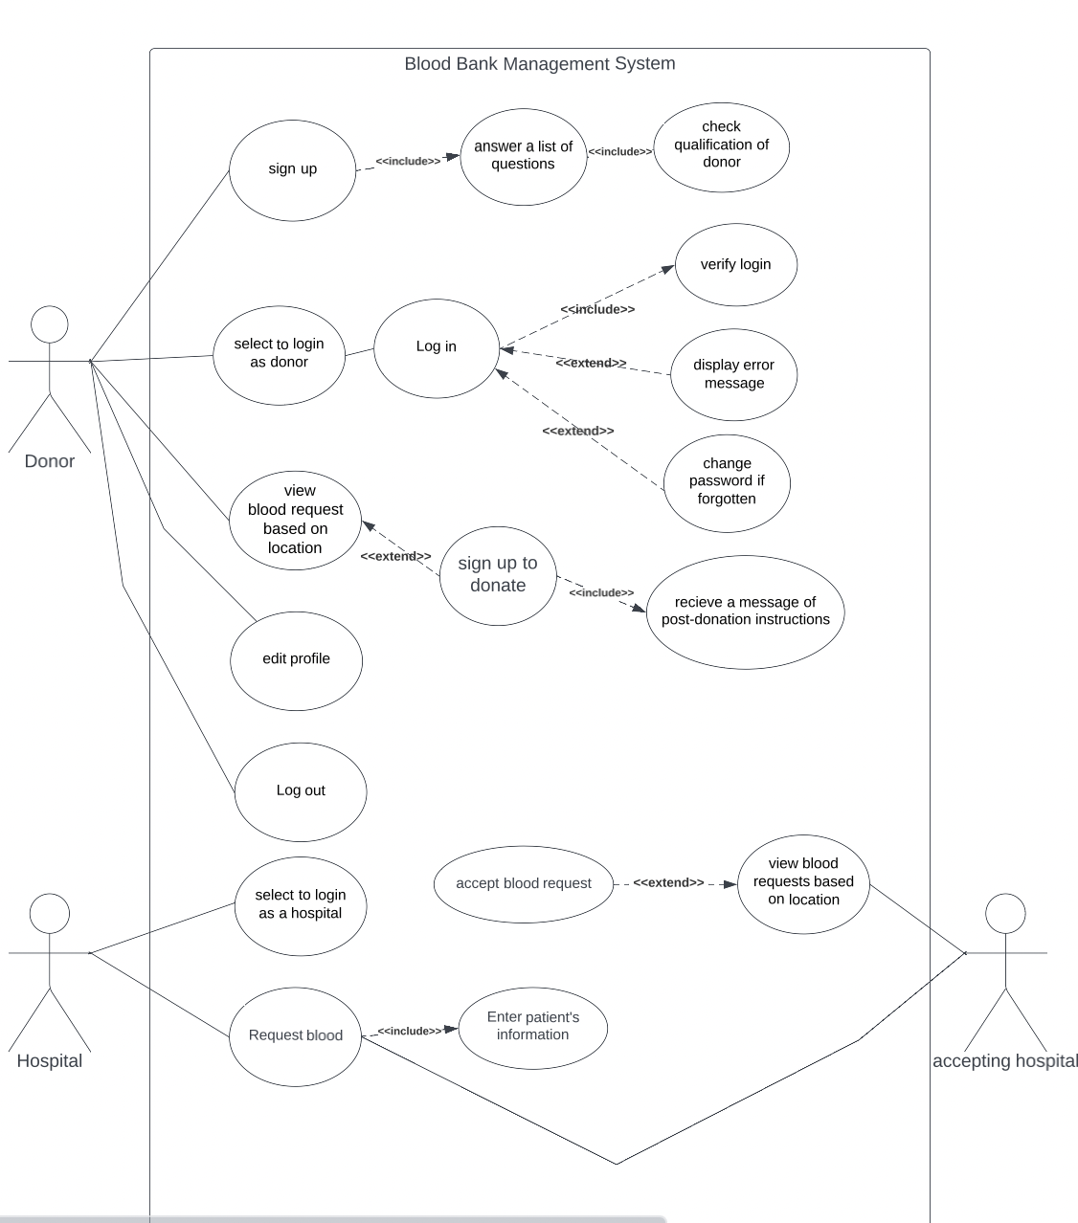

UC1: Sign up

Scope: Application system

Level: Sign up

Primary Actor: Donor

Precondition: No

Stakeholders and interests:

Patient

Donor

System

Scenario of UC1:

1- Donor or patient enters the application and starts the registration and login procedures

UC2: Select to login as donor

Scope: Application system

Level: Select to login as donor

Primary Actor: Donor

Precondition: Sign up

Stakeholder and interests:

Patient

System

Scenario of UC2:

After signing up the user should select if he/she is a patient or a donor. If he/she selects donor, the system will display questions that he/she should answer correctly.

UC3: View blood request based on location

Scope: Application system

Level: View blood request based on location

Primary Actor: Donor

Precondition: Donor login

Stakeholder and interests:

Patient

Scenario UC3:

After when the donor answers all the questions correctly then it will show to him/her the patient blood request based on their location then the donor will choose the place that they want to donate in.

UC4: Edit profile

Scope: Application system

Level: Edit profile

Primary Actor: Application system

Precondition: sign up as donor or as patient

Stakeholder and interests:

Patient

Donor

System

Scenario UC4:

After signing up as donor or patient they can edit their profile such as their location, phone number

UC5: log out

Scope: Application system

Level: log out

Primary Actor: Application system

Precondition: should sign up

Stakeholder and interests:

Patient

Donor

System

Scenario UC5:

After when the user finishes the operation that he/she want to do in the application they should log out for more privacy and security.

UC6: Select to login as a hospital

Scope: Application system

Level: Select to login as a hospital

Primary Actor: Hospital

Precondition: should sign up

Stakeholder and interests:

Patient

Scenario UC6:

The hospital should sign up then they can do their operations or requests

UC7: Request blood

Scope: Application system

Level: Request blood

Primary Actor: Hospital

Precondition: should login

Stakeholders and interests:

Patient

Scenario UC7:

The hospital logs in as a hospital so they can request a blood will by displaying patient information

UC8: Answer a list of questions

Scope: Application system

Level: Answer a list of questions

Prime Actor: Donor

Precondition: Sign up

Stakeholder and interest:

Donor

System

Scenario UC8:

1- user signed up

2- user entered his signing up information

3- checking qualifications of the donor

UC9: log in

Scope: Application system

Level: Log in

Prime Actor: Donor

Precondition: Donor selects to log in

Stakeholder and interest:

Donor

System

Scenario UC9:

1- user select to log in

2- the user entered his username and password to log in

UC10: Sign up to donate

Scope: Application system

Level: Sign up to donate

Prime Actor: Donor

Precondition: Donor view blood requests in his location

Stakeholder and interest:

Donor

System

hospital

Scenario UC10:

1- user selects to donate

2- the user fills out information

UC11: accept blood request

Scope: Application system

Level: accept blood request

Prime Actor: accepting hospital

Precondition: View blood requests based on location

Stakeholders and interest:

hospital

accepting hospital

Scenario UC11:

1- The hospital is requesting blood from accepting hospital

2- accepting hospital accepted the blood request

UC12: Check qualifications of donor

Scope: Application system

Level: Check qualifications of donor

Prime Actor: System

Precondition: Donor signs up with his/ her information

Stakeholder and interest:

Donor

System

Hospital

Scenario UC12:

1- user signed up his information

2- Systems checking the qualification of donor

UC13: verify login

Scope: Application system

Level: verify login

Prime Actor: Donor

Precondition: Login

Stakeholder and interest:

Donor

system

Scenario UC13:

1- user select to login as donor

2- The system verifies the login

UC14: display error message

Scope: Application system Leve: display error message

Prime Actor: Donor

Precondition: login

Stakeholders and interest:

Donor

System

Scenario UC14:

1- user select to login as donor

2- system displays error message

UC15: Change password if forgotten

Scope: Application system

Level: Change password if forgotten

Prime Actor: Donor

Precondition: Log in

Stakeholder and interest:

Donor

System

Scenario UC15:

1- user trying to login to his account

3- user forget his password

4- user send a request to reset password

UC16: receive a massage of donate instruction

Scope: Application system

Level: receive a massage of donate instruction

Prime Actor: System

Precondition: sign up or login to donate

Stakeholder and interest:

Donor

System

Scenario UC16:

1- user signed or login to donate

2- system views the blood type requested

3- user views his blood type to donate

4- user received a message with a donate instruction

UC17: view blood request based on location

Scope: Application system

Level: view blood request based on location

Prime Actor: System

Precondition: accept a blood type request

Stakeholder and interest:

Hospital

System

Donor

Scenario UC17:

1- Hospital accepted a blood type request

2- Hospital view blood request based on location

UC18: enter patent’s information

Scope: Application system

Level: enter patent’s information

Prime Actor: Hospital

Precondition: request blood

Stakeholder and interest:

Hospital

Scenario UC18:

1- Hospital request a blood

2- system received the blood request

3- Hospital entering patents information they received from the donate system

# Sequence diagram:

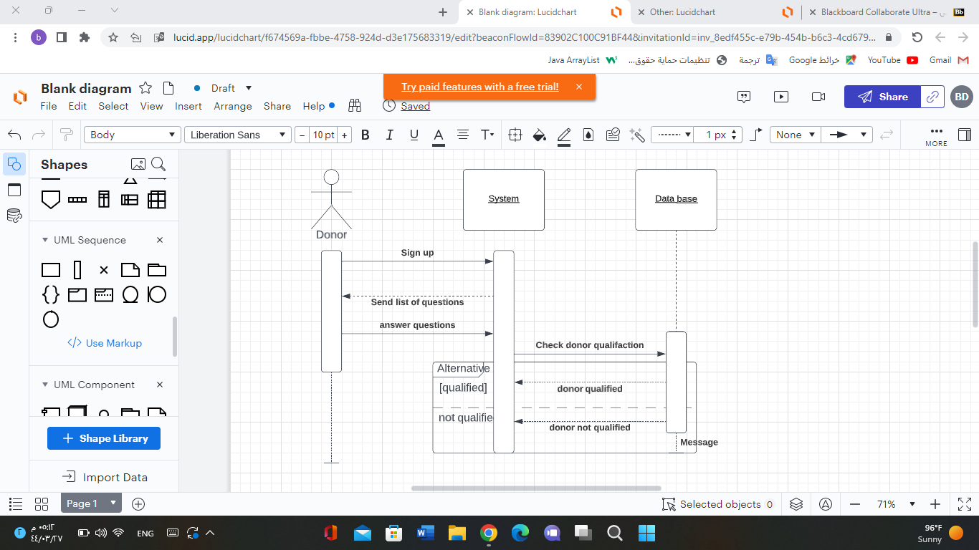

Main flow:

1-user signs up

2-user must answer a list of questions

3- system checks if user is qualified to donate

صورة تحتوي على منضدة

تم إنشاء الوصف تلقائياً

Main flow:

1-user chooses to edit her/his profile

2-user make changes to her/his account

3-user save changes

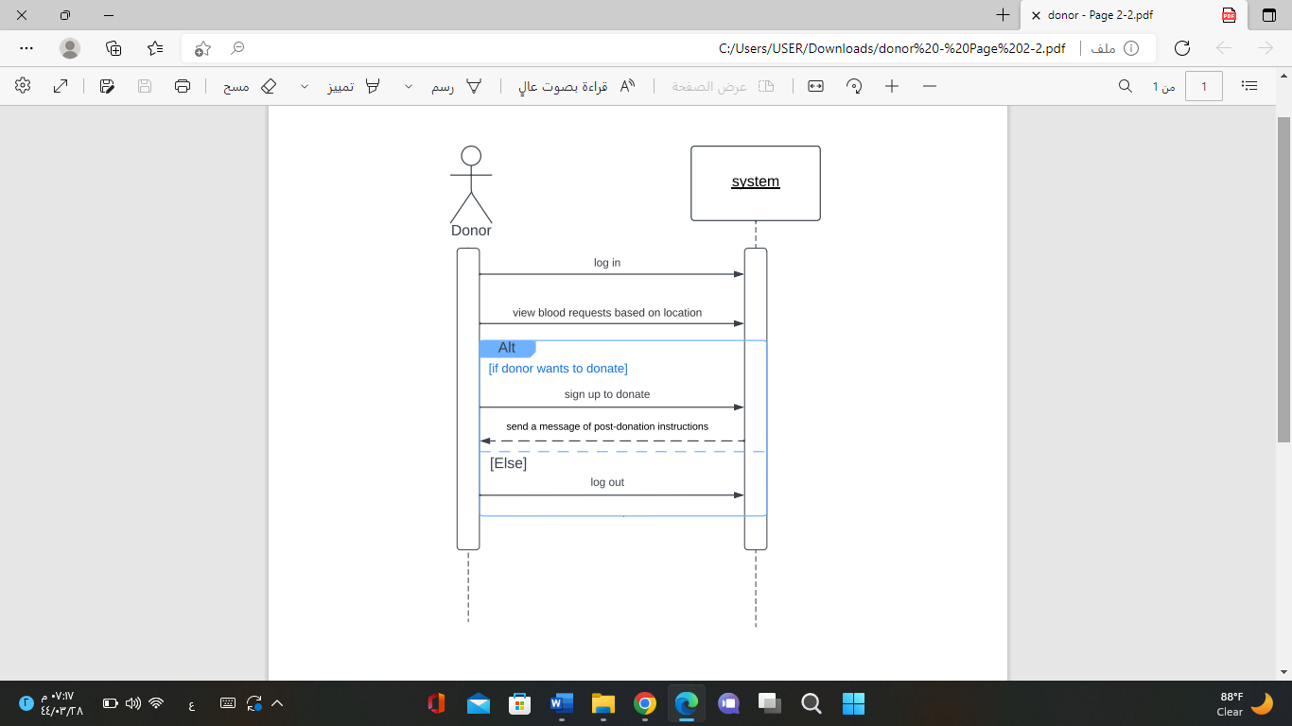

Main flow:

1. Donor logs in to their account

2. Donor views blood requests based on location.

3. Donor signs up to donate if they'd like to continue.

4.System sends a message of post-donation instructions.

5. Donor logs out.

صورة تحتوي على نص, لقطة شاشة, شاشة عرض

تم إنشاء الوصف تلقائياً

Main flow:

1. Hospital request blood.

2. Hospital sends request blood and patient's information to the accepting hospital

3.accepting hospital accept blood request.

4.view the hospitals based on location

صورة تحتوي على منضدة

تم إنشاء الوصف تلقائياً

Main flow:

1. Hospital signs up
2. Hospital login
3. Check the validity
4. Hospital logs in to their account
5. Hospital requests a blood
6. Hospital enters the patient's information's
7. Ask the Hospital if they want to confirm
8. Confirmed and log out or not confirmed and log out

# Class Diagram:

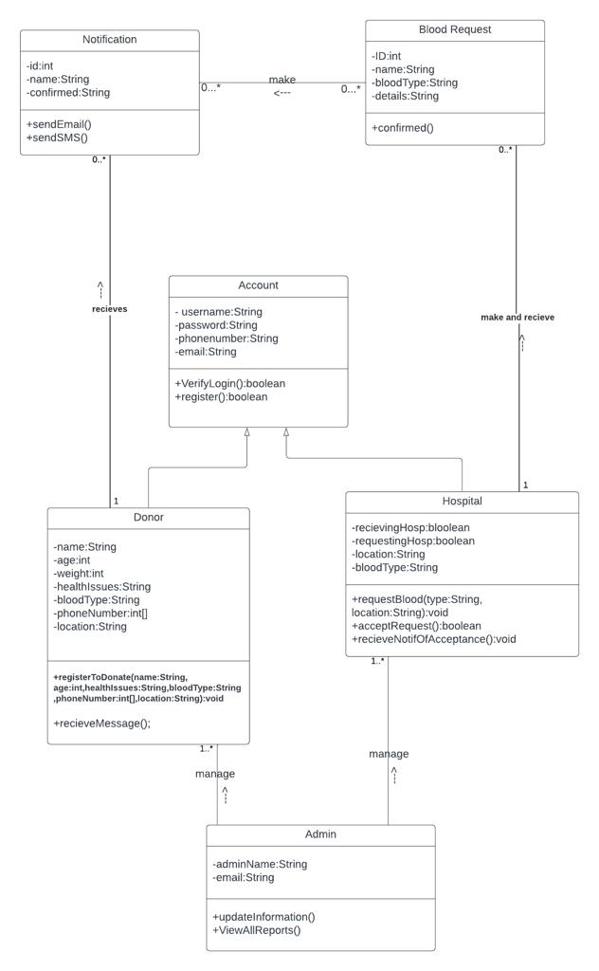

|  |  |  |  |
| --- | --- | --- | --- |
| Class Name | Attributes | Methods | Relationships |
| Donor | -name:String -age:int -weight:int -healthIssues:String -bloodType:String -phoneNumber:int[] -location:String | +registerToDonate(name:String, age:int,healthIssues:String,bloodType:String ,phoneNumber:int[],location:String):void  +recieveMessage(); | 1-inheritance with the “Account” class.  2-Association with the “Notification” class, receives alert. Donor can receive from 0 to any number of notifications. |
| Hospital | -  recievingHosp:bloolean -requestingHosp:boolean -location:String -bloodType:String | +requestBlood(type:String, location:String):void +acceptRequest():boolean +recieveNotifOfAcceptance():void | 1-inheritance with the “Account” class.  2-Association with the “blood request” class, make or receive a blood request. Can make from 0 to any number of blood requests. |
| Account | - username:String -password:String -phonenumber:String -email:String | +VerifyLogin():boolean  +register():boolean | 1- inheritance with classes "Donor" and  "Hospital" |
| Admin | -adminName:String  -email:String | +updateInformation()  +ViewAllReports() | 1- Association with "Donor" and "Hospital", can manage 1 to any number of donors and hospitals |
| Blood Request | -ID: int  -name: String  -bloodType:String  -details:String | +confirmed() | 1-Association with "Hospital", can make and receive 0 to any number of blood request.  2- Association with notification can make 0..* number of notification for accepted blood request |
| Notification | -id:int -name:String -confirmed:String | +sendEmail() +sendSMS() | 1. Association with "Donor" can receives 0..* of accepted notification |