Lab_04 Note Questions

1. Why does the main method need to be “public”? What does this mean?

The main method needs to be public in order for the system can run the method and it allows the system to access it freely without any issues.

1. Why does the main method need to be “static”? What does this mean?

When the system makes a call to the main method their is no object that exists for the class being called. Static method to allow invocation from class.

1. Why do we need parameters? How do they enhance our use of methods? What do they enable use to do?

Parameters gives a program the information it needs to do a proper program.

1. What are the differences between static and non-static methods? Why do we need to create an object to use a method that is non-static?

A static method belongs to the class itself and a non-static method belongs to each object that is generated from that class. Static is used whenever, but non-static requires a new abject.

1. Draw a diagram of a class with a static return method. You should include at least one variable with user input, and how it travels from the main method, to the parameters, to the function in a method, back to the main for the output.

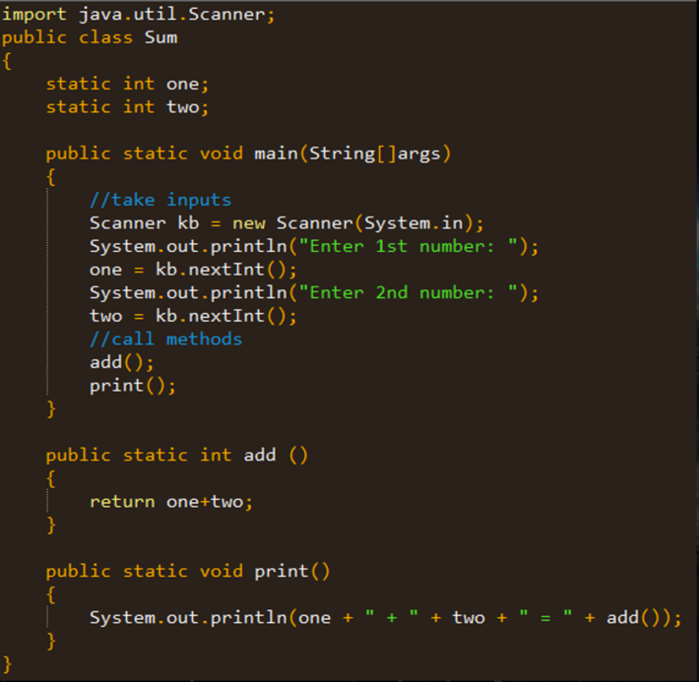

1. In this chapter, the concept of a single point of failure is discussed. Do some research online and describe what you think is the meaning of this, and why it would be beneficial in a large program?

A single point of failure is a very important part of a system that if it were to fail you the whole system is done. A single point of failure is only wanted when have a low high availability and reliability program.