5.2.2:

Matlab function for Simpson’s Rule:

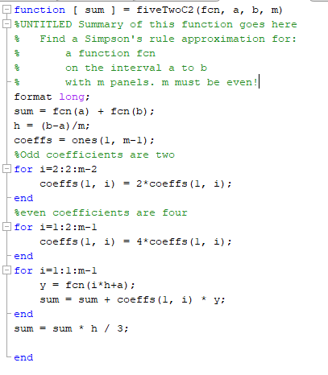

5.2.C2c: f(x) = xe^x, actual = 1

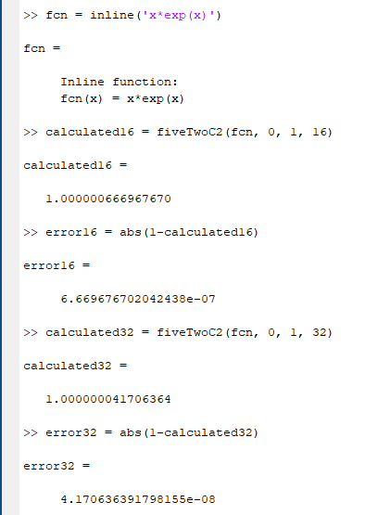

5.2.c2e: f(x) = x\*x\*sin(x), actual = pi^2 - 4

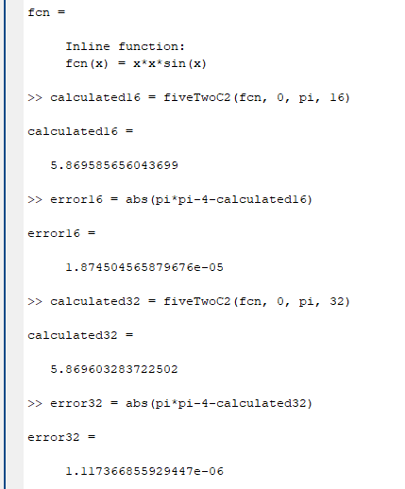

5.2.C5

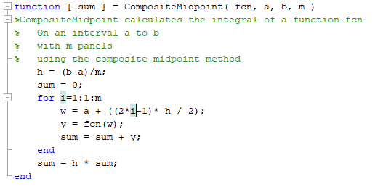

5.2.C5a: f(x) = x^(-1/2), actual = 2

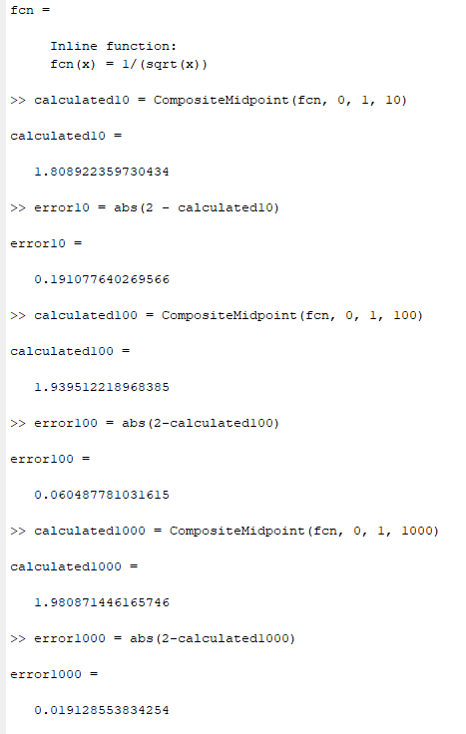

5.2.C5b: f(x) = x^(-1/3), actual = 1.5

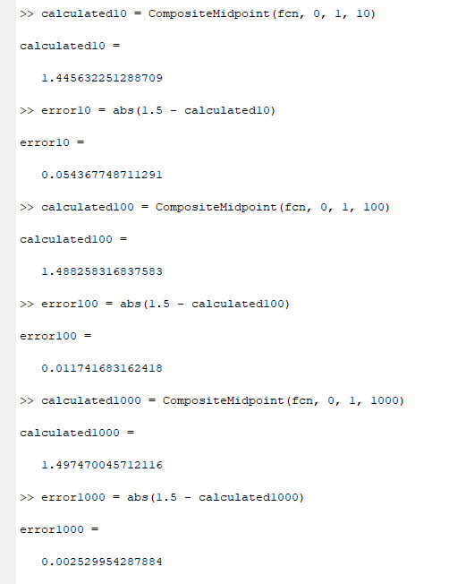

5.2.C8b: f(x) = tan(x), f’(x) = sec(x)\*sec(x), g(x) = sqrt(1 + (sec(x)^4)))

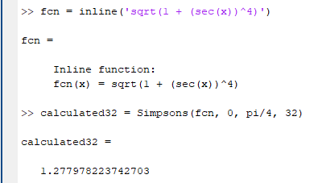

5.3.C1d: f(x) = x\*e^x, actual = 1

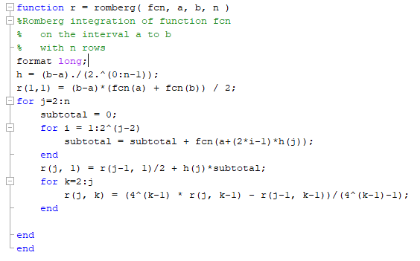

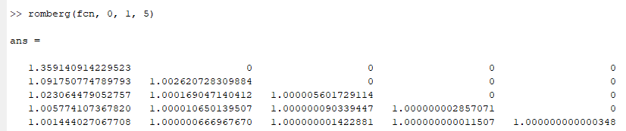

5.3.C2c: f(x) = e^(cos(x)) on 0 to pi

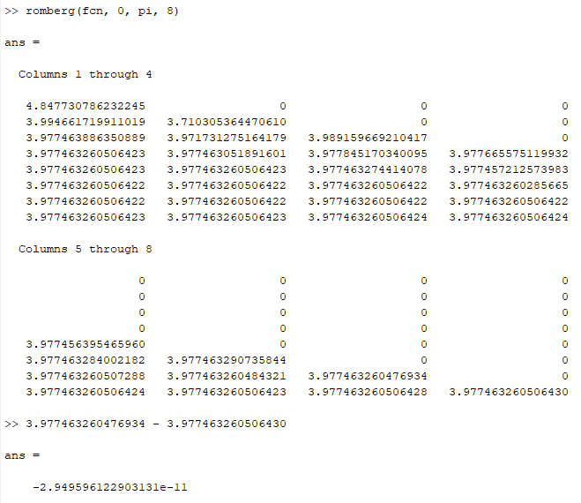

5.3.C3a

If the second column of Romberg is a fourth-order approximation, then the log-log plot should be essentially linear with a positive slope. If error (e) is proportional to the fourth power of the step size (h), then we expect to see log(e) = 4log(h), so we expect to see a slope of 4 on the log-log plot.

f(x) = ln(x) from 1 to 2, actual = ln(4) – 1

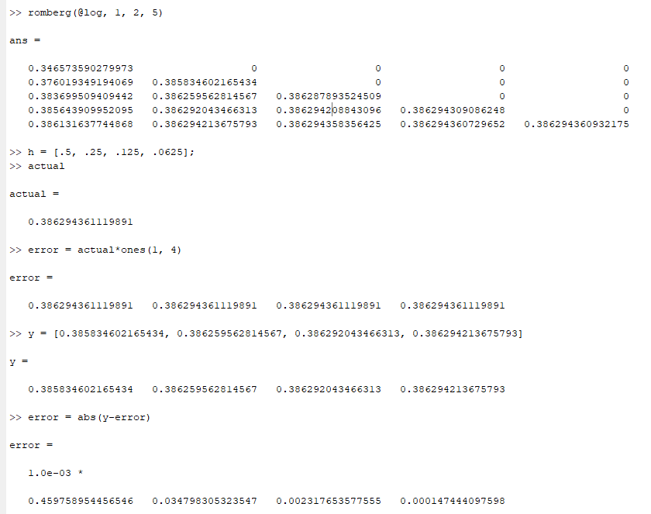

Making a log-log plot of error vs h, we get the following:

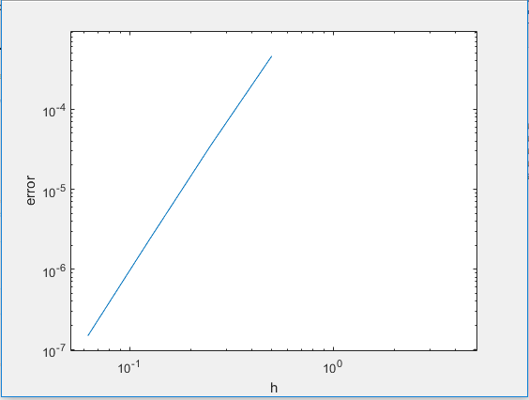

…which looks a lot more like a slope of two.