5.1.C1
My function to calculate f’(x):
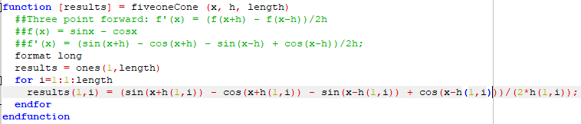
The table:
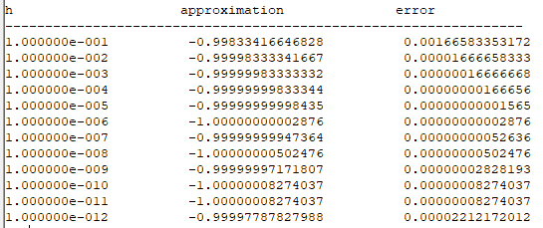

The plot:
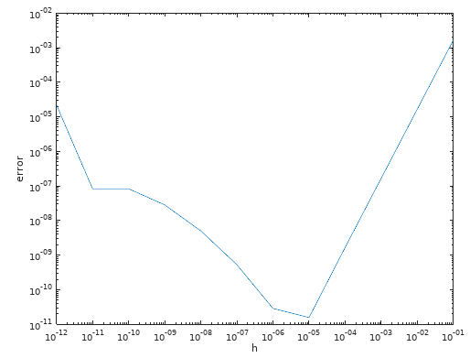

The minimum error appears to agree with the theoretical calculation, so long as we account for the machine epsilon. Merely taking into account the calculation errors, we would have predicted the error to continue to diminish as h diminishes.

5.1.C5a
My function to calculate f’’(x):
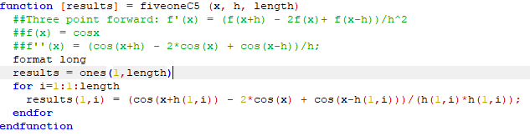
The table:
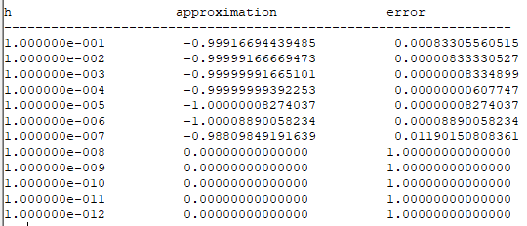

The plot:
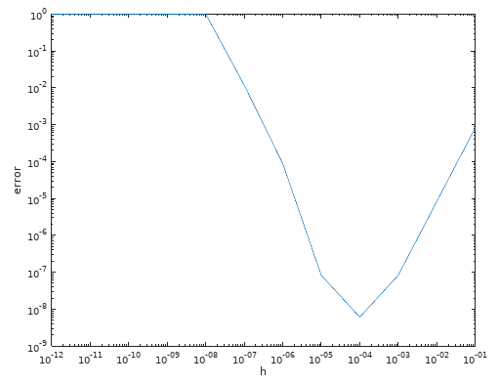

Minimum error occurs at 10-4, machine epsilon is 2.22044604925031e-016 so the minimum error occurs at about epsilon to the ¼ power

5.1.C5b
My function to calculate f’’(x):
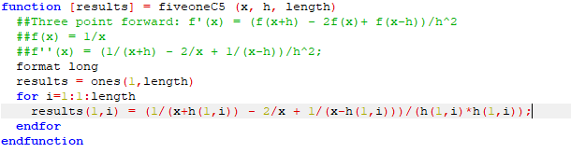

The table:

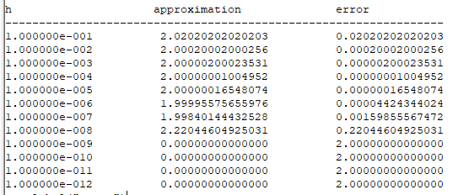

The plot:
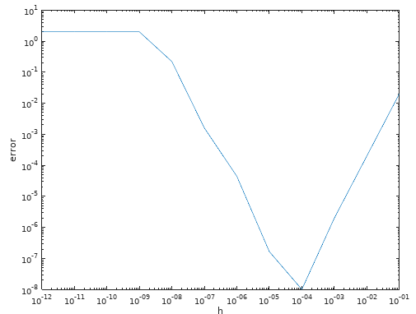

As in part a, the minimum error is proportional to epsilon to the ¼ power.

5.2.C1
c) My function for calculating the area using the Composite Trapezoidal Rule:
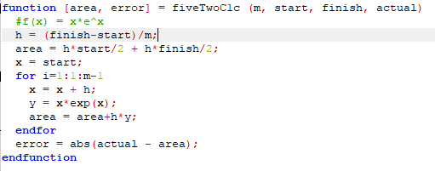

Results for 16 and 32 trapezoids:
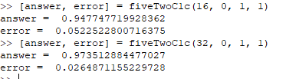

d) My function for calculating the area using the Composite Trapezoidal Rule:
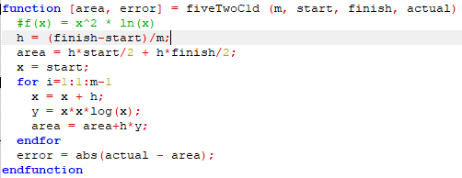

Results for 16 and 32 trapezoids:
