1.1.C3b: e^(x-2) + x^3 – x

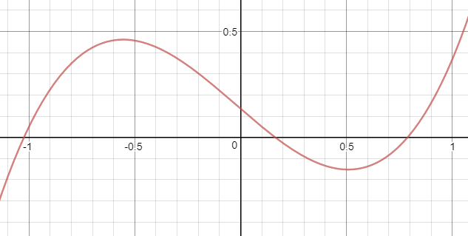

Intervals with roots: [-1.5, -0.5], [-0.5, 0.5], [0.5, 1.5]
Using fzero to find the roots, then testing each one:
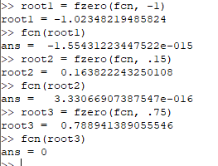

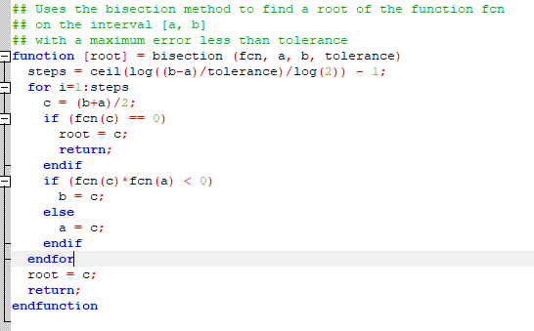
My bisection method function. Yeah, I called it that just to write ‘method function’.

Calculated roots compared with the fzero roots:
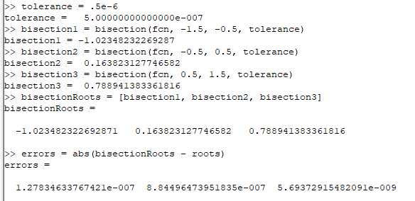

Assuming all the fzero roots are good (and we checked them out above: plugged into g(x), they gave us values within 10^-14 of zero), then our errors are all accurate to within six decimal places as desired.

1.1.C9:
v(h) = pi*h^2(r – h/3) = 1 = pi*h^2*r – pi/3*h^3 = 1
Since r = 1, then v(h) = pi*h^2 – pi/3*h^3 = 1
Converting to a root problem: pi*h^2 – pi/3*h^3 – 1 = 0
Since we’re working in meters, we need our answer to be within .001m. which means we want our tolerance to be .0005m
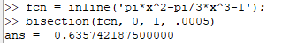

Thus the height should be .636±.001m
Checking with Octave:
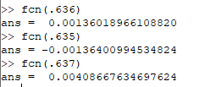

Seems pretty reasonable!

1.1.C4c: g(x) = (2x + A/x^2)/3 where A =5
My function for Fixed Point Iteration:
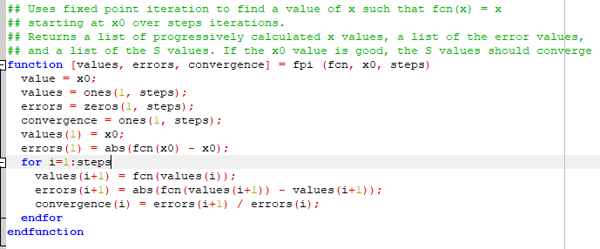
The results:
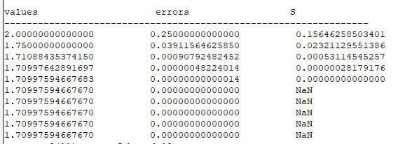

So even with a terrible beginning guess of 2, FPI only took 5 steps (counting the initial x0 step) to attain 8 decimal places of accuracy.
1.1.C6a: f(x) = 2x^3 - 6x – 1 = 0
i. 2x^3 – 1 = 6x → (x^3 – 1)/6 = x → g(x) = (x^3 – 1)/6
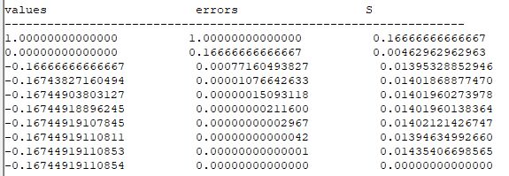

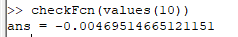

ii. 2x^3 = 6x + 1 → x = cbrt((6x+1)/2)
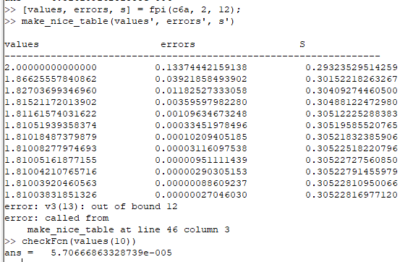

We can get the third root using this same equation with a different seed and some extra iterations:
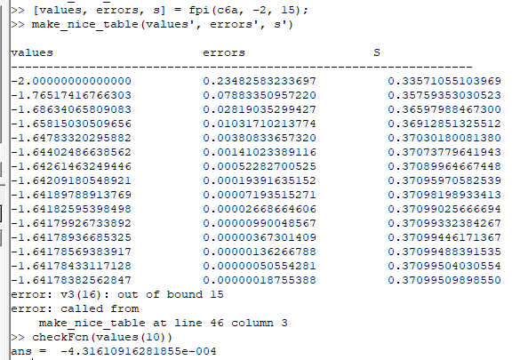
iii. Adding 2x^3 to both sides:
2x^3 + 2x^3 - 6x – 1 = 2x^3 → 4x^3 – 6x = 2x^3 + 1 → x(4x^2 – 6) = 2x^3 + 1
→ g(x) = (2x^3 + 1)/(4x^2 – 6)
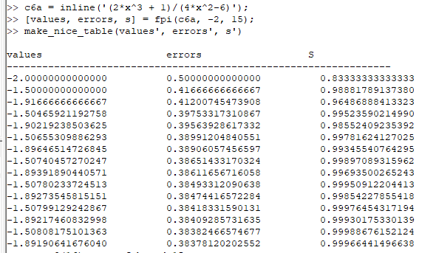
Unsurprisingly, this function converges quite poorly, since I made a WAG as to the additional value.
That’s fine, we got three good results from the first two functions.

Comparison of S with predicted S:
i. g = (x^3 – 1)/6 so g’ = (x^2)/2 so g’(-.16744918896245) = .01402, which matches the S generated by our FPI.
ii. g = cbrt((6x+1)/2) so g’ = ((6x+1)/2)^(-2/3) = cbrt(4) / cbrt((6x+1)^2) so g’(1.81003831851326) = 0.305228 which matches the S generated by our FPI.
iii. g’ the same as in (ii), so g’(-1.64178382562847) = .370995, which again matches the S generated by our FPI.

1.2.C7a: g(x) = 1 – 5x + 15/2 x^2 – 5/2 x^3 cycling within (0, 1).
a starting point of ½ seems to cycle endlessly within (0, 1):
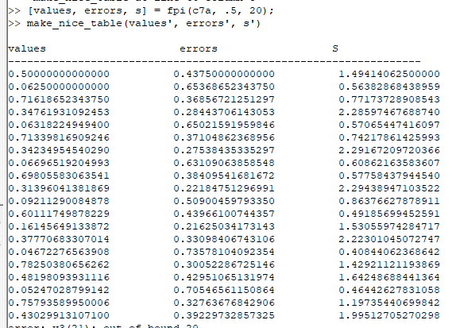

a starting point of ¾ does the same:
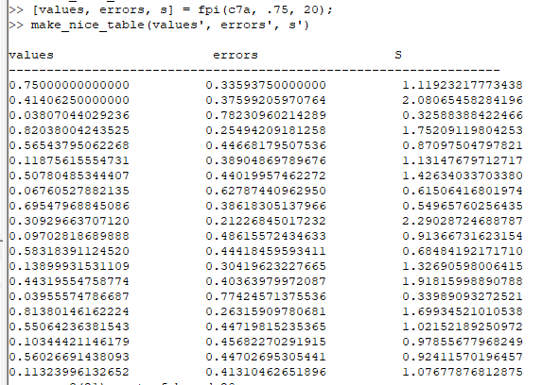

Obviously, a starting point of 0 or 1 converges instantly.
A starting point of 5/4 breaks out of the interval, and it becomes obvious that for x > 1, the higher order terms dominate and g(x) > 1. Via trial and error it appears that as long as our initial guess is between 0 and 1, g(x) cycles within (0, 1).

5.4.C6g: integrate x^x dx from 0 to 1

Adaptive quadrature method, straight from the book:
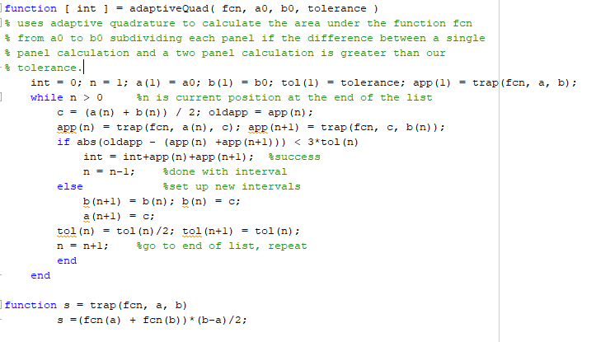

Results of using it on the integral of x^x dx on [0, 1]:
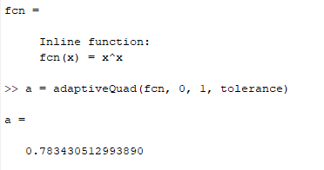

Compute the area under f(x) from x=0 to x=1 where
f(x) = 1/((x-0.3)^2+0.01) + 1/((x-0.9)^2 + 0.04) - 6

using adaptive quadrature with an error tolerance of 0.5*10^(-5). Make a plot of the curve along with the subintervals so we can see that more are used where the function is changing quickly.

