1.3.C2: f(x) = sin(x^3) – x^3
f’(x) = (3x^2)cos(x^3) – 3x^2 = 3x^2(cos(x^3) – 1);
f’(0) = 0
f’’(x) = 6x(cos(x^3) – 1) + 3x^2(-sin(x^3)*3x^2) =
6x(cos(x^3) – 1) – 9x^4(sin(x^3).
f’’(0) = 0
f’’’(x) = 6(cos(x^3) – 1) + 6x(3x^2)(-sin(x^3) – (36x^3)(sin(x^3) – (3x^2)… and this is getting really quite tedious. Since this is a computer problem, let’s use Octave’s Symbolic library:
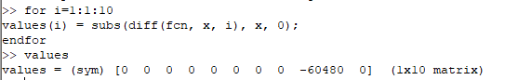

Thus f(x) has a root of multiplicity 9 at 0.
Using fzero at x = 0.1 we get -0.0018116 with a forward error of 0 and a backward error of 0.0018116:
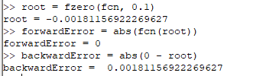

The forward error seems suspicious, so let’s check it out in more detail:
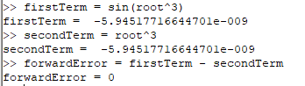

Well, at least it’s consistent.

1.4.C2b: f(x) = sin(x) – 6*x – 5 = 0 so f’(x) = cos(x) – 6
Using the following function for Newton’s method:
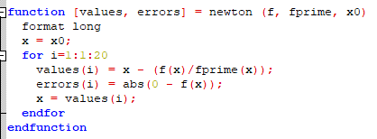

We get:
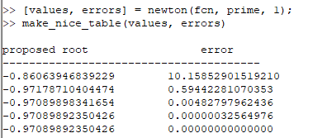

So our root, to eight correct decimal places, is -0.97089892.

1.4.C6: Clearly whomever wrote this problem has spent insufficient time with ice cream, but supposing we could actually fill an entire cone, and have a hemisphere on top that does not overlap the cone, the volume would be h*pi*r*r/3 = 10*r^2*pi/3
The volume of the hemisphere is 2*r^3*pi/3
Thus the total volume of ice cream is (r^3 + 5r^2)*2*pi/3 = 60;
Thus f(x) = (r^3 + 5r^2)2*pi/3 – 60;
And f’(x) = (3r^2 + 10r)*2*pi/3
Using our previous newton function with an x0=2, we get the following:
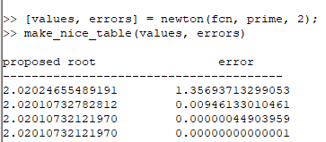

Thus the radius of the scoop, to four correct decimal places is 2.0201 cm.

1.4.C13: f(x) = (1 - 3 / (4 * x)) ^ (1 / 3)
So f’(x) = (1/4)(x^-2)(1-3/(4*x))^(-2/3)

Using fzero, we get the expected root of x = 0.75

Using the following updated newton function with an initial guess of x=0.7
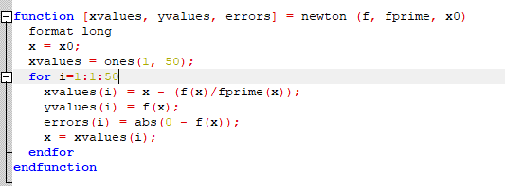

...and plotting our f(x) values against our x values we get the following mess:
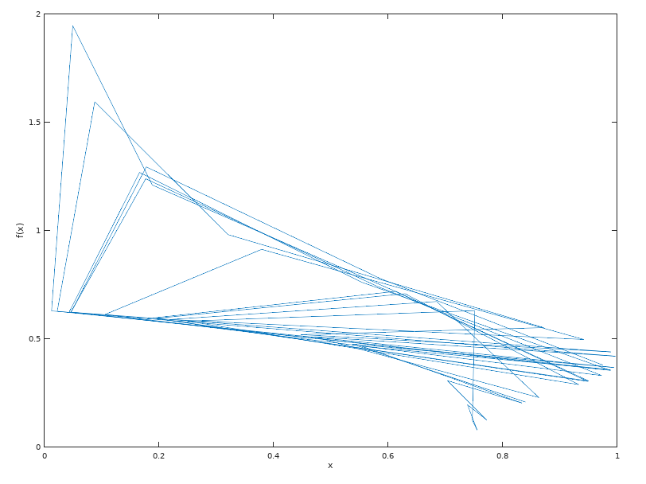
Newton’s method does not work in this case because f’(x) is not defined at the root x=.75 (divide by zero error).

1.5.C4: f(x) = 54*x^6 + 45*x^5 – 102*x^4 – 69*x^3 + 35*x^2 +16*x – 4
Plotting the function using 1000 points on the interval [-2, 2] and adding a reference line at x = 0 gives us the following:
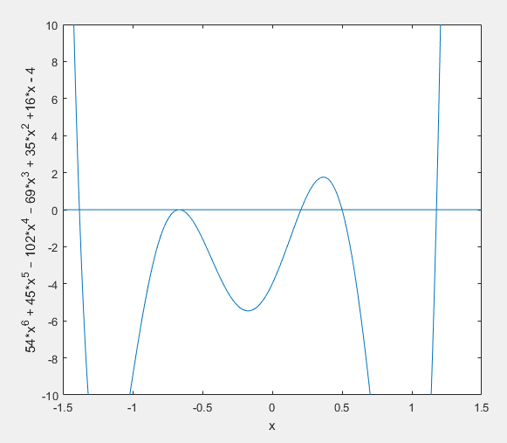

In order to find the roots, we want to bracket the roots and use the secant method on each one. I created a multipleRootsSecant function that (naively) splits the interval into equal segments and checks each segment for a root, but this misses roots 3 and 4. Finer intervals should work reasonably well, but given that we can see roughly where the roots are on the plot, it became easier to just run the following basic secant function five times:

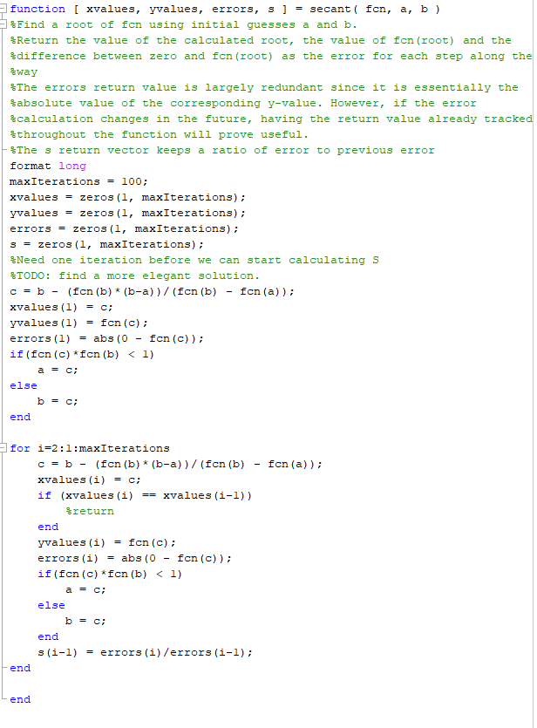

Finding each root:
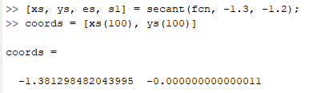

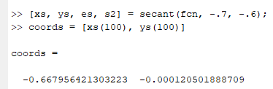

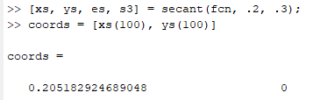

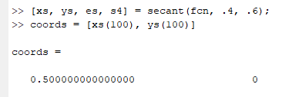

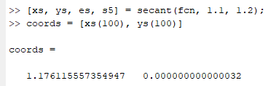

By default, the secant function tracks S as the current error divided by the previous error. Inspecting each set, we see the following:
S1 = S2 = S3 =
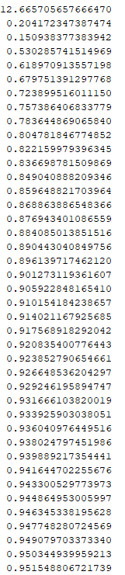
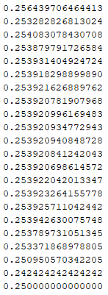
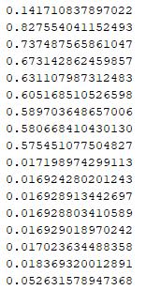

S4 = S5 =
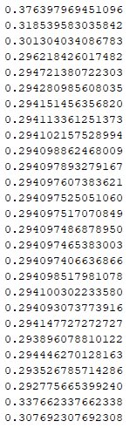
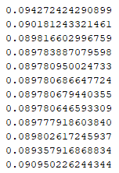

When the secant method converges linearly, we expect to see S converge to a relatively constant value, as is the case with S3, S4, and S5.

When the secant method converges superlinearly, we expect to see the the current error/(previous error^alpha) converge to a constant value, where alpha = (1 + sqrt(5))/2 or about 1.62. If we create a new vector called superS for the remaining error vectors (e1 and e2), we see:

superS1 = superS2 =
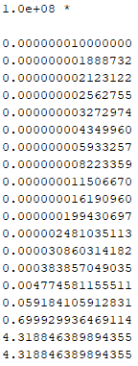
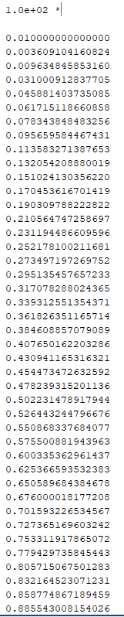

It looks like superS1 one converges, but superS2 does not, so the secant method converges superlinearly around root 1 but linearly around root 2. It is interesting that both S2 and superS2 continue to grow, but superS2 grows substantially more quickly than S2.

Thus, the secant method converges superlinearly around x = -1.38123 and converges linearly around
x = -0.66796, 0.20518, 0.5, 1.17612

