Battista, Jude
MA-350-1
Rempe
HW 06
Problem 1:
The Stewart function on theta, taken step by step from the text book.
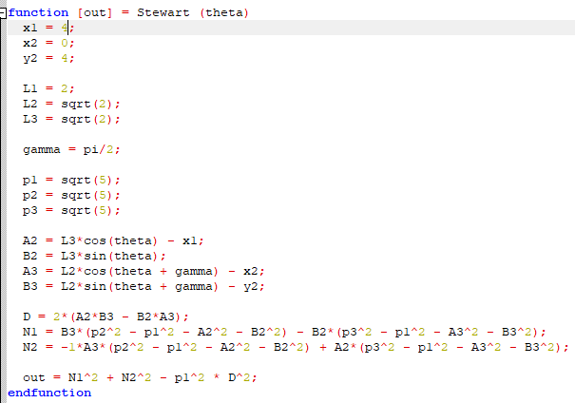
Due to the single parameter, we have to edit our initial values in the function for varying configurations. With the values set to the test values in the book we see that a theta of -pi/4 or pi/4 does indeed produce zero or something very close to it.
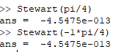

Problem 2:
Plotting the solution on the interval [-pi, pi] is somewhat problematic given the large y-values at the ends of the interval. Accordingly, I have included the initial plot and a zoomed in version to verify that it does cross the x-axis at roughly -pi/4 and pi/4.

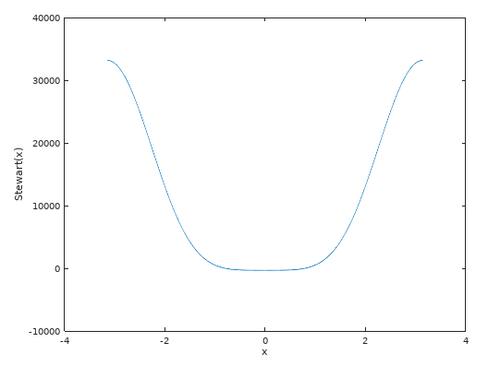

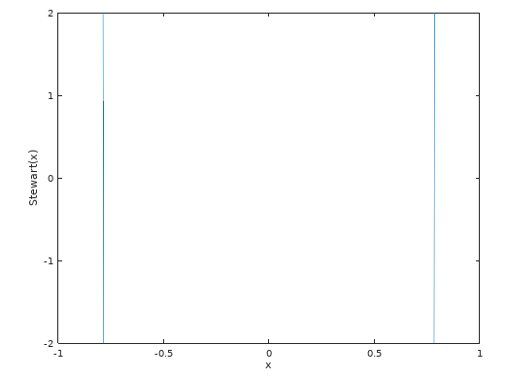
Problem 3:
Using the following function and changing the xvals and yvals parameters, I plotted the two diagrams in figure 1.15:
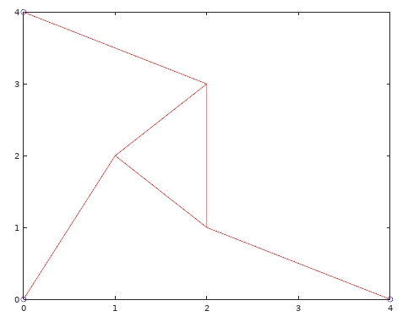
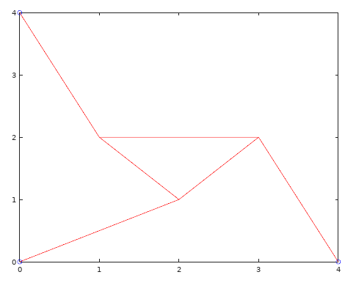
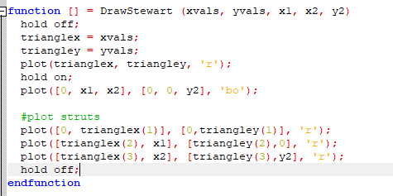
Problem 4:
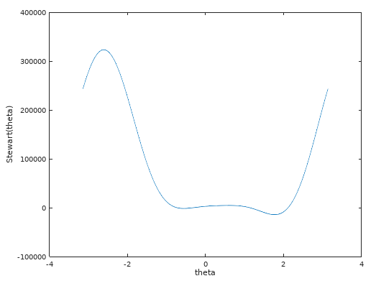

Zooming in, we see that this gives us four intervals with roots: (-1, -0.5), (-0.5, 0), (1. 1.5), and (2, 2.5). Plugging in these intervals and the Stewart function to the Secant function from the previous assignment, we get the following roots:
-0.720849204460390
-0.331005184283870
1.143685517821374
2.115909014086459

Now we need our plot function to calculate the triangleX and triangleY values. Yay, trig! Since this trig will rely on the intermediate values we calculate during the Stewart function, it makes sense to combine them. Enter StewartAndPlot(theta)!

Plugging each zero into our new StewartAndPlot function we get the following diagrams:

-0.720849204460390 gives us:
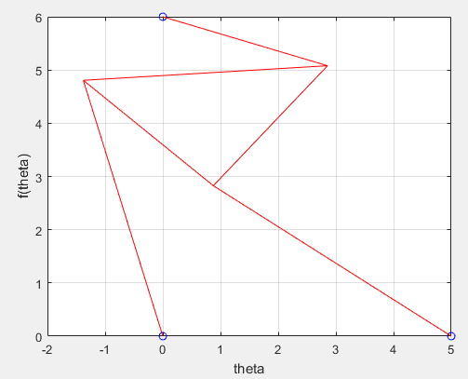

With errors on our p-values of 1.0e-15 * (0 ,0, 0.8882).

-0. 331005184283870 gives us:
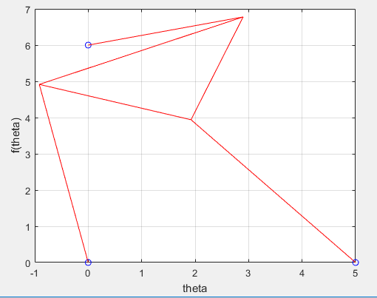
With errors on our p-values of 1.0e-14 *(0, 0.0888, 0.1332).

1.143685517821374 gives us:
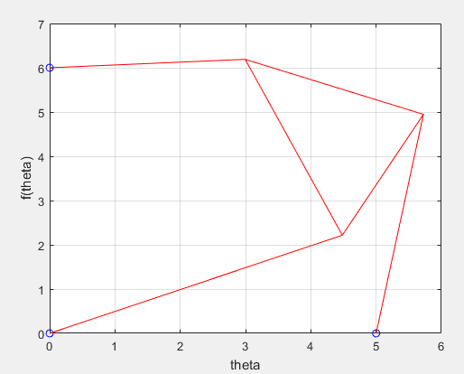
With errors on our p-values of 1.0e-14 * (0.0888, 0.1776, 0.1332)

2.115909014086459 gives us:
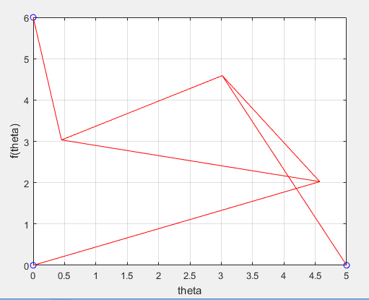
With errors on our p-values of 1.0e-14 * (0.0888, 0.1776, 0.2220)

