2.5.C1:
I used the following function to solve the sparse matrix using the Jacobi Method:
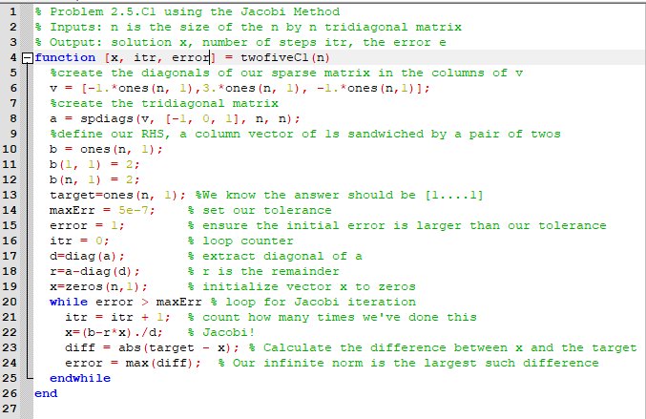
Which gave me the following output for n = 100:
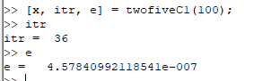

Thus it required 36 steps and had an error of 4.5784e-7
For n = 100000, I got… the exact same thing, which does not match the answer in the book, so I decided to check different values of n. It turns out that this algorithm has the same number of iterations and error value for n = 1000000 and n = 50. If we drop to n = 20, the iterations remain at 36, but the error value changes to 3.827014767310288e-07. I can only conclude the my function is incorrect, which seems less likely since the output exactly matches the book’s prediction for n = 100, or MATLAB’s computational engine has changed since the book was printed.

2.5.C4:
I used the following function to solve the ‘sparse’ matrix (which has more non-zero entries than zero entries…)
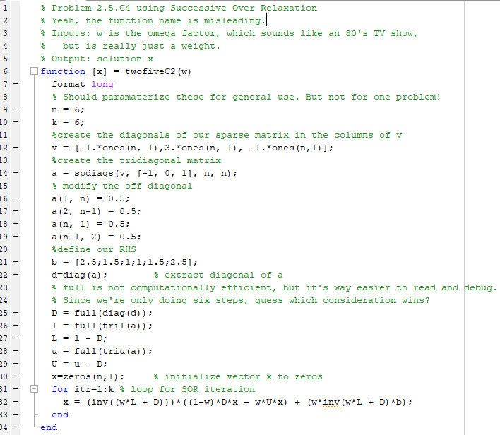

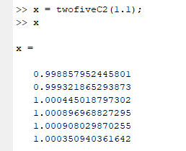
Which matches the book’s results nicely
2.7.C1b:
I used the following function for Newton’s Method:
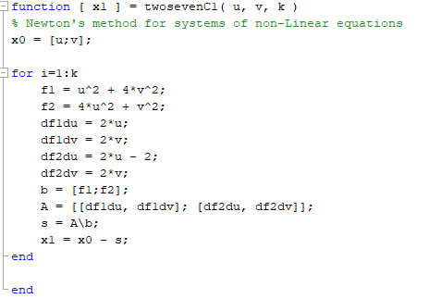
And got the following results:
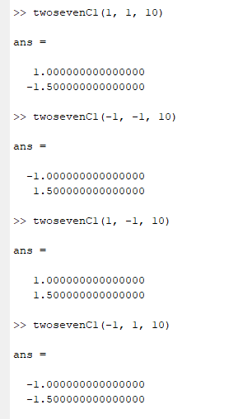
Note that this does not match up with the pencil and paper results, which I trust more than my ad hoc MATLAB function. I suspect that I erred when creating the function.

3.1.C1:

I used the following function to examine the different degrees of polynomial interpretation for population data.
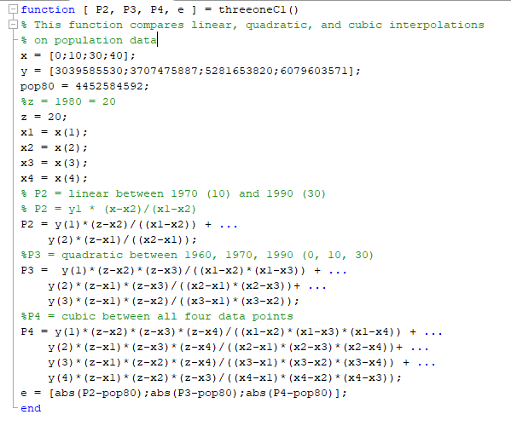
- The linear interpolation gives us a value of 4.375366244000000e+09
- The quadratic interpolation gives us a value of 4.454831983666667e+09
- The cubic interpolation gives us a value of 4.472888287833334e+09

Looking at the resultant error values using the given approximation for the population in 1980, we get
