3.2.C4
I used the following function to take a series of points and evaluate the Lagrange interpolation of those points at a specific x-value:

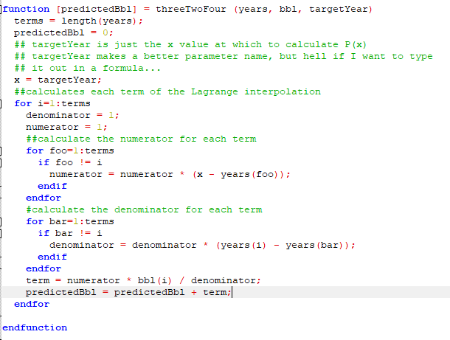
Because this function will work with an arbitrary number of points, I was able to verify its output on 3.2.C3, which has its answer in the back of the book.

Plugging in the first four years, we get the following:
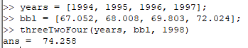

Since the actual value for 1998 was 73.400 we are not seeing the exaggerated wiggle associated with the Runge phenomonon.

3.4.C1
For this problem I used the book’s code. In fact, I was so lazy I did not even copy the code manually but grabbed it from the author’s site on Pearson. Since the code was published in the book, I believe this to be an acceptable use of course resources. As the code is used without modification (save for adjusting it for Octave), I am not reprinting it here. The relevant functions for splinecoeff and spline plot can be found on pages 172 and 173 of the text.

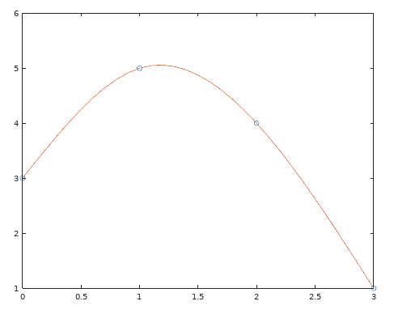
a: x = [0, 1, 2, 3] y = [3, 5, 4, 1]
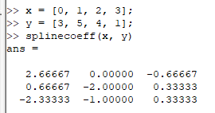

S1 = 3 + 8/3*x – 2/3*x3 on [0, 1]
S2 = 5 + 2/3*(x-1) – 2*(x-1)2 + 1/3*(x-1)3 on [1, 2]
S3 = 4 – 7/3*(x-2) – (x-2)2 + 1/3*(x-2)3 on [2, 3]

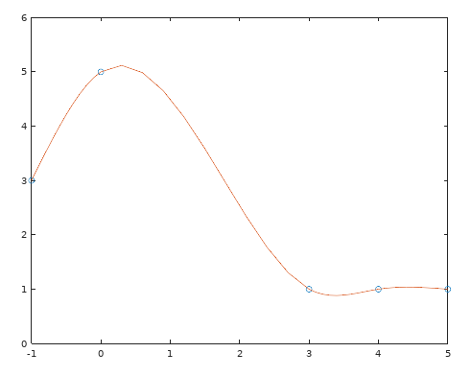
b. x = [-1, 0, 3, 4, 5] y = [3, 5, 1, 1, 1]
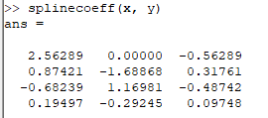

S1 = 3 + 2.563*(x+1) - 0.563*(x+1)3 on [-1, 0]
S2 = 5 + 0.874*x – 1.689*x2 + 0.318*x3 on [0, 3]
S3 = 1 – 0.682*(x - 3) + 1.170*(x - 3)2 – 0.487*(x-3)3 on [3, 4]
S4 = 1 + 0.195*(x - 4) – 0.292*(x - 4)2 + 0.097*(x - 4)3 on [4, 5]

3.2.C14:
I pulled 101 days of GOOG’s stock price into a spreadsheet, yanked the closing column into a separate sheet, and exported that column as a CSV. Which proved, much to my dismay, to actually use newlines to separate the values. A quick trip to vim and its regex engine and all the newlines were now properly commas, giving me the following vector:
prices=[1019.98,1067.45,1072.96,1087.7,1072.08,1074.16,1037.98,1029.27,1032.51,1019.97,1031.64,1015.45,1007.04,1027.81,1025.14,1013.41,1006.47,1031.79,1004.56,1005.1,1053.21,1021.57,1049.08,1090.88,1097.71,1099.82,1135.73,1149.58,1149.49,1138.17,1164.5,1160.04,1126,1109.64,1095.06,1090.93,1078.92,1069.52,1104.73,1118.29,1143.75,1126.79,1106.63,1111.34,1102.46,1094.8,1089.52,1069.7,1052.1,1051.94,1037.78,1001.52,1048.58,1080.6,1055.8,1111.9,1167.7,1169.94,1163.69,1175.58,1175.84,1170.37,1164.24,1169.97,1155.81,1137.51,1129.79,1131.98,1121.76,1122.26,1105.52,1102.61,1106.26,1106.94,1102.23,1086.4,1082.48,1065,1046.4,1048.14,1049.37,1056.74,1060.12,1063.63,1064.95,1070.68,1077.14,1064.19,1049.15,1040.61,1040.48,1041.1,1037.05,1030.93,1018.38,1005.15,998.68,1010.17,1021.41,1021.66,1047.41]
We can then create our x and y vectors:
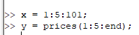

a) Modifying my code from 3.2.C4 to handle a vector of x-values from which to calculated the y values along the interpolated function
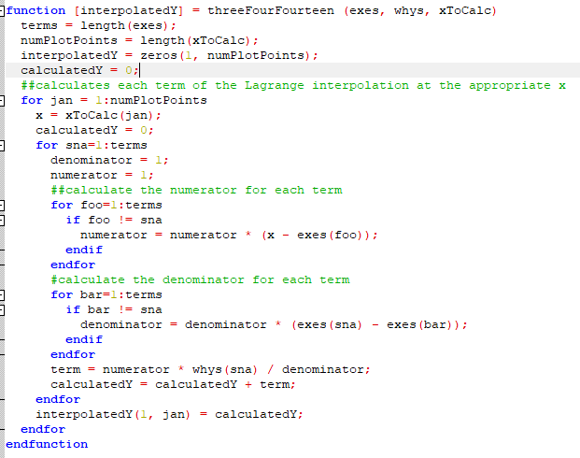
I then created the vectors of points to plot:

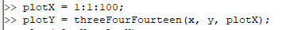

Which yielded the following plot:
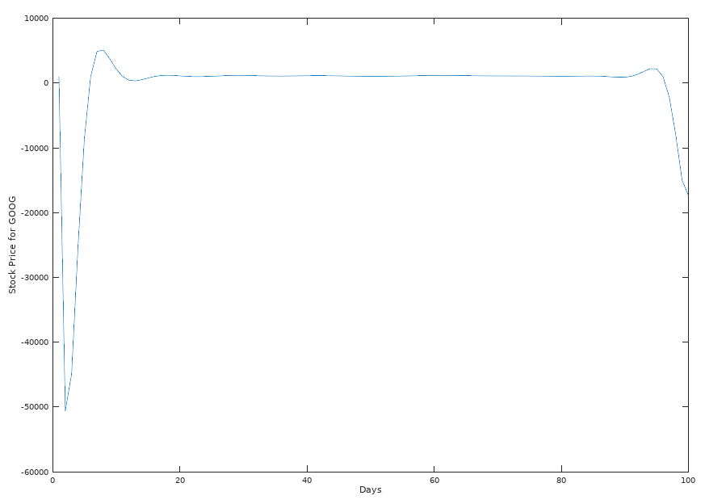
Obviously, the Runge phenomonon is evident here, with its oscillations near the endpoints dwarfing the actual day to day variations in the stock price. If we restrict our y-axis values, we lose the (meaningless) extremes, but get a better picture of the polynomial.
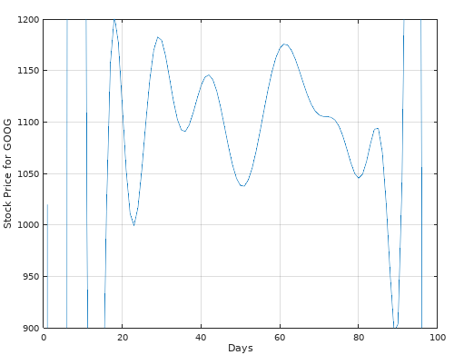

Again, the Runge phenomenon is evident, but the fluctuations of the polynomial in its more restrained state become evident.
I found the maximum interpolation error as follows:
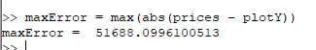

b) We can reuse the same spline code from before with our current x and y vectors to get the following plot:
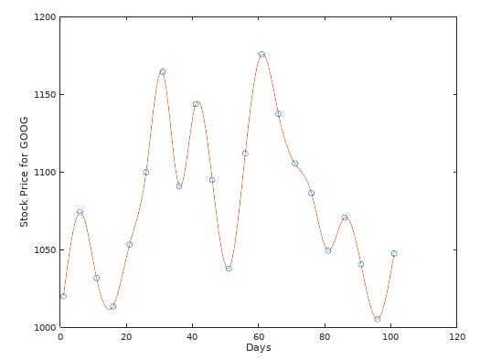

Obviously, this does not suffer from the Runge phenomenon since it is a series of splines rather than a high-degree single interpolating polynomial.
The maximum interpolation error is:

c) Clearly, the spline plot fits our data more neatly and more accurately. However, it is essentially a representation of our data rather than a model of our data, which means it has essentially zero predictive value. Does make a pretty picture though. The interpolated function, while ugly, does a better job creating a model for our data. While the resulting polynomial is also likely useless for predictive purposes, it offers the possibility that with sufficient refinement it may prove valuable for analytics, even if it never becomes functionally predictive.

Reality Check #3
3) Thank goodness for vim and regex! The mass transcription of numbers was thrilling enough, but getting to manually format everything might have been more excitement than I could handle. Here’s the text of the PDF:

%PDF-1.7
1 0 obj
<<
/Length 20 R
>>
stream
289 452 m
289 452 166 452 166 452 c
S
166 452 m
166 452 166 568 166 568 c
S
166 568 m
166 627 258 647 276 618 c
S
276 618 m
292 589 304 580 321 580 c
S
321 580 m
345 580 363 598 363 621 c
S
363 621 m
363 657 319 683 259 683 c
S
259 683 m
196 683 144 656 118 611 c
S
118 611 m
092 566 084 530 083 450 c
S
083 450 m
083 450 001 450 001 450 c
S
001 450 m
001 450 001 418 001 418 c
S
001 418 m
001 418 083 418 083 418 c
S
083 418 m
083 418 083 104 083 104 c
S
083 104 m
083 031 072 019 000 015 c
S
000 015 m
000 015 000 000 000 000 c
S
000 000 m
000 000 260 000 260 000 c
S
260 000 m
260 000 260 015 260 015 c
S
260 015 m
178 018 167 029 167 104 c
S
167 104 m
167 104 167 418 167 418 c
S
167 418 m
167 418 289 418 289 418 c
S
289 418 m
289 418 289 452 289 452 c
S
endstream
endobj
2 0 obj
1000
endobj
4 0 obj
<<
/Type /Page
/Parent 5 0 R
/Contents 1 0 R
>>
endobj
5 0 obj
<<
/Kids [4 0 R]
/Count 1
/Type /Pages
/MediaBox [0 0 612 792]
>>
endobj
3 0 obj
<<
/Pages 5 0 R
/Type /Catalog
>>
endobj
xref
0 6
0000000000 65535 f
0000000000 00000 n
0000000000 00000 n
0000000000 00000 n
0000000000 00000 n
0000000000 00000 n
trailer
<<
/Size 6
/Root 3 0 R
>>
startxref
1000
%%EOF

4) If we add these two lines
1.0 0.5 1.0 RG
0.5 0.0 0.1 0.5 200 200 cm
to the beginning of the stream segment, we can create a small, purple, italic f.

