**VULNERABILITY ANALYSIS USING NIKTO**

**Ex No :6**

**Date :08-05-2023**

**Aim :**

To do Vulnerability analysis using Nikto.

**Procedure :**

* Open the Kali Linux.
* Open the Root Terminal
* TYPE nikto -h [www.zoho.com](http://www.zoho.com) -Tuning x COMMAMD
* Nikto starts web scanning with all turning options enabled.
* TYPE nikto -h [www.certifiedhacker.com](http://www.certifiedhacker.com) -Cgidirs all
* Nikto will scan web server as it looks vulnerable CGI directories. It scans webserver and list of directories.

**Output :**

**1.open terminal and type nikto -h** [**www.zoho.com**](http://www.zoho.com) **-tuning x commamd**

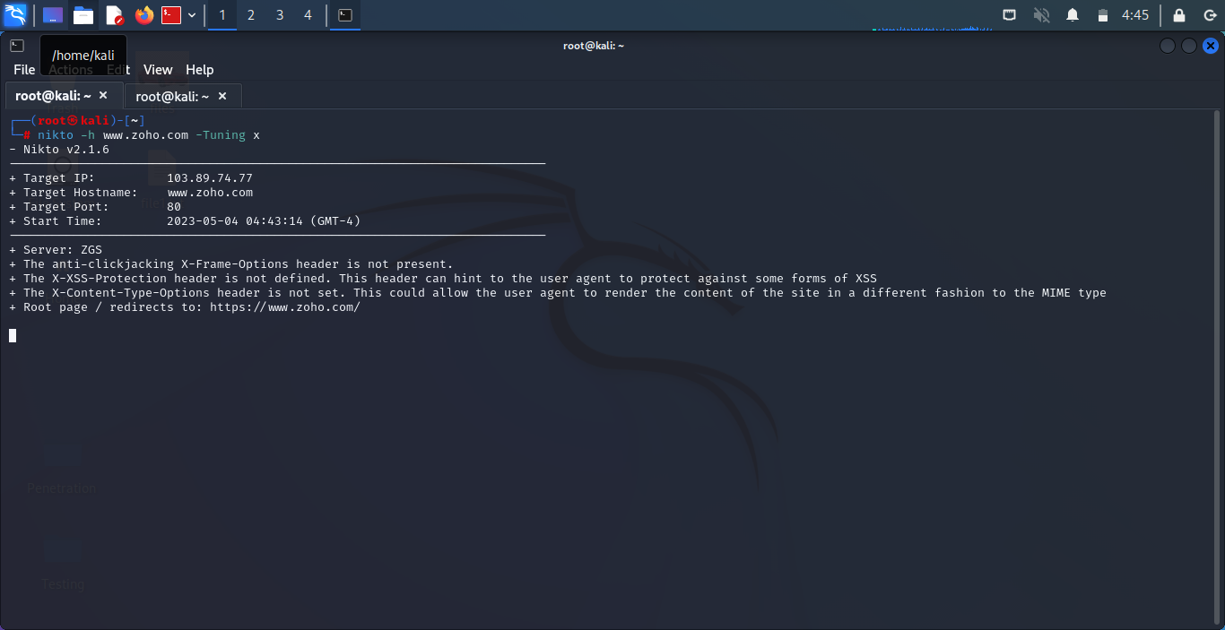

**2.nikto starts web scanning with all tuning options enabled**

**3.type nikto -h** [**www.certifiedhacker.com**](http://www.certifiedhacker.com) **-cgidirs all**

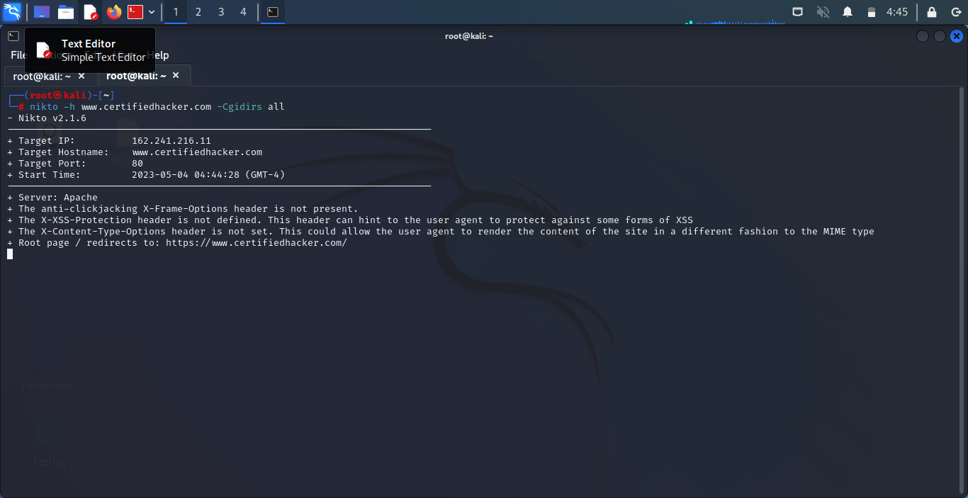

**4.Nikto will scan web server as it looks vulnerable CGI directories. It scans webserver and list of directories.**

**Result :**

Hence the Vulnerability Analysis using Nikto is Executed.