PBUtil
Functional Requirements and Design
Rev B
04/26/2010

Purpose:
The purpose of this product is the generation of a set of generic tools that allow for the preparation and matching of data between files and/or relative to constants. These tools can then be used as part of multiple applications and/or standalone.
Example: The following depicts how these utilities will be used at multiple points in the support of using UAAC data. A similar process would be used for use with ACS data.
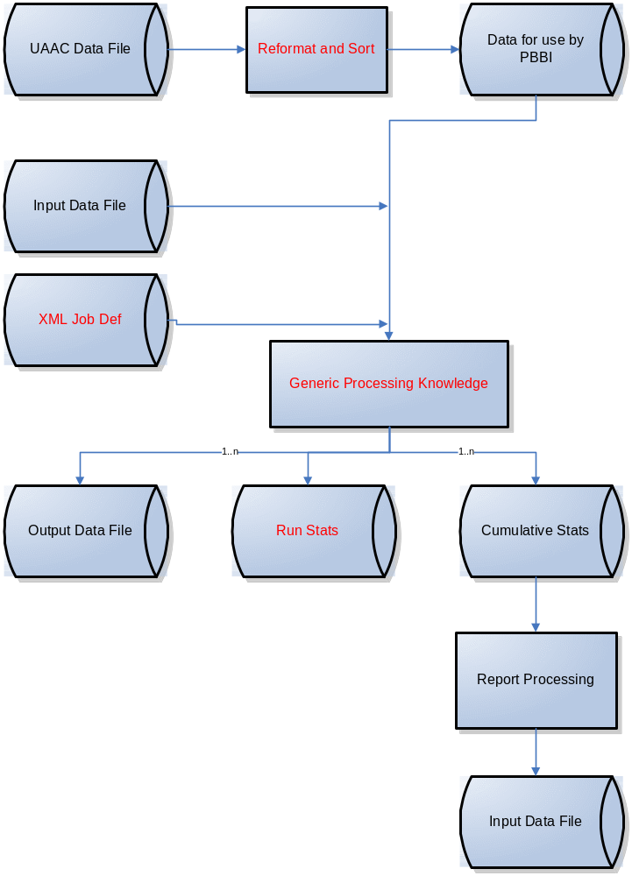

Goals / Requirements:
- Interface
  - Interactive: API interface that sets up the job details and then passes input records one at a time for processing. Allow for integration of functionality into other products and solutions
    - Returns the data as part of the API call
    - If an output file has been specified, also outputs the results to the output file
  - Batch: XML Job definition provides the detail for the job execution to be performed in Batch processing
- Data / solutions to be supported:
  - UAAC
  - ACS:
    - Sources:
      - Traditional
      - OneCode
      - Full Service Batch Files
      - Full Service – XML (not at this time)
      - Manual Returns – data captured by the mailer
    - NOTE: the idea is to pre-process all the different formats into a single fixed length, TXT format. A universal design is being worked on by MTAC 133.
- Capabilities: ability to execute a number of different capabilities. Where allowable, support multiple operations in a single execution. For example: CONVERT and SORT: converts the records and creates the output file in sorted order.
  - SORT: ability to sort extremely large files by priority of up to 5 fields.
    - NOTE/QUESTION: thought is to only have this be a BATCH operation, but could also offer via Interactive if we can think of a need.
  - CONVERT: Reorder layout of data within a record with allowance for minor modifications to the data:
    - FORMAT: Change basic file format between CSV and Fixed Length Text (NOTE: may not be a special function)
    - CASE: Change Case:
      - UPPERCASE: convert to all upper case (like: 12 MAIN ST)
      - MIXEDCASE: convert to mixed case (like: John Smith)
    - UAACDATE: convert from UAAC date format to standard date
    - JUSTIFY:
      - RIGHT: right justify the data in the field
      - LEFT: left justify the data in the field
    - ADD: Add information to the record for tracking purposes
      - STATICID: same ID for all records
      - VARIABLEID: specify initial value – will be incremented for each record
      - DATE: current date: format MMDDYYYY
    - CLEAN: removes duplicate spaces and any non-ACSII characters. Need to decide if want to do more that just this. For example, replace certain punctuation with a space.
    - COMBINE: Combine 2 fields together into a single field --- still thinking about the value and need for this.
  - DEDUP: identify and remove duplicates.
    - NOTE/QUESTION: planning to require SORT prior to DEDUP – so just comparing the fields in one record to the next
  - MATCH
    - Support up to 10 output files with their own set of match comparisons
      - NOTE/QUESTION: should it be more than 2? If a person want’s more than 2, could always re-run
    - File-to-File: Records from input file or Interactive interface compared to data in DateFile per specified parameters.
    - Support up to 10 Matching fields
      - NOTE/QUESTION: should it be more than 5?
      - NOTE/QUESTION: all matching fields will be “AND” logic. To obtain “OR” logic, use multiple passes, combine the two result files, use SORT and DEDUP to remove duplicates
    - Matching logic types to support:
      - Amount of field to used
        - Full
        - Partial
          - First X characters
          - Last X characters
          - First X words
          - Last X words
      - Logic to be used
        - Exact match
        - Fuzzy logic
          - Match level specified
        - Comparison of values:
          - = (not required, same as Exact match)
          - >
          - <
            - NOTE: can combine
          - Group: exact match to any of a set of values listed (i.e. NCOALink Footnotes 01,02, and 03)
          - NotGroup: exact match to any of a set of values not listed
  - STATS
    - Generate stats on the fields specified.
      - Track counters for each combination encountered
      - Track counters to each match (per matching requirements specified – same matching options as noted above)
- Performance:
  - Every process must be able to occur at a minimum of 2 million records per hour. Target goal is 4 million records per hour

Execution:
BATCH:
PBUTIL.EXE jobdef inputfile

INTERACTIVE:
PBUTIL_INIT: Initialize processing – set job information via XML
PBUTIL_PROCESS_RECORD: send the record for processing
PBUTIL_PROCESS_BATCH: Execute batch process defined
PBUTIL_END: Stop the interactive session
NOTE: must be able to launch multiple instances of this from a single application. For example, to allow for matching against an ACS file, followed by a Deceased file, followed by a customer’s internal file…

JobDef:
<PBUtilDef>
<VERSION>
Value to track format version – start with 1
</VERSION>
<Function1>
SORT
CONVERT
DEDUP
MATCH
STATS
</Function1>
<Function2>
Same list as above – not supported in initial release
</Function2>
<Function3>
Same list as above – not supported in initial release
</Function3>
<Function4>
Same list as above – not supported in initial release
</Function4>
<Function5>
Same list as above – not supported in initial release
</Function5>
<CopyInputToOutput>
Yes – start by copying the entire input record to the output file, then apply the defined output fields (which would allow for data to be overwritten)
No
</CopyInputToOutput>
<InputLayout>
<Format>
Fixed – fixed length. Length determined by fields defined
FixedCRLF - fixed length with a CRLF. Length determined by fields defined plus 2 characters (for CRLF)
CSV – comma separated. Number of fields determined by number defined. Length parameter ignored.
CSVCRLF – comma separated with CRLF. Number of fields determined by number defined. Length parameter ignored.
</Format>
<Field>
<FieldNumber>
Start with 1 and increment (max of 100)
<Start>
Position in the record where the field begins
<Length>
Value (maximum of 250?).
</Field>
</InputLayout>
<DataFile> /*only used with MATCH, but even optional then
Path and filename to the data file
</DataFile>
<DataLayout>/*only used with MATCH, but even optional then
<Field>
<FieldNumber>
Start with 1 and increment (max of 100)
<Start>
Position in the record where the field begins
<Length>
Value (maximum of 250?)
</Field>
</DataLayout>

<OutputLayout> (NOTE: only 1 output format even if producing multiple output files)
<Format>
Fixed – fixed length. Length determined by fields defined
FixedCRLF - fixed length with a CRLF. Length determined by fields defined plus 2 characters (for CRLF added to the end of each record)
CSV – comma separated. Number of fields determined by number defined. Order based on Start position. Length parameter ignored.
CSVCRLF – comma separated with CRLF. Number of fields determined by number defined. Order based on Start position. Length parameter ignored.
</Format>
<Field>
<FieldType>
Input1 – Input File Field 1
Input2 – Input File Field 2
…
Input100 – Input File Field 100
Data1 – Data File Field 1
Data2 – Data File Field 2
…
Data100 – Data File Field 100
Date – today’s date MMDDYYYY
MatchLevel – 3 digit percentage. 100% indicates a perfect match. Below 100% represents the fuzzy logic score.
Static /*same value in every output records
<CStatic> string </CStatic>
Variable /*incremented with each output record
<CVariable> initialvalue </CVariable>
</FieldType>
<Start>
Position in the record where the field begins
</Start>
<Length>
Value <= the Maximum Allowed Field length for the specified field as described later in this document
</Length>
<Fill> /* not sure that this is really needed
Populate with X (left justified, rest of field blank). This can be used add identification of the logic or database used to obtain the match.
</Fill>
</Field>
<SORT>
<OutputFile>
Path and filename to the output file
</OutputFile>
/* Format of output file is the same as the input
<SortField1>
<SortFieldNumber> 1..100 </SortFieldNumber> /*Number of the input File Field
<Direction>
Ascend – sort in ascending order
Descend – sort in descending order
</Direction>
<SortField2> </SortField2> \
<SortField3> </SortField3> \ Support up to 5 fields. Sorts occur in
<SortField4> </SortField4> / order from field 1 -> 5
<SortField5> </SortField5> /
</SORT>
<CONVERT>
<OutputFile>
Path and filename to the output file
</OutputFile>
<Conversions>
<Field>
<CField>
input field 1..100
</CField>
<CAction1>
NONE (used when just rearranging data fields)
UPPERCASE
MIXEDCASE
UAACDATE
JUSTIFYRIGHT
JUSTIFYLEFT
CLEAN
/* other functions to be added in the future
</CAction1>
<CAction2> </CAction2> \ Support up to 5 actions,
<CAction3> </CAction3> \ processed in order.
<CAction4> </CAction4> /
<CAction5> </CAction5> /
</Field>
</Conversions>
</CONVERT >
<DEDUP> /* output file in same format as input
<OutputFile>
Path and filename to the output file
</OutputFile>
<DSortation>
Yes – file is sorted by order of Detect fields
No – file is not sorted
</DSortation>
<Detect> (list fields to used in comparison to identify duplicate records. To dedup on the entire record, just define the entire record as 1 field).
<Field>
<DField>
input field 1..100
</DField>
</Field>
</Detect>
<Use> /*when duplicate found per detect field, how to determine which record to keep
<DField1>
<DField>
input field 1..100
</DField>
<DFactor>
Highest - (number / string value)
Lowest - (number / string value)
Newest – date
Oldest - date
</DFactor>
</DField1>
<DField2> </DField2> \
<DField3> </DField3> \ Support up to 5 decision fields.
<DField4> </DField4> / Checked in order. If still
<DField5> </DField5> / identical – keep either one
</Use>
</DEDUP >
<MATCH>
<MatchFile1>
<OutputFile>
Path and filename to the output file
</OutputFile>
<MatchLogic1>
<MatchingType>
INPUTtoDATA – input field to data field
INPUTtoValue – input field to a defined value
DATAtoValue – data field to a defind value
</MatchingType>
<InputField> /* if applicable
<INumber> 1..100 </INumber>
<IPortion>
?? best way to specify
          - Full
          - Partial
            - First X characters
            - Last X characters
          - First X words
          - Last X words
</IPortion>
</InputField>
<DataField> /* if applicable
<DNumber> 1..100 </DNumber>
<DPortion>
?? best way to specify
          - Full
          - Partial
            - First X characters
            - Last X characters
          - First X words
          - Last X words
<DIPortion>
</DataField >
<MatchValue> string </MatchValue> /* if applicable
<Logic>
?? best way to specify TBD
Exact – exact match (or fuzzy of 100%)
Fuzzy logic
< MinimumScore > % </MinimumScore>
Comparison for input to Data Field or MatchValue:
= (not required, same as Exact match)
> \
< \_NOTE: can combine on one field
Group: exact match to any of a set of values listed (i.e. NCOALink Footnotes 01,02, and 03)
NotGroup: exact match to any of a set of values not listed
</Logic>
</MatchLogic1>
<MatchLogic2> </MatchLogic2> \ Support up to 5 matching
<MatchLogic3> </MatchLogic3> \ parameters. Assumption is
<MatchLogic4> </MatchLogic4> / that the data file is sorted by
<MatchLogic5> </MatchLogic5> / the matching logic fields to
facilitate performance
</MatchFile1>
<MatchFile2> </MatchFile2> \ Support up to 5 output files with
<MatchFile3> </MatchFile3> \ different matching logic in a
<MatchFile4> </MatchFile4> / single pass
<MatchFile5> </MatchFile5> /
</MATCH>
<STATS>
<OutputFile>
Path and filename to the output file
</OutputFile>
/* Format of output file is the same as the input
<StatField1>
<Field> /* supports up to 5 fields per StatField
<StatFieldNumber> 1..100 </SortFieldNumber> /*Number of the Input File Field
</Field>
</StatField1>
<StatField2> </StatField2> \
<StatField3> </StatField3> \ Support up to 5 sets of stats fields.
<StatField4> </StatField4> / Reported in order from field 1 -> 5
<StatField5> </StatField5> /

</STATS >
</PBUtilDef>
Completing the UAAC Solution:
UAAC Date Preparation:
Utilize PBUtil on the UAAC data received:
CONVERT: the UAAC data:
- date to a regular format date
- data to allow for faster search of multiple fields
SORT: after using CONVERT to re-arrange the data.

Execution:
Looking to implement the option that will have the best performance
OPTION 1: Create a wrapper around the PBUTIL that will:
- take in the same JobDef to use to initialize the PBUtil
- utilize the interactive interface
  - Read in the Input data
  - Pass interactively (allowing {PBUtil to create the output file
  - Use the data returned interactively to develop the necessary billing reports
OPTION 2:
Use the PBUtil to do the processing.
Create a Reporting Utility that takes the output file to develop the necessary billing reports

From Kathy’s document Friday – for further discussion:
- It should track the source that it matched on
- A report should be generated to show the number s of records read from the master, the matching file and number of matches. A breakdown by matching confidence would also be nice but not mandatory for the first release.
- A parameter should also be available to set a flag on the customers original input file. If the customers allows us to set this we will add the date matched, new address and name (in CASS format), source of match and confidence level of match.
- All output records should be standardized to receive mailing discounts.
- This module has to be able to integrate into the existing systems , so the customer only has to do one pass of the input file. We do not want the customers to have to cycle through their files more than once.
  - OK – with INTERFACE, but not with batch (initially)

