Software requirement specification (SRS) document template:



Review history



Approval history

Project name:

pharmacy online website

Date: 26-03 Version:

By: Jude Khalil 1123092 - Mariam Karbala 1123320 - Marwa Hawi 1123201



Revision history

|  |  |  |  |
| --- | --- | --- | --- |
| Version | Author | Version description | Date completed |
|  |  |  |  |

|  |  |  |  |
| --- | --- | --- | --- |
| Approving party | Version approved | Signature | Date |
|  |  |  |  |
|  |  |  |  |
|  |  |  |  |
|  |  |  |  |

|  |  |  |  |
| --- | --- | --- | --- |
| Reviewer | Version reviewed | Signature | Date |
|  |  |  |  |
|  |  |  |  |
|  |  |  |  |
|  |  |  |  |

# Table of contents



1. Introduction
   1. Product scope
   2. Product value
   3. Intended audience
   4. Intended use
   5. General description

2 Functional requirements

1. External interface requirements
   1. User interface requirements
   2. Hardware interface requirements
   3. Software interface requirements
   4. Communication interface requirements
2. Non-functional requirements
   1. Security
   2. Capacity
   3. Compatibility
   4. Reliability
   5. Scalability
   6. Maintainability
   7. Usability
   8. Other non-functional requirements

5 Definitions and acronyms

Introduction



1

Describe the purpose of the document.

The purpose of the online pharmacy website is to serve the customer and healthcare providers. It achieves convenience, accessibility and availability . It also ensures more options ( not only medication but also beauty products , healthcare products..) . In addition it’s a global reach , and provides reliable information and support.

* 1. Product scope

List the benefits, objectives, and goals of the product.

GOALS:

1. **Improve Medication Access** : Make prescription easily available to people.
2. **Enhance Convenience** : Allow users to order medicines anytime, anywhere, without visiting a physical store.
3. **Reduce Costs** : Offer pricing through lower operational costs compared to in-store pharmacies.
4. **Ensure Safety & Compliance** : Provide FDA-approved or legally regulated medications with proper prescriptions.
5. **Promote Health Awareness** :Educate customers through drug information and blogs. consultations.
6. **Support severe Disease Management** : Enable auto-refills, reminders, and subscription services for long-term treatments.
7. **Integrate Telehealth Services** : Can do a consultations with online doctors.
8. **Expand Market Reach** : Serve a global audience, especially for rare or specialty medications.
9. **Streamline Insurance & Payments** :Offer digital insurance claims, flexible payment options, and discounts.

BENEFITS:

Customer:

1. 24/7 Availability: At any time, you can place your order .
2. Home delivery: Saves time and effort especially for elder people.
3. Wider selection: Access to rare medications
4. Price comparison: the customer can compare the price of drug and choose the suitable.

**Pharmacy Businesses:**

1. **Lower Overhead Costs: There is no need or store rent and payments and no need for employees since it’s an online store.**
2. **Broader Customer Base: Reach patients and customers globally.** 
   1. Product value

Describe how the audience will find value in the product.

The audience will find this product convenient and time-saving and too many more benefits as mentioned , and it helps the elder people mostly , since they can not go to in-stores pharmacies for that this product will ease their life and save time and efforts . In addition to pharmacy owners it reduces cost and employees .

Intended audience

Write who the product is intended to serve.

The online pharmacy website is intended to serve : patients (elder people especially benefit from this product ), caregivers which means birth givers , healthcare providers, and even pharmacy businesses since it is **convenient , affordable , accessible, and enhances healthcare support as mentioned above** .

Intended use

Describe how will the intended audience use this product.

First of all the audience (elder people ,caregivers, patients in general) will sign in or log in to their accounts , and search for their own needs(medications , drugs , skin-care products , beauty product) they can use the search button to ease the process and do the sort category ( may be sorted by price , alphabetic order , oldest , newest…) then when they find the suitable product and add to cart , they have the access to view their cart and delete products . After that , they can place their order and apply the payments by PayPal , credit card , cash , checks… . At the end they will receive their order by delivery .

Give a summary of the functions the software would perform and the features to be included.

* 1. General description

Online pharmacy website is made to ease the shopping process on people in general , the functions the software will perform are : **User Management ,search and recommendation system ,Medication Sourcing,Order Fulfillment, Payments and Providing security and insurance.**

**Each function has a specific feature to do , will be explained in the functionality part.**

# Functional requirements



2

List the design requirements, graphics requirements, operating system requirements, and constraints of the product.

User management :

The user will sign in to create an account , or if there is an existing account , the user will log in . the user has the opportunity and access to search for a medicine , product , add , delete .

In addition user can update his profile .

**search and recommendation system:**

**the website gives the user suggestions and recommendations upon his history .**

Medication resourcing :

Checks if the medicine or product is available and if it should be restocked nearly .

Lists a drugs or medicines that are the same but differs in price , ingredients …

Order fulfillment :

User have the access to view their cart and place the order , and should give his personal details (name , address , email , phone number…) for the delivery .

Users can track the delivery.

Payments:

how payments should be done (PayPal , cash , check …)

Security :

The website should be safe for users by using different ways for security( Two-authentication verification…).

Notifications:

When an item is out of stock , the website sends a message or a notification to the user that its re-stocked.

External interface requirements



3

Describe the logic behind the interactions between

the users and the software (screen layouts, style guides, etc).

* 1. User interface requirements

User interface requirements play a vital role in defining how users interact with the system, ensuring both usability and efficiency.

**1-Dashboard Screen**

* **Provides an overview of the pharmacy operations.**
* **Interaction Logic:**
  + **Display active prescriptions, inventory status, and sales.**
  + **Quick access to common tasks (e.g., dispensing, medication search).**
  + **Real-time updates and notifications (e.g., low stock alerts).**

List the supported devices the software is intended

to run on, the network requirements, and the communication protocols to be used.

**1-Desktop and Laptop Computers**

**Windows (Windows 10/11 or higher)**

**macOS (Latest version)**

**Linux (Popular distributions like Ubuntu, CentOS)**

**Browser Support:**

* + **Google Chrome**
  + **Microsoft Edge**
  + **Safari (for macOS)**

**2. Network Requirements:**

**Internet Connection(wifi)**

**3.Communication Protocols:**

* **MQTT (Message Queuing Telemetry**
* **Transport)**

* 1. Hardware interface requirements

List any requirements for the communication programs your product will use, like emails or embedded forms.

1. Email Communication Requirements

Email communication is essential for various operations, such as notifying staff about prescription statuses, alerts for inventory or stock levels, patient notifications, and system updates.

* To send automated and personalized emails (e.g., prescription status updates, payment receipts, reminder notifications).
* **Requirements**:
  + Customizable email templates for different communication scenarios.
  + Dynamic fields that can be populated with patient information, medication details, and prescription statuses.
  + Support for rich-text formatting (HTML) for better presentation of content (e.g., invoices, prescriptions).
  + The ability to send bulk emails to multiple recipients for notifications (e.g., system updates or scheduled pharmacy hours).
  1. Software interface requirements

Include the connections between your product and other software components, including frontend/backend framework, libraries, etc.

1-Communication interface requirements

**Push Notifications (for Mobile Apps)**:

**Push Notification Service**: Integrate with **Firebase Cloud Messaging (FCM)** for Android and **Apple Push Notification Service (APNs)** for iOS.

**Real-time Alerts**: Push notifications for real-time updates (e.g., prescription status, inventory alerts).

2-**In-App Messaging**

* **Real-time Messaging**: Implement real-time chat or messaging features within the application for communication between pharmacy staff and patients (e.g., clarifications, prescription inquiries).
* **Secure Messaging**: Ensure messages are encrypted and comply with privacy regulations
* **File Attachments**: Support the sending of prescription images or other documents through the messaging interface.

# Non-functional requirements



4

Include any privacy and data protection regulations that should be adhered to.

* 1. Security

**Patient Data Protection**: All patient data (e.g., health records, prescription information) must be stored and product privacy ; **Access Control** only authorized personnel should have access.

Describe the current and future storage needs of your software.

* 1. Capacity

To fit patient requirements, scalable cloud storage and database solutions should be employed, ensuring that the system can meet both current and future demands for secure, reliable, and high-performance data storage.

List the minimum hardware requirements for your software.

* 1. Compatibility

The hardware requirements for the pharmacy software range from **basic minimums** for client devices (e.g., desktops, laptops, and mobile devices).

Calculate what the critical failure time of your product would be under normal usage.

* 1. Reliability

• Assuming the software is used regularly in a **24/7** operation, we will aim for **MTBF** (Mean Time Between Failures ) to be very high, for instance, **6 months**.

• In hours, **6 months** = **6 × 30 days × 24 hours** = **4,320 hours**.

Calculate the highest workloads under which your software will still perform as expected.

• MTBF = **4,320 hours**.

Describe how continuous integration should be used to deploy features and bug fixes quickly.

* 1. Scalability

For a pharmacy software system, continuous integration will be critical for ensuring that new features, improvements, and bug fixes are deployed efficiently without interrupting the user experience or the availability of the software.

• **Unit Tests**: Write unit tests for each feature or bug fix. These tests should cover both the backend (e.g., prescription processing, data handling) and frontend components (e.g., user interface responsiveness, input validation).

• **Scalability**:

* CI pipelines are easily scalable, allowing the software development process to grow with the software system. As the software adds more features and users, the CI pipeline can be extended to handle more complex tests and deploy to additional environments without interrupting the workflow.
  1. Maintainability

Describe how easy it should be for end-users to use your software.

**Maintainability**  which software can be updated, fixed, improved, and adapted over time to meet evolving requirements. In the context of pharmacy software, maintaining the system involves tasks such as fixing bugs, adding new features, ensuring regulatory compliance, and updating for performance improvements. Ensuring that the software remains maintainable is crucial for long-term success, as it reduces downtime, enhances efficiency, and ensures that new features can be quickly integrated without significant disruption.

* 1. Usability

• **Usability is a critical aspect of pharmacy software that directly impacts efficiency, accuracy, and user satisfaction ,by focusing on a user-centered design, ensuring easy navigation, providing clear feedback, and offering customizationoptions.**

**For example :**

**Mobile-Friendly Interfaces**: Given that pharmacy staff might work on the go or from different locations (e.g., multiple branches), ensure the software is mobile-friendly or has a dedicated mobile app for easy access to prescriptions, patient data, or inventory management.

List any additional non-functional requirements.

* 1. Other

Feasibility study:

Phase 2 – Diagrams:

Software engineering.

Pharmacy online website .

Members:

Jude Khalil 1123092 - Mariam Karbala 1123320 - Marwa Hawi 1123201

Use case / activity diagrams / class diagram / data-flow diagrams (context diagram – level-0 dfd).

|  |
| --- |
| Pharmacy online website |

Activity diagram : 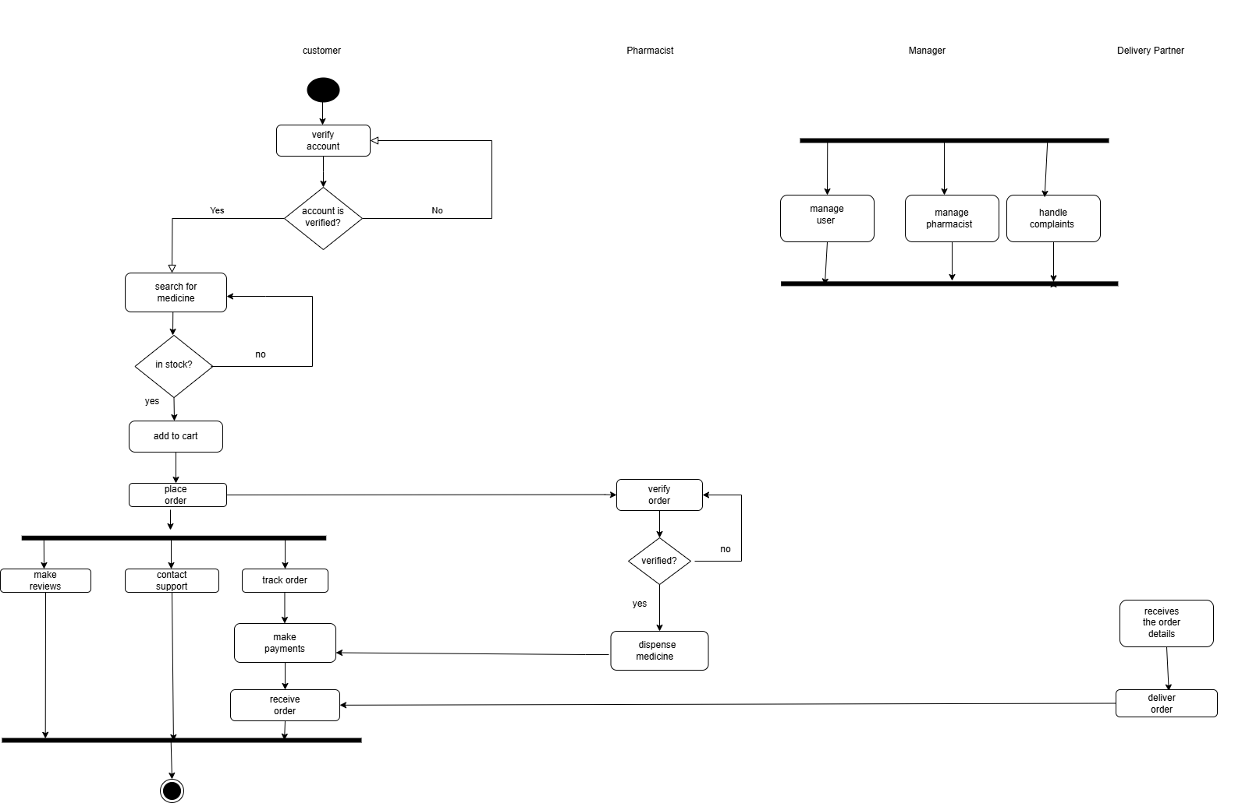

Class diagram:

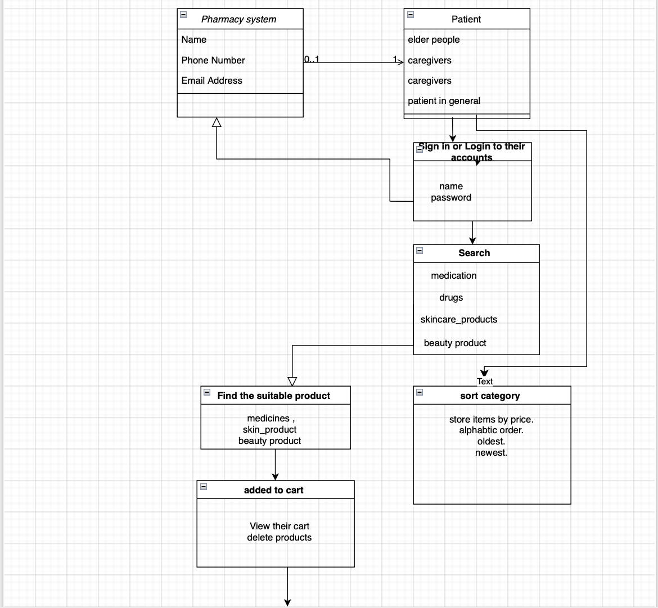

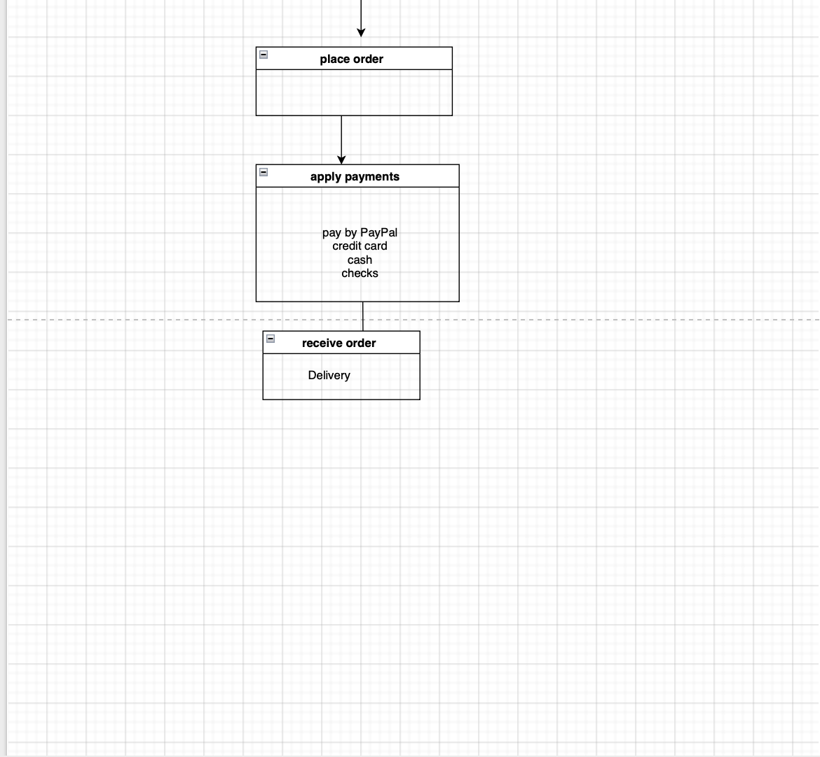

Data flow :

Context diagram:

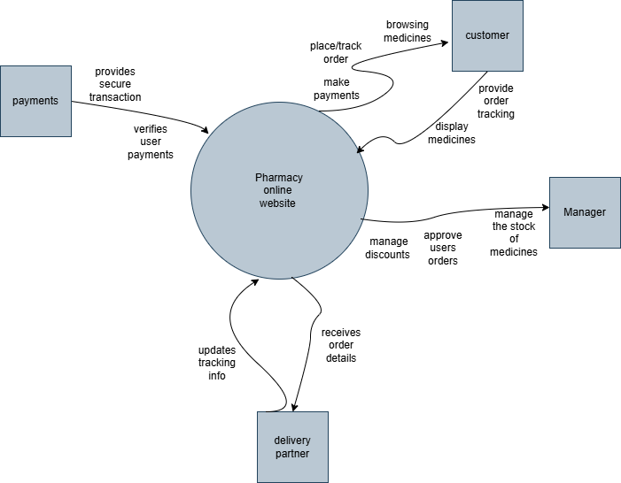

dfd-level-0:

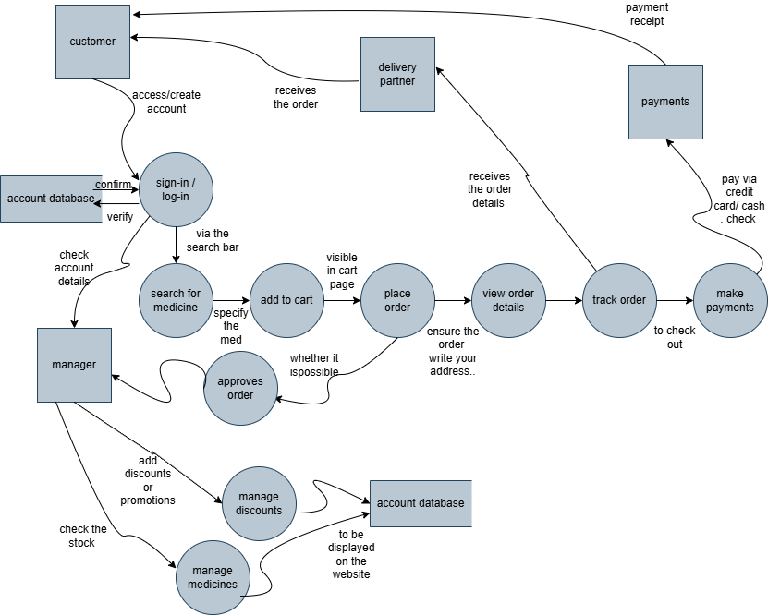

Phase 3:

Jude Khalil

Mariam Karbala

Marwa Hawi

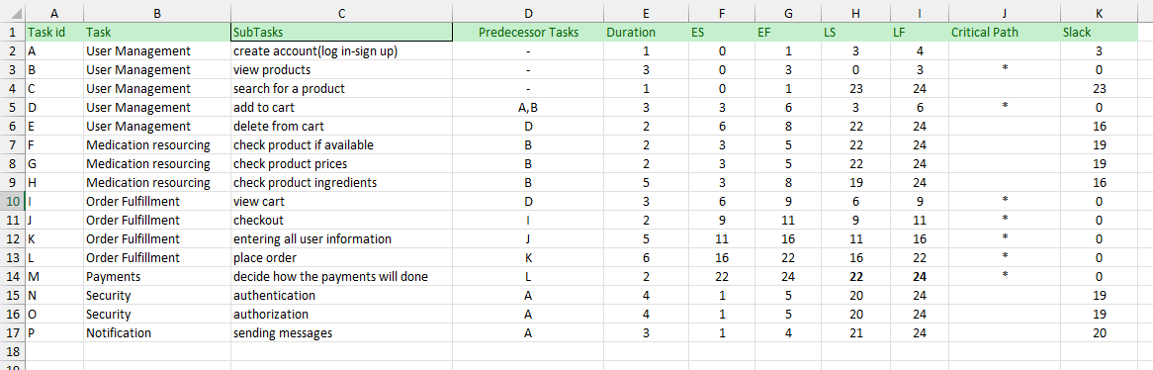

Pert Chart:





GANTT CHART:



Orange: non-critical tasks

Grey: critical path