John Judge

Alessandro Sarra

Assembly Language Programming

2/18/16

Exercise 03 Documentation

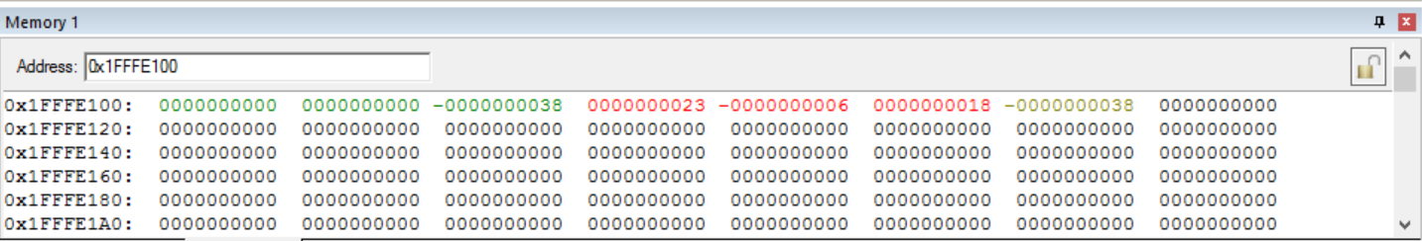

Figure (1.0): Result of Input Set One

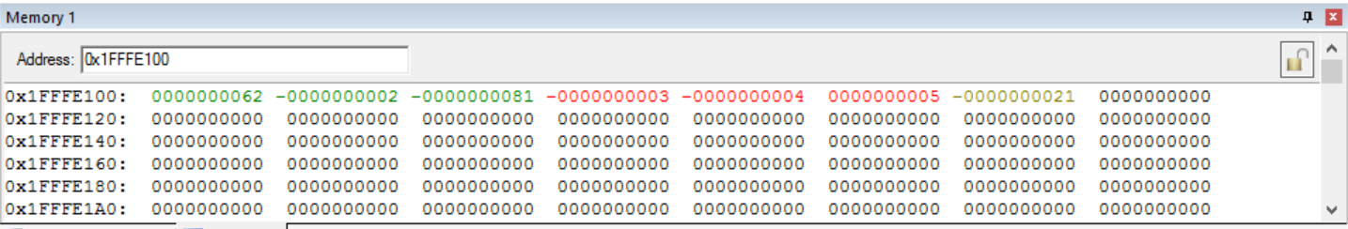

Figure (1.1): Result of Input Set Two

1. It is possible to reduce the chance of overflow by ignoring the order of operations when solving for *F*, *G, H*, and *Result* but it is impossible to eliminate the chance of overflow. Instead the chance of overflow is dependent on the variables. Not the order of operations.

In certain situations, such as solving for *F* when $P=64 and Q=2$, if order of operations is ignored it may result in the equation not overflowing when it normally would but instead overflowing when the normal order of operations wouldn’t. Consider the following example when making the substations above.

$$F=2\left(64\right)-3\left(2\right) Eq. (1.1)$$

When preforming addition and subtraction first the overflow that $2\left(64\right)=128$ would result in is eliminated. However, when then multiplying in the next step $244=2\left(61\right)2$ results in overflow.

What this example proves is that order of operations is not the primary cause of overflow. Instead, the chance of overflow is dependent on the variables. Order of operations will not eliminate the chance for overflow in all situations. The only way the chance of overflow can be eliminated is by changing the order of operations case by case depending on the sign and magnitude of the variables.