**CMPE-250 Laboratory Exercise Five**

**Polled Serial I/O**

By submitting this report, I attest that its contents are wholly my individual writing about this exercise and that they reflect the submitted code. I further acknowledge that permitted collaboration for this exercise consists only of discussions of concepts with course staff and fellow students; however, other than code provided by the instructor for this exercise, all code was developed by me.

John Judge

Performed 2/25/16

Submitted 3/3/16

Lab Section 02

Instructor: Dr.Shaaban

TAs: Peter Muller

Stephen Moore

Connor Goss

Lecture Section 01

Professor: Allesandro Sarra

**Documentation**

1. The exact memory range of the executable code in the memory map was between the base address of 0x00000000 and 0x00000410 of ROM. This was found in the memory map produced by the program.

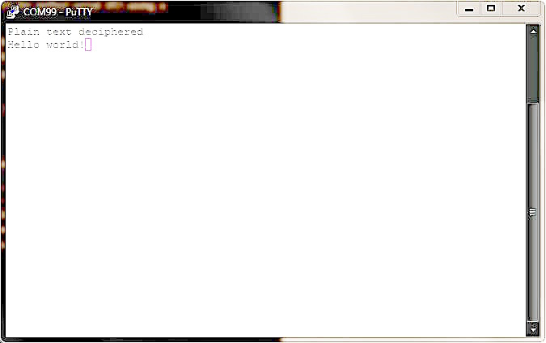

Figure 1.1: Capture of Console Output