**CMPE-250 Laboratory Exercise Seven**

**Circular FIFO Queue Operations**

By submitting this report, I attest that its contents are wholly my individual writing about this exercise and that they reflect the submitted code. I further acknowledge that permitted collaboration for this exercise consists only of discussions of concepts with course staff and fellow students; however, other than code provided by the instructor for this exercise, all code was developed by me.

John Judge

Performed 3/17/16

Submitted 3/31/16

Lab Section 02

Instructor: Dr.Shaaban

TAs: Peter Muller

Stephen Moore

Connor Goss

Lecture Section 01

Professor: Allesandro Sarra

1. As seen below in Figure 1.0, the program was tested and the code executed as desired. In the first case, a dequeue command was operated on an empty queue resulting in a failure. Next, four successful enqueue commands took place followed with the in pointer changing respectively. This was followed by an unsuccessful enqueue since the queue was then full. A successful dequeue operation took place and the out pointer changed respectively. The queue was then printed and then the status command and the help command were assured to be correct. Several other tests also occurred, which are not pictured, the results of all of the tests ensured the program had been implemented correctly.

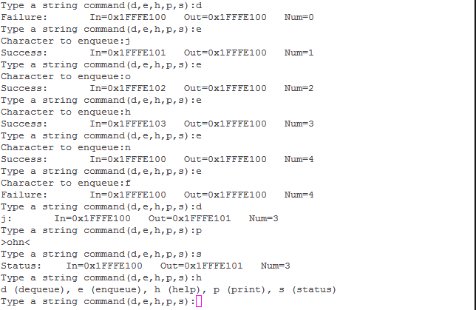

Figure 1.0: Results of program

1. Following the test of the program the memory map of the program was examined. A capture of the memory map file can be seen in Figure 1.2. From the memory map it was concluded that the executable range of the code was between 0x00000000 and 0x000008b8. The range for the constants was between 0x00000204 and 0x000002B4. Within RAM the queue record structure could be found between 0x1fffe104 and 0x1fffe118. The queue buffer could be found between 0x1fffe100 and 0x1fffe103.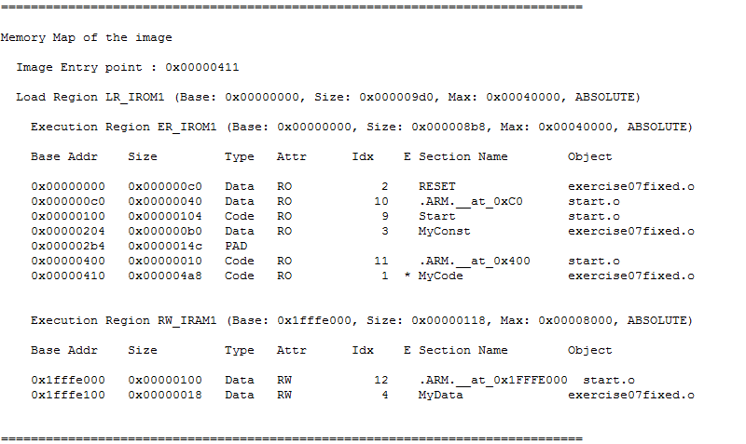

Figure 1.1: Memory Map of Program