**CMPE-250 Laboratory Exercise Nine**

**Serial I/0 Driver**

By submitting this report, I attest that its contents are wholly my individual writing about this exercise and that they reflect the submitted code. I further acknowledge that permitted collaboration for this exercise consists only of discussions of concepts with course staff and fellow students; however, other than code provided by the instructor for this exercise, all code was developed by me.

John Judge

Performed 4/7/16

Submitted 4/14/16

Lab Section 02

Instructor: Dr.Shaaban

TAs: Peter Muller

Stephen Moore

Connor Goss

Lecture Section 01

Professor: Allesandro Sarra

1. The results of the program are shown in Figure (1.0). The program ran as expected and the results matched the desired outputs. During the testing the program as tested by using uppercase and lowercase commands. The queue operations were tested on an empty queue, partially full queue, full queue, and a queue that required a circular buffer operation. Each of the results matched the expected results.

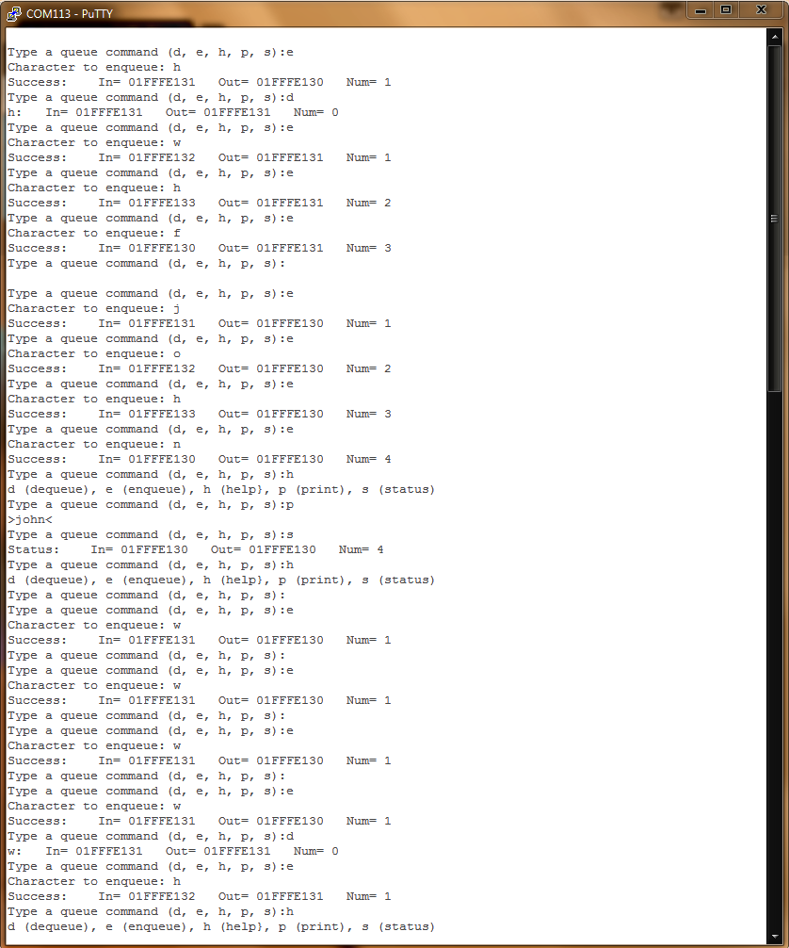

Figure (1.0): The results of the program

1. Following the test of the program the memory map of the program was examined. From the memory map it was concluded that the executable range of the code was between 0x00000410 and 0x00000927. The range for the constants was between 0x00000204 and 0x000002C7. Within RAM the program queue buffer could be found between 0x1fffe130 and 0x1fffe133 Its record structure could be found between 0x1fffe1034 and 0x1fffe14b. The receive queue can be found between 0x1fffe100 and 0x1fffe103 and its record structure between 0x1fffe104 and 0x1fffe11c. The transmit queue can be found between 0x1fffe118 and 0x1fff411b and its record structure can be found between 0x1fffe11c and 0x1fffe133.