John Judge

Dr. Rommel

Circuits 1

2/20/12

Prelab Exercise 02

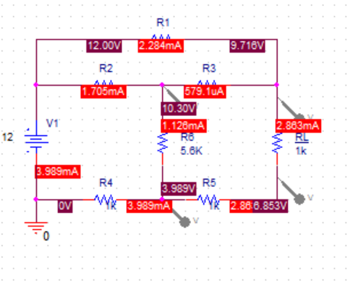

Figure 1: Circuit Schematic with Voltage and Current Markers