The Two Faces of Bureaucratic Policymaking

May 16, 2019

Administrative rulemaking is often presented as a straightforward translation of legislative delegations into agency rules, where bureaucrats adopt their most preferred policy given their constraints, often speeding up or slowing down the policy process to do so. The rulemaking process is indeed highly formulaic, requiring publication of a draft, external review, and public comment before a final rule is published. However, much of the politics of rulemaking may play out in the less formal and transparent process before a draft policy is published. In this stage, different priorities and constraints may drive decisions about which draft policies are published and when. Theories of policymaking suggest that the politics of rulemaking may differ significantly in the pre-proposal stage. Yet, this part of the policy process has largely eluded quantitative study due to a lack of systematic data. This paper begins to fill this gap. We introduce a new dataset based on thousands of monthly internal project status reports by the U.S. Department of Transportation that allow us to track a rulemaking effort from its origin date through its finalization. Additionally, we develop several novel measures of prioritization and constraints that we measure both before and after a draft rule is made public, including the degree of agency resource constraints, internal agency prioritization, changes in sub-agency political appointees, congressional and presidential attention, and the threat of litigation and sanction by courts. Using these new data and measures, we model the drivers of prioritization and constraint as a multi-stage policy process and identify different political forces at work in each stage. Specifically, we use a multi-stage duration model to test factors that may affect the timing of rules being proposed or finalized thus identify predictors of prioritization and delay. Previous research suggests that that greater internal agency resources—in terms of personnel and budgets—will speed up rulemaking during the largely opaque pre-proposal stage, while attention from external actors, including Congress and the president, will speed up rulemaking during the more transparent notice and comment period. Our data and measures allow new tests of these theories. We show that resources, complexity, and salience have different effects on the speed of rule-writing across different stages. Our findings hold important implications for our understanding of transparency and bureaucratic policymaking within a representative democracy.

# Introduction

Rulemaking is important…

Scholars have thus far focused on the second, more transparent phase of rulemaking after proposed rules are published…

Yet much happens before proposed rules are published…

We address this gap.

We make three contributions: - We describe when and why rulemaking projects get started, providing the first systematic analysis into how long it takes to write a rule. - We compare the factors that influence the fate of a rulemaking project before and after an NPRM is published. - We assess why rulemaking projects move slower or faster at pre- and post- NPRM stages.

In doing so, we make several methodological contributions. First, we apply multi-state duration modeling to policymaking. Most policy processes involve multiple stages marked by important transitions, such as the publication of a draft or approval of different branches of government, but empirical work rarely models policymaking as a multi-stage process. Furthermore, we develop a suite of new, more refined measures of factors hypothesized to influence agency policymaking, including agency resources and leadership, congressional attention and opposition, and the threat of litigation.

# The rulemaking process

Scholars of bureaucratic policymaking have long sought to explain why agencies choose to write rules, the fate of these initiatives, and how long it takes.

## Why agencies write rules

## The fate of rulemaking projects

## The duration and timing of rulemaking

# Data and Methods

## Data

We combine a large dataset on all rulemaking processes cited in the Unified Agenda or by the Office of Information and Regulatory Affairs with a smaller dataset of over 350 Department of Transportation rules about which we have collected extremely detailed information extending before the publication of an NPRM. These data come from monthly internal rulemaking status reports that DOT.

# Hypotheses

Presidential transitions increase the likelihood of withdrawal in both pre- and post- NPRM stages, i.e., compared to publication of an NPRM or publication of a final rule given that an NPRM has been published.

Agencies with more resources per rule are more likely to finish proposed and final rules on time. Specifically, agencies with more policy-level staff per rulemaking project are more likely to deliver rulemaking documents to the Office of the Secretary and the White House for review and ultimately publish documents on time.

# Results

## Reasons for rulemaking

(descriptive statistics)

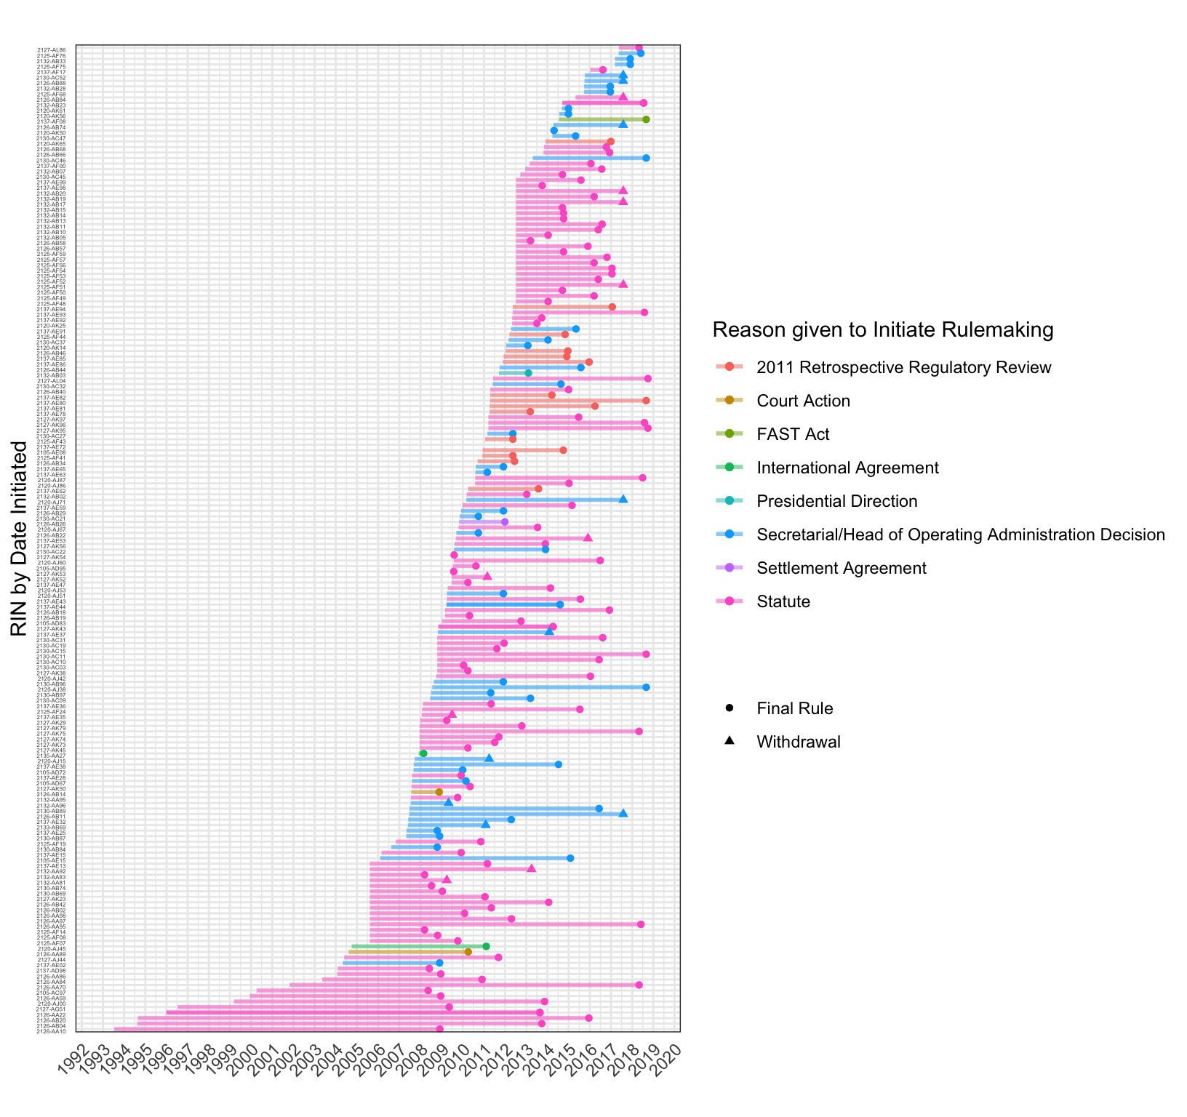

Rulemaking projects completed 2008-2018 by Prompting Reason

## Causes of delay

(descriptive statistics)

[Rulemaking projects completed 2008-2018, Reasons given for Delay](Figs/completion-time-by-delay-1.png)

## Factors that affect the fate of a rulemaking project

(models)

### Publication or withdrawal

Rulemaking projects may ultimately result in a final rule being published or the project being withdrawn. However, most final rules in our data first had a draft rule, known as a Notice of Proposed Rulemaking or NPRM published. An agency may terminate or withdraw a rulemaking project before or after the draft is published. We thus consider three possible outcomes in the first stage of the policy process: publication of a draft rule, withdrawal, and, very rarely, publication of a final rule without a draft. For rules that reach the post-NPRM stage, there are two outcomes: publication of a final rule or withdrawal.

#### External political pressure

[] (Figs/mstate-presidential-transitions-fate-1.png)

[] (Figs/mstate-congress-attention-fate-1.png)

[] (Figs/mstate-congress-opposition-fate-1.png)

### Publication on time

We now consider the outcome of being published “on time” according to the agency’s own timeline. The transitions of interest are an on-time NPRM publication, a delayed NPRM publication, an on-time Rule publication, and a delayed rule publication. Withdrawal at each stage is also possible, leading to three possible outcomes at each stage.

[] (Figs/mstate-ontime-fate.png)

Expanding on this model, we consider additional transitions that most rulemaking projects go through at each stage, delivery to the Office of the Secretary and the Office of Management and Budget.

[] (Figs/mstate-ontime-OST-OMB-fate-1.png)

## Factors that affect the speed of the policy process

#### External political pressure

[] (Figs/mstate-presidential-transitions-rate-1.png)

[] (Figs/mstate-congress-attention-rate-1.png)

[] (Figs/mstate-congress-opposition-rate-1.png)

#### Rule complexity

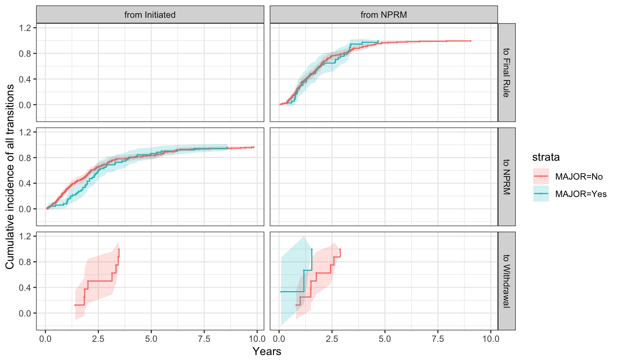

How quickly major and non-major DOT rules advance from each stage to the next

[] (Figs/mstate-has-ANPRM-rate-1.png)

# Discussion

# Conclusion