* I felt as if there should have been an option for me to also add a plant via the catalogue, not just camera and survey
  + What if I already know that plant I have?
  + I shouldn’t have to go through a redundant plant identification process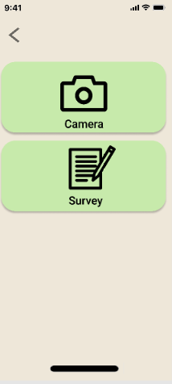
* Maybe the background should be darkened more when the menu button is pressed on the “Plant List”
  + The “Add new plant” and button and to a lesser extent, the “catalogue” button are a little hard to see because of the background

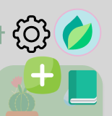

* Should the settings design better match the rest of the design?
  + Also, I feel like the text for version of the app is too big
  + Shouldn’t the languages in the language change be in their respective languages? (like Francais, Espanol)

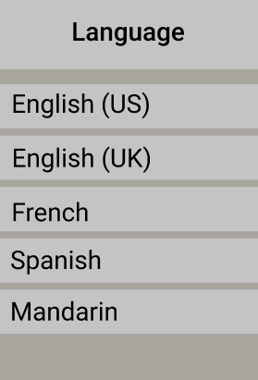

* + Is the gear on the settings screen centered?

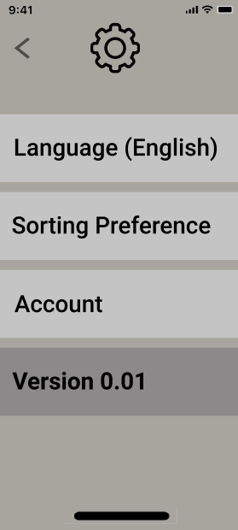

* I feel like the progress circle within the water droplet on the “My plant Info Page” makes it a bit too cluttered
  + Number in the droplet enough?
  + 
* The text for set reminders and health status on “My plant Info Page” is hard to see before scrolling down



* + I’m noticing that this may just be an issue that varies from screen to screen because on one monitor it is clear, but on another, it is a bit difficult to read
* Dia plant info page has no back button in top left

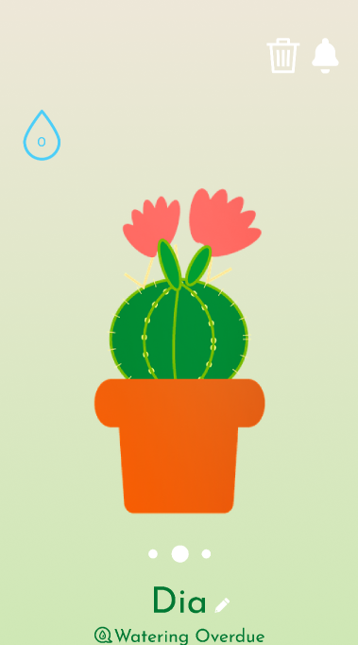

* Went to camera to add plant -> clicked best match for more info -> went to plant info page -> clicked back button -> brought me back to My Plant List
  + Should bring back to results of camera
* No way exit out of setting a reminder without submitting a new reminder

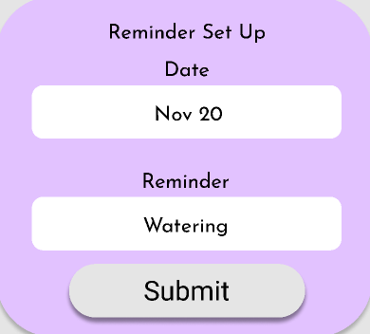

* I think the whole “Update Status Button” in journal should be clickable, not just the icon



* No way exit out of submitting a new journal entry without submitting a new journal entry

