**Flow Analysis**

The final IDEO card that we decided to implement was flow analysis. From the information gathered using the survey and questionnaire and scenarios methods, we were able to imagine possible paths that users would take when using the application, and represent it in a process flow. While creating the process flow, we were able to identify potential bottlenecks with the design we originally had in mind, as well as catch bits of information and data that may have been overlooked at first. However, the biggest benefit to this method was that creating a process flow from the information we gathered via the other two IDEO cards allowed us to gain further insight into when, where, and how people may use the app. This in turn enabled us further streamline the application as we now had a better idea as to what features were essential, and what features were more trivial.

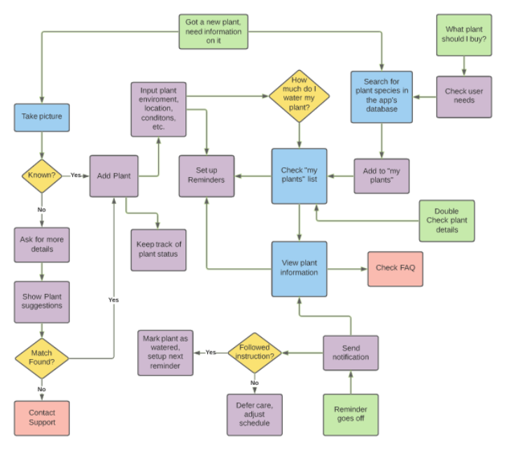

As seen in the flow chart presented above, many uses cases for the application pass through the “Check my plants list” feature. This indicated to us that it was this feature would be a key focus of our app, as it could potentially cause a bottleneck if it were not designed well.