Plant List

* A little tricky to see the plant/water images on the medium green
* Names don’t particularly stand out

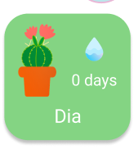Plant list items with 0 days should maybe stand out somehow

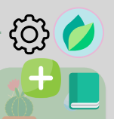  
  
A little tricky to see the buttons against the background, especially the + button

Settings

* Minor Typo -> “Comming Soon” should be “Coming Soon”

Catalogue

* Expected to be able to tap the entire row to view a plant
* … button was confusing and hard to guess what it was for
* Not clear that default items are recommendations
* No prototyping for actual search – do we want this?

Add – Camera

* Feels very dark compared to other pages

Best Match

* Prototype back navigation breaks after getting to the best match screens
* No good way to get back to the home screen if you don’t want to add the plant after all

Add – Survey

* No good way to escape once you’ve started
* Don’t know button is a bit hard to see
* Consistency -> should all the option buttons have an info button, even if they seem pretty straightforward?
* Other Matches – horizontal scrolling is broken in the prototype
  + Should we just show top 3 next results?

Plant Info

* White text is a bit hard to read in the plant care section
* No clear way to escape this page if you got here from the survey or catalogue and just want to go straight back to the plant list instead of adding

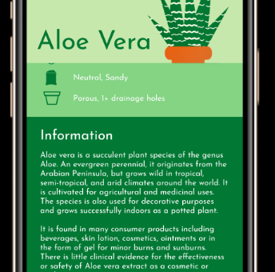  
  
Got a little disoriented when scrolling down to the info didn’t fill the whole bottom of the screen. Seeing the little bit of the plant care felt a bit odd

My Plant Info

* Delete button doesn’t do anything – could maybe show a confirmation dialog?
* Unclear what happens when the notification bell is on/off since there’s also Set Reminders below

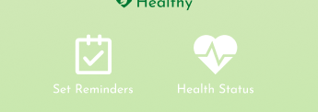White icons are hard to see on this background

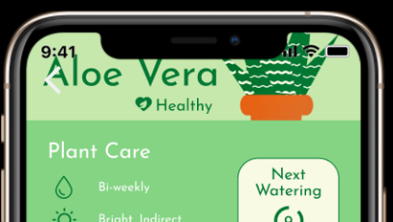   
If the plant bar could have a fixed position once it hits the top, that’d be super cool

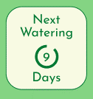  
I felt like I should be able to tap this like a button

Reminders

* The number of colours doesn’t quite feel like it fits with the rest of the app
  + The dates don’t’ really feel important enough to all be highlighted in red
  + The purple modal is inconsistent with other modals in the app
* Not super clear what the difference is between the add reminder button and edit
* Can’t cancel add/edit
* Uncertain how I would set up auto-scheduled reminders or edit the days between auto-reminders
* Add/Edit buttons will be too small to tap on a real device
* Back button is hard to see

Journal

 Thought this whole thing was a button, was confused when I couldn’t click it all

* Add button uses a different icon than other pages in the app
* Colours get a bit overwhelming
* Can’t cancel status update
* Status updates area a little intimidating if you don’t really know what it means for your plant to be healthy – was expecting a few more details in the status update window
  + Eg from sketches  
    