* Vertical Tasks:

1. Add a new plant using the camera. First, the user identifies the plant via camera, then they are shown a list of best matches based on the results. The user may then select a plant to add to their Plant List. If a match is not found, they have the option to try again or use a different method to identify the plant.
2. Add a new plant from the Catalogue. After browsing through the Catalogue, a user may select a plant to view its info or add the plant to their Plant List directly using the add button on the plant item.
3. Set up Reminders. When adding a new plant, the app will automatically calculate and set reminders based on the plant’s status. The user may turn on/off these notifications and edit or add extra reminders as necessary.

* Horizontal Tasks:

1. View list of currently owned plants, more information about the plant, and its current status.
2. View a list of recommended plants in Catalogue that will be derived based on your preferences.
3. View plant information of currently owned plants as well as plants in the database/ Catalogue
4. Search for a specific plant in Catalogue. The search engine may feature an autocomplete function.
5. Add a new plant status to the journal to keep track of the plant’s health.
6. Add new plant to the Plant List by taking a survey to identify the plant species.
7. Use the camera to find information on a plant.
8. Edit a reminder that was previously set.
9. Navigate smoothly between different interfaces.

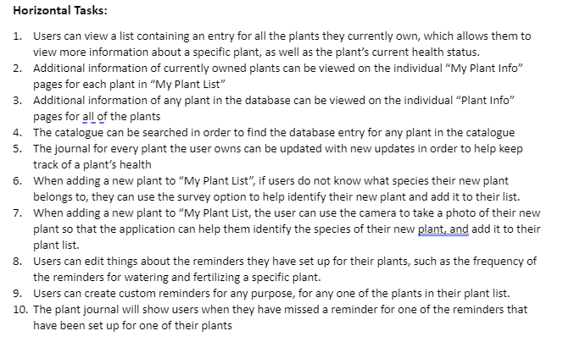

Vertical Script

* Add new plant using the camera
  + Open the menu
  + Click the add new plant icon
  + Select the camera option
  + Take a photo of the plant using the camera feature in the app
  + The app will show a list of best matches it found
  + Select the correct plant to add to plant list
* Add new plant by browsing the catalogue
  + Open the menu
  + click on the icon for catalogue
  + search for the plant species in the catalogue
  + click the plus button on the entry for that plant species to add to plant list
* Set up reminders
  + From plant list, tap on the entry for the plant you want to set up reminders for
  + When on the “plant info” screen, tap on the set reminders icon
  + Tap on the pencil icons to create a new reminder or edit and existing reminder