Christine Bush

1761 Russell Chapel Church Road

Pittsboro, NC 27312

January 23, 2021

**Well Evaluation Report**

*Background*

The purpose of the well evaluation is to get a better understanding of the characteristics of the well. Of prime importance is the yield of the well or its production rate. In addition, the dynamic behavior of the well is also examined as the pumping experiments proceed. The well tag has the original information provided at the time of well drilling and these data serve as a starting point for the well evaluation. The steps of the evaluation are given below.

1. Record all tag data for the well and the pump that is available
2. Hook up water meter to hose at outside spigot and position Sonic Detector for well level measurements.
3. Measure static level of well – record this value
4. Start stopwatch at same time hose spigot is turned on
5. Record water meter data and well level measurement at one or two minute intervals
6. Draw the well down a significant amount based on observations and well parameters
7. Shut off all flow
8. Record well level as it refills – this is the static refill rate or static yield
9. Plot data and evaluate results.

*Set-up and Methods*

The data was collected from the well on 1/18/21. The equipment was set-up by inserting the Sonic Detector into the vent port of the well cap. The Sonic Detector measures the water level in the well bore using the reflection of sound waves off the surface of the water. Since there was a check valve on the water line to the house, the hose and water meter had to be hooked up at the house to an outside spigot. For this reason data was collected at 2-minute intervals during the water running phase to allow time to traverse back and to the wellhead for the well level measurements. During the water running portion of the test, the water meter and the sonic detector were read every two minutes.

*Results*

The raw data are shown in the attached table (Excel Spreadsheet - Data). Data was collected every 2 minutes during the water running phase. The static level of the water was measured at 27.9 feet at the start of the experiment. The hose was started and the average flow at the hose was about 6.8 GPM gallons per minute (GPM). The well pump was cycling periodically during this part of the test.

After 40 minutes of running the water, the valve was closed. The level of the well had dropped to the lowest point of 130 feet at this point, meaning we removed 102 feet of water. Once the water was off, the refill data was collected every minute for about 40 minutes. The total test ran for 80 minutes.

The data were then used to calculate two parameters, dynamic well yield and static well yield. For the dynamic yield we assume that the well is a 6” diameter bore into the ground going down the full depth of the well. Ignoring the volume of the central pipe itself, this means that each foot of water in the well bore equates to about 1.48 gallons of water. When the pump is activated by opening the hose spigot, water was pumped from the well at an average rate of about 6.8 GPM. At this flow rate the level of the well should drop about 4.6 feet every minute if no new water is being added to the well from the aquifer during the test. The data indicate that for the entire water-running period the well level was dropping at a rate lower than this. This means that the well was “recharging” as the water was running from the hose. Any “recharge” during water running is called the dynamic yield. This is determined by taking the total volume of water removed from the well by pumping (271.4 gallons) and subtracting the water loss reflected by the change in well level (149.96 gallons), then dividing by the elapsed time. This is summarized in the table below (Table 1).

Table . Dynamic well yield calculation

|  |  |  |
| --- | --- | --- |
| **Dynamic Yield Calculation** | | |
| Total Gallons from hose | 271.4 | gals |
| Total Gallons lost by h | 149.96 | gals |
| Total gallons recovered by well during pumping | 121.44 | gals |
| Hose running time (min) (during recharge) | 40 | min |
| **Dynamic Yield (Average)** | **3.04** | **GPM** |

From these data it is clear that while water was running out of the hose at about 6.8 GPM, the well was being replenished by the surrounding aquifer at a rate near 3 gallon per minute (GPM).

Once the water stopped after 40 minutes, the static refill rate was measured with no water running. After 40 minutes of static refilling, the well level had raised by 73.9 feet. This indicates that in this depth range of the water column the well was filling at a rate of about 2.7 GPM. This rate is very similar to the calculated dynamic yield. As the well fills even more, the fill rate will slowly drop off to zero as the backpressure inside the well bore balances the driving force of water from the aquifer to the well.

Below is a graph of the data (Excel Spreadsheet Graph). On the vertical axis the well level is plotted versus the time on the horizontal axis. It is clear to see the decrease in well level while running the water, including the well pump cycles as the well tank filled and the switch shut off the well pump briefly. After 40 minutes of running, the static refill data is shown. The water was run until the well level reached about 130 feet and then refill started. You can see from the data that the well was filling up after the water was shut off at an average rate of about 2.7 GPM.

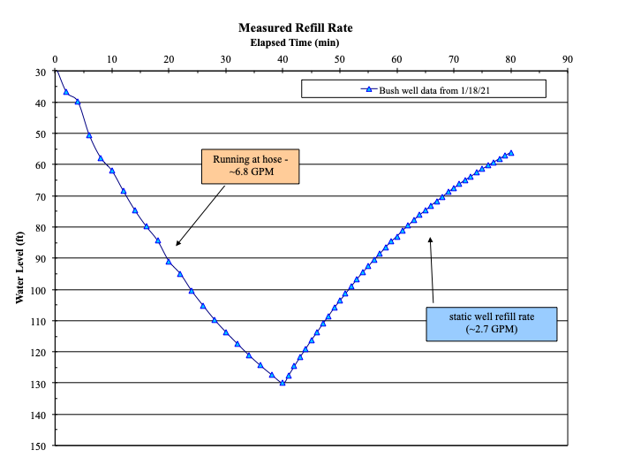

*Discussion*

Based on the data collected from this well, including tag data, level data, and refill data, the following conclusions may be drawn.

1. The static level of this well represents a “full well” which is around 27 feet.
2. The measured production rate of this well is near 2.7-3.0 GPM. This is near the tag value of 3 GPM. This well is classified as a “low-yield” well.
3. The dynamic yield was also calculated at about 3.0 GPM.
4. Based on the yield of this well, it should be relatively safe for normal domestic use. The yield is probably not enough for landscaping use or a dedicated irrigation system. Uncontrolled use at rates higher than 4-5 GPM would eventually draw the well down to very low levels.
5. To protect the aquifer and groundwater resource, a Well Manager System would be a great addition to harvest this water, store it and then re-pressurize it for domestic and other uses.
6. If the well is to be used for irrigation, it will make Well Management much more important as well as employing careful irrigation zone and water budget design.