Diversity_analysis_new_dataset

library(microeco)  
library(magrittr)

library(mecodev)  
library(ggplot2)

microeco_abu_bacteria_new <- read.delim("C:/Users/jguitart/OneDrive/DOCTORAT-IRTA/AA_PROJECTE/METAGENOMICS/Diversity_Abundance_analysis/microeco_new/microeco_abu_bacteria_new.txt", header=T, row.names=1, check.names = FALSE)  
microeco_tax_bacteria_new <- read.delim("C:/Users/jguitart/OneDrive/DOCTORAT-IRTA/AA_PROJECTE/METAGENOMICS/Diversity_Abundance_analysis/microeco_new/microeco_taxonomy_new.txt", row.names=1, check.names = FALSE)  
metadata_table_new <- read.csv("C:/Users/jguitart/OneDrive/DOCTORAT-IRTA/AA_PROJECTE/METAGENOMICS/Diversity_Abundance_analysis/microeco_new/metadata_table.csv", row.names=1, sep=";")  
metadata_new <- subset(metadata_table_new, Visit!='enf')  
dim(metadata_new)

## [1] 279 11

class(microeco_abu_bacteria_new)

## [1] "data.frame"

class(microeco_tax_bacteria_new)

## [1] "data.frame"

class(metadata_new)

## [1] "data.frame"

microeco_tax_bacteria_new %<>% tidy_taxonomy()  
dataset_bacteria_new <- microtable$new(otu_table = microeco_abu_bacteria_new, sample_table = metadata_new, tax_table = microeco_tax_bacteria_new)

## 1809 taxa are removed from the otu_table, as the abundance is 0 ...

dataset_bacteria_new

## microtable class:  
## sample_table have 279 rows and 11 columns  
## otu_table have 23038 rows and 279 columns  
## tax_table have 24847 rows and 7 columns

dataset_bacteria_new$tidy_dataset()

dataset_bacteria_new$sample_sums() %>% range

## [1] 2170245 208141880

library(tidyverse)

## Warning: package 'tidyverse' was built under R version 4.1.3

## -- Attaching packages --------------------------------------- tidyverse 1.3.2 --  
## v tibble 3.1.7 v dplyr 1.0.9  
## v tidyr 1.2.0 v stringr 1.4.0  
## v readr 2.1.2 v forcats 0.5.1  
## v purrr 0.3.4

## Warning: package 'tibble' was built under R version 4.1.3

## Warning: package 'dplyr' was built under R version 4.1.3

## -- Conflicts ------------------------------------------ tidyverse_conflicts() --  
## x tidyr::extract() masks magrittr::extract()  
## x dplyr::filter() masks stats::filter()  
## x dplyr::lag() masks stats::lag()  
## x purrr::set_names() masks magrittr::set_names()

rownames_to_column(metadata_new, var = "id")

rarefaction_new <- trans_rarefy$new(dataset_bacteria_new, alphadiv = "Shannon", depth = c(0, 10, 50, 500, 2000, 4000, 6000, 8000))

rarefaction_new$plot_rarefy(color_values = rep("grey", 279), show_point = TRUE, add_fitting = FALSE, show_legend = FALSE)

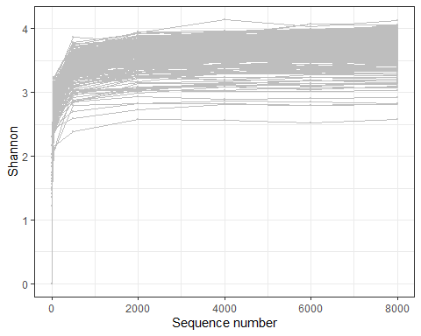

#rarefaction_new$cal_ordination(ordination = "PCoA")

dataset_bacteria_new$cal_abund()

## The result is stored in object$taxa_abund ...

dataset_bacteria_new$save_abund(dirpath = "taxa_abund_bacteria_new")

dataset_bacteria_new$cal_alphadiv(PD = FALSE)

## The result is stored in object$alpha_diversity ...

dataset_bacteria_new$save_alphadiv(dirpath = "alpha_diversity_bacteria_new")

dataset_bacteria_new$cal_betadiv()

## The result is stored in object$beta_diversity ...

dataset_bacteria_new$save_betadiv(dirpath = "beta_diversity_bacteria_new")

ta_bacteria_new <- trans_alpha$new(dataset = dataset_bacteria_new, group = "Group")

## The group statistics are stored in object$alpha_stat ...

## The transformed diversity data is stored in object$alpha_data ...

ta_bacteria_new$cal_diff(method = "anova")

## Registered S3 methods overwritten by 'klaR':  
## method from   
## predict.rda vegan  
## print.rda vegan  
## plot.rda vegan

## The result is stored in object$res_alpha_diff ...

ta_bacteria_new$res_alpha_diff[1:6, ]

## Observed Chao1 ACE Shannon Simpson InvSimpson Fisher Coverage  
## 3 a a a ab a ab a a  
## 5 a a a a a a ab a  
## 1 a a a a a a ab a  
## 4 a a a ab a a ab a  
## 2 a a a ab ab ab a a  
## G a a a b b b ab a

ta_bacteria_new$plot_alpha(add_letter = T, measure = "Shannon", use_boxplot = TRUE)

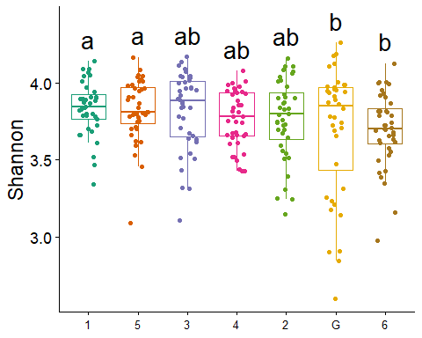

ta_bacteria_visit_new <- trans_alpha$new(dataset = dataset_bacteria_new, group = "Visit")

## The transformed diversity data is stored in object$alpha_data ...

ta_bacteria_visit_new$cal_diff(method = "anova")

ta_bacteria_visit_new$res_alpha_diff[1:4, ]

## Observed Chao1 ACE Shannon Simpson InvSimpson Fisher Coverage  
## 3 a a a a a a a ab  
## 2 a a a a a ab a ab  
## 4 b b b b b c a b  
## 1 c c c b b bc b a

ta_bacteria_visit_new$plot_alpha(add_letter = T, measure = "Shannon", use_boxplot = TRUE)

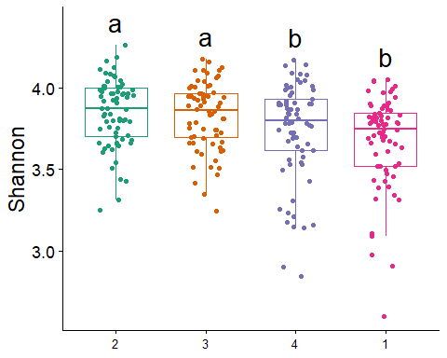

tb_bacteria_new <- trans_beta$new(dataset = dataset_bacteria_new, group = "Group", measure = "bray")  
tb_bacteria_new$cal_ordination(ordination = "PCoA")

## The ordination result is stored in object$res_ordination ...

tb_bacteria_new$plot_ordination(plot_color = "Group", plot_shape = "Group", plot_group_ellipse = TRUE)

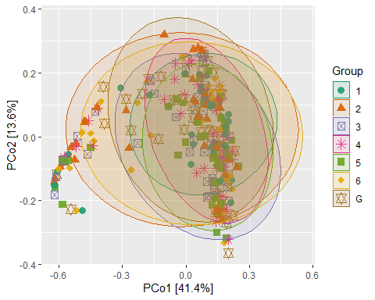

tb_bacteria_visit_new <- trans_beta$new(dataset = dataset_bacteria_new, group = "Visit", measure = "bray")  
tb_bacteria_visit_new$cal_ordination(ordination = "PCoA")

## The ordination result is stored in object$res_ordination ...

#tb_bacteria_visit_new$plot_ordination(plot_color = "Visit", plot_shape = "Visit", plot_group_ellipse = TRUE)

#tb_bacteria_new$cal_group_distance(within_group = TRUE)  
#tb_bacteria_new$cal_group_distance_diff(method = "wilcox")  
#tb_bacteria_new$plot_group_distance(boxplot_add = "mean")

tb_bacteria_new$cal_manova(cal_manova_all = TRUE)

## The result is stored in object$res_manova ...

tb_bacteria_new$res_manova$aov.tab

## Permutation: free  
## Number of permutations: 999  
##   
## Terms added sequentially (first to last)  
##   
## Df SumsOfSqs MeanSqs F.Model R2 Pr(>F)  
## Group 6 0.806 0.13426 0.89302 0.01932 0.615  
## Residuals 272 40.894 0.15035 0.98068   
## Total 278 41.699 1.00000

tb_bacteria_new$cal_manova(cal_manova_paired = TRUE)

## The result is stored in object$res_manova ...

tb_bacteria_new$res_manova

## Groups measure permutations R2 p.value Significance  
## 1 G vs 2 bray 999 0.007718189 0.698   
## 2 G vs 3 bray 999 0.009004702 0.652   
## 3 G vs 4 bray 999 0.010184460 0.550   
## 4 G vs 6 bray 999 0.007873990 0.716   
## 5 G vs 1 bray 999 0.008540970 0.719   
## 6 G vs 5 bray 999 0.019268210 0.137   
## 7 2 vs 3 bray 999 0.008989639 0.541   
## 8 2 vs 4 bray 999 0.018915322 0.163   
## 9 2 vs 6 bray 999 0.007138646 0.724   
## 10 2 vs 1 bray 999 0.013409669 0.337   
## 11 2 vs 5 bray 999 0.023892706 0.098   
## 12 3 vs 4 bray 999 0.010232936 0.543   
## 13 3 vs 6 bray 999 0.008042414 0.671   
## 14 3 vs 1 bray 999 0.010661635 0.498   
## 15 3 vs 5 bray 999 0.007697593 0.731   
## 16 4 vs 6 bray 999 0.012689253 0.367   
## 17 4 vs 1 bray 999 0.005768100 0.872   
## 18 4 vs 5 bray 999 0.011060963 0.476   
## 19 6 vs 1 bray 999 0.010594473 0.492   
## 20 6 vs 5 bray 999 0.014094379 0.315   
## 21 1 vs 5 bray 999 0.012986817 0.374

tb_bacteria_new$cal_manova(cal_manova_set = "Group + Visit")

## The result is stored in object$res_manova ...

tb_bacteria_new$res_manova$aov.tab

## Permutation: free  
## Number of permutations: 999  
##   
## Terms added sequentially (first to last)  
##   
## Df SumsOfSqs MeanSqs F.Model R2 Pr(>F)   
## Group 6 0.806 0.1343 0.999 0.01932 0.434   
## Visit 1 4.486 4.4862 33.393 0.10758 0.001 ***  
## Residuals 271 36.408 0.1343 0.87310   
## Total 278 41.699 1.00000   
## ---  
## Signif. codes: 0 '***' 0.001 '**' 0.01 '*' 0.05 '.' 0.1 ' ' 1

#tb2_bacteria_new <- trans_beta$new(dataset = dataset_bacteria_new, group = "Group", measure = "betaNRI")  
tb_bacteria_new$cal_group_distance()

## The result is stored in object$res_group_distance ...

g1_new <- tb_bacteria_new$plot_group_distance(distance_pair_stat = TRUE)

## The ordered groups are 1 2 3 4 5 6 G ...

g1_new

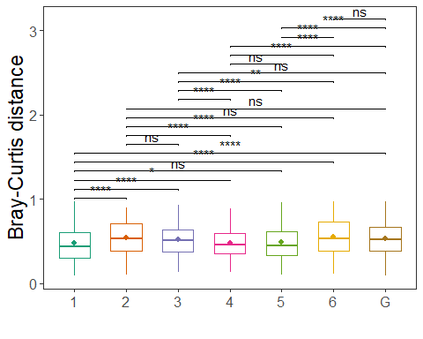

library(ggplot2)  
tb_bacteria_new$cal_group_distance(within_group = FALSE)

## The result is stored in object$res_group_distance ...

g2_new <- tb_bacteria_new$plot_group_distance(distance_pair_stat = TRUE)

## The ordered groups are 1 vs 5 2 vs 1 2 vs 3 2 vs 4 2 vs 5 2 vs 6 3 vs 1 3 vs 4 3 vs 5 3 vs 6 4 vs 1 4 vs 5 4 vs 6 6 vs 1 6 vs 5 G vs 1 G vs 2 G vs 3 G vs 4 G vs 5 G vs 6 ...

g2_new + scale_color_manual(values=c("#bbbbbb", "#ff6362", "#b1b1ff", "#282828", "#b30100", "#0100b1", "#2927ff", "#000000","#bbbbbb", "#ff6362", "#b1b1ff", "#282828", "#b30100", "#0100b1", "#2927ff", "#000000","#bbbbbb", "#ff6362", "#b1b1ff", "#282828", "#b30100"))

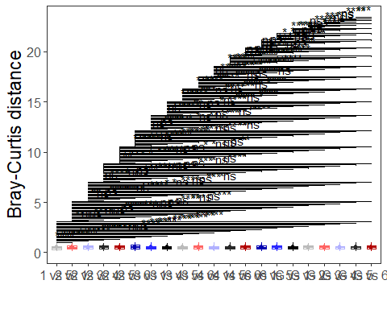

tb_bacteria_new$plot_clustering(group = "Group")

## Scale for x is already present.  
## Adding another scale for x, which will replace the existing scale.

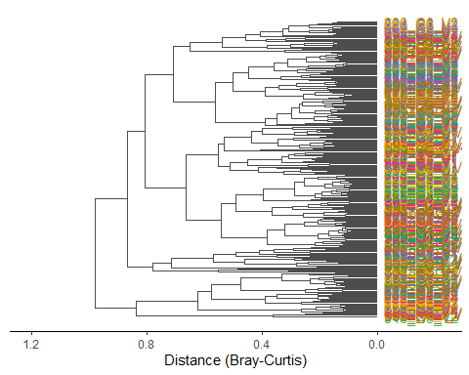

tb_bacteria_new$cal_manova(cal_manova_all = TRUE)

## The result is stored in object$res_manova ...

tb_bacteria_new$res_manova

##   
## Call:  
## adonis(formula = reformulate(self$group, substitute(as.dist(use_matrix))), data = self$sample_table, permutations = permutations)   
##   
## Permutation: free  
## Number of permutations: 999  
##   
## Terms added sequentially (first to last)  
##   
## Df SumsOfSqs MeanSqs F.Model R2 Pr(>F)  
## Group 6 0.806 0.13426 0.89302 0.01932 0.62  
## Residuals 272 40.894 0.15035 0.98068   
## Total 278 41.699 1.00000

tb_bacteria_new$cal_manova(cal_manova_paired = TRUE)

## The result is stored in object$res_manova ...

tb_bacteria_new$res_manova

## Groups measure permutations R2 p.value Significance  
## 1 G vs 2 bray 999 0.007718189 0.702   
## 2 G vs 3 bray 999 0.009004702 0.616   
## 3 G vs 4 bray 999 0.010184460 0.561   
## 4 G vs 6 bray 999 0.007873990 0.709   
## 5 G vs 1 bray 999 0.008540970 0.670   
## 6 G vs 5 bray 999 0.019268210 0.168   
## 7 2 vs 3 bray 999 0.008989639 0.567   
## 8 2 vs 4 bray 999 0.018915322 0.168   
## 9 2 vs 6 bray 999 0.007138646 0.726   
## 10 2 vs 1 bray 999 0.013409669 0.342   
## 11 2 vs 5 bray 999 0.023892706 0.098   
## 12 3 vs 4 bray 999 0.010232936 0.526   
## 13 3 vs 6 bray 999 0.008042414 0.676   
## 14 3 vs 1 bray 999 0.010661635 0.486   
## 15 3 vs 5 bray 999 0.007697593 0.727   
## 16 4 vs 6 bray 999 0.012689253 0.372   
## 17 4 vs 1 bray 999 0.005768100 0.875   
## 18 4 vs 5 bray 999 0.011060963 0.469   
## 19 6 vs 1 bray 999 0.010594473 0.491   
## 20 6 vs 5 bray 999 0.014094379 0.322   
## 21 1 vs 5 bray 999 0.012986817 0.368

tb_bacteria_new$cal_manova(cal_manova_set = "Group + Visit")

## The result is stored in object$res_manova ...

tb_bacteria_new$res_manova

##   
## Call:  
## adonis(formula = reformulate(cal_manova_set, substitute(as.dist(use_matrix))), data = self$sample_table, permutations = permutations)   
##   
## Permutation: free  
## Number of permutations: 999  
##   
## Terms added sequentially (first to last)  
##   
## Df SumsOfSqs MeanSqs F.Model R2 Pr(>F)   
## Group 6 0.806 0.1343 0.999 0.01932 0.442   
## Visit 1 4.486 4.4862 33.393 0.10758 0.001 ***  
## Residuals 271 36.408 0.1343 0.87310   
## Total 278 41.699 1.00000   
## ---  
## Signif. codes: 0 '***' 0.001 '**' 0.01 '*' 0.05 '.' 0.1 ' ' 1

tb_bacteria_new$cal_betadisper()

## The result is stored in object$res_betadisper ...

tb_bacteria_new$res_betadisper

##   
## Permutation test for homogeneity of multivariate dispersions  
## Permutation: free  
## Number of permutations: 999  
##   
## Response: Distances  
## Df Sum Sq Mean Sq F N.Perm Pr(>F)  
## Groups 6 0.1469 0.024484 0.953 999 0.465  
## Residuals 272 6.9878 0.025691   
##   
## Pairwise comparisons:  
## (Observed p-value below diagonal, permuted p-value above diagonal)  
## 1 2 3 4 5 6 G  
## 1 0.15100 0.33100 0.84400 0.77600 0.13500 0.288  
## 2 0.13469 0.53300 0.11900 0.20400 0.90000 0.680  
## 3 0.33010 0.55984 0.35100 0.46200 0.51100 0.867  
## 4 0.81486 0.11935 0.36135 0.94300 0.12200 0.292  
## 5 0.79309 0.19430 0.45740 0.95159 0.18800 0.374  
## 6 0.12641 0.90022 0.50396 0.11494 0.18007 0.631  
## G 0.27897 0.68109 0.88057 0.29787 0.38757 0.61346

#dataset_bacteria_subset <- subset(dataset_bacteria, Visit!="enf")

subset_bacteria_phylum_new <- clone(dataset_bacteria_new)  
subset_bacteria_phylum_new$tax_table %<>% subset(Phylum != "p__Unassigned")  
tphylum_bacteria_subset_new <- trans_abund$new(dataset = subset_bacteria_phylum_new, taxrank = "Phylum", ntaxa = 12)

tphylum_bacteria_subset_new$plot_bar(others_color = "grey70", facet = "Visit", facet2 = "Group", xtext_keep = FALSE, legend_text_italic = FALSE)

## Scale for y is already present.  
## Adding another scale for y, which will replace the existing scale.

tphylum_bacteria_subset_new$plot_bar(others_color = "grey70", facet = "Group", xtext_keep = FALSE, legend_text_italic = FALSE)

## Scale for y is already present.  
## Adding another scale for y, which will replace the existing scale.

subset_bacteria_genus_new <- clone(dataset_bacteria_new)  
subset_bacteria_genus_new$tax_table %<>% subset(Genera != "g__Unassigned")  
tgenus_bacteria_subset_new <- trans_abund$new(dataset = subset_bacteria_genus_new, taxrank = "Genera", ntaxa = 16)  
tgenus_bacteria_subset_new$tax_table

tgenus_bacteria_subset_new$plot_bar(others_color = "grey70", facet = "Visit", xtext_keep = FALSE, legend_text_italic = FALSE)

subset_bacteria_species_new <- clone(dataset_bacteria_new)  
subset_bacteria_species_new$tax_table %<>% subset(Species != "s__Unassigned")  
tspecies_bacteria_subset_new <- trans_abund$new(dataset = subset_bacteria_species_new, taxrank = "Species", ntaxa = 20)

tspecies_bacteria_subset_new$plot_box(group = "Group")

tspecies_mean_bacteria_subset_new <- trans_abund$new(dataset = subset_bacteria_species_new, taxrank = "Species", ntaxa = 12, groupmean = "Group")

tspecies_mean_bacteria_subset_new$plot_bar(xtext_keep = FALSE, legend_text_italic = FALSE) + theme_classic() + theme(axis.title.y = element_text(size = 18))

tspecies_bacteria_subset_new$plot_heatmap(facet = "Visit", xtext_keep = FALSE, withmargin = FALSE)

tspecies_bacteria_subset_new$plot_heatmap(facet = "Group", xtext_keep = FALSE, withmargin = FALSE)

