# shoppingNotes

Django shopping list notes

# Regex

Anchors — ^ and $ Beginning and end

Quantifiers — * + ? and {}

<https://medium.com/factory-mind/regex-tutorial-a-simple-cheatsheet-by-examples-649dc1c3f285>

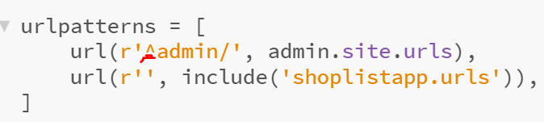

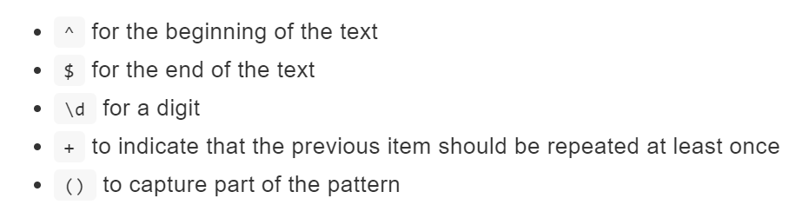

<https://tutorial.djangogirls.org/en/django_urls/>

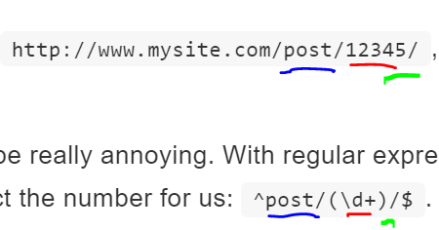

r'^$' is a regular expression that matches an empty line

 ?? same as r’^$ ??

<https://djangobook.com/views-urlconfs/>

<https://www.codingforentrepreneurs.com/blog/>

<https://www.codingforentrepreneurs.com/courses/ecommerce/>

Get started

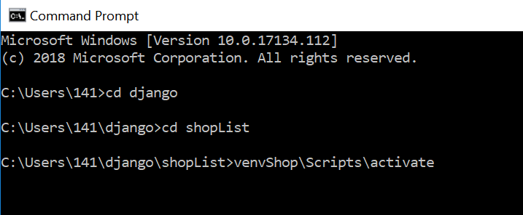

July 19 status

|  |  |
| --- | --- |
|  |  |
| Created virtual environment | venvShop\Scripts\activate |
| Installed django |  |
| Create project | django-admin.exe **startproject** mysite |
| mysite/settings.py | Amend |
| Set up database | Python manage.py migrate |
| Start webserver | python manage.py runserver |

### Runserver pic

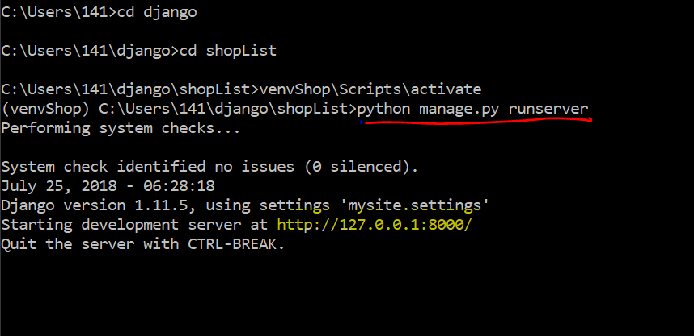

|  |  |
| --- | --- |
|  |  |
|  |  |
| Open new terminal | Cd Django  Cd shoplist  venvShop\Scripts\activate |
| Create application | python manage.py startapp blog  python manage.py **startapp** shoplistapp  amend mysite/settings.py |
| Create shoplist model | blog/models.py  class = shoplistclass |
| Create tables for model | python manage.py makemigrations blog |
| Create superuser | Pytoh manage.py createsuperuser  Username July18  Email – lqm e  PW VikingsRule04  In lastpass  (also user 141 – pw is missing) |
|  |  |
| Create model | In: shoplistapp/models.py  Eg blog post model Post  Shoplist model – ShopListClass |
| Add model to database | Python manage.py makemigrations Shoplistapp  Python manage.py migrate shoplistapp |
| Admin | blog/admin.py  <http://127.0.0.1:8000/admin/>.  For login |
| Deploy |  |
| Mysite/urls.py | Add line to import blog.urls |
| Blog/urls.py | Views  Urls pattern |
| Blog/views.py | Refers to templates |
| templates | C:\Users\141\django\shopList\shoplistapp\templates\shoplistapp  Html docs |
| Deploy inc git |  |
| Querysets | Objects in model  Database  Python manage.py shell |
|  |  |
|  |  |

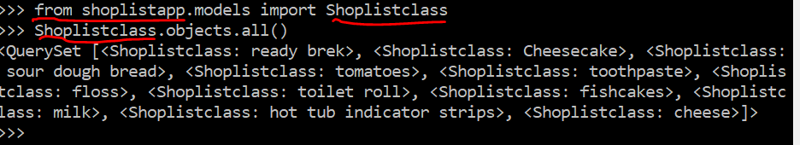

|  |  |
| --- | --- |
| Querysets – list objects in model  Objects  .Create  .get  .filter(x=y) | From blog.models import Shoplistclass  Shoplistclass.objects.all()  import user model  Create instance of user  User.objects.all()  Shoplistclass.objects.create(x=y,) |
| Querysets – create object |  |
|  |  |
|  |  |

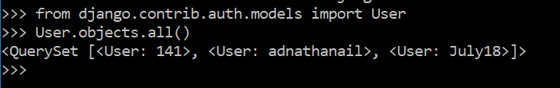

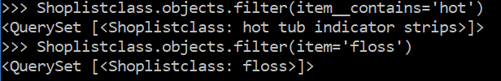

Note 2 __ in item__contains

Item is field name

Contains is an operation (part of filter)

|  |  |
| --- | --- |
|  |  |
| Filter on dates | Shoplistclass.objects.order_by('-entered_date') |
|  |  |

NB – has come problems with date, solved by importing timezone into console

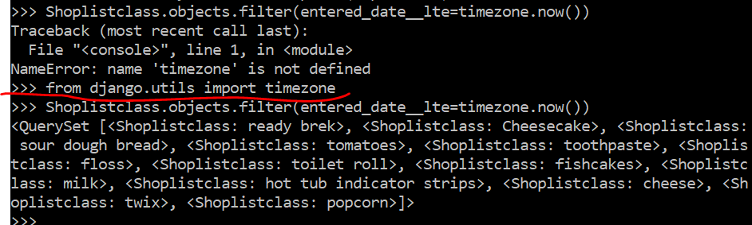

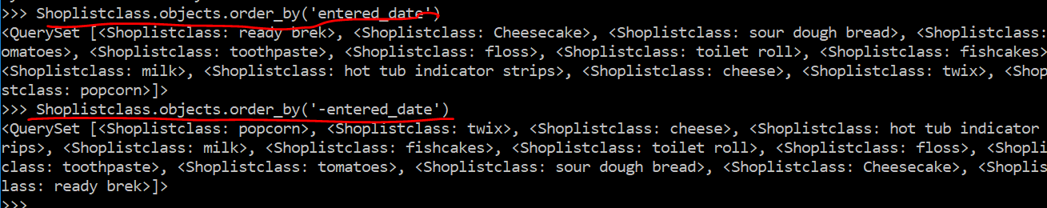

Chaining query sets

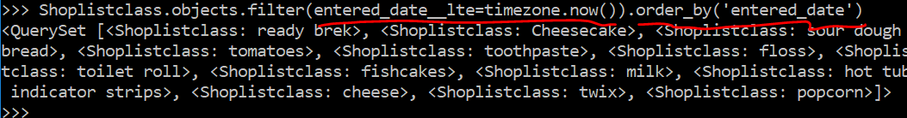

Exit() to leave console

## views

|  |  |
| --- | --- |
| Views | Connect models and templates |
| Import our model  Dot means same directory | From .models import Post |
| Add querysets | create variable for our query set – items (==posts) |
| Posts variable | Gives template a list of posts(items) |
|  |  |

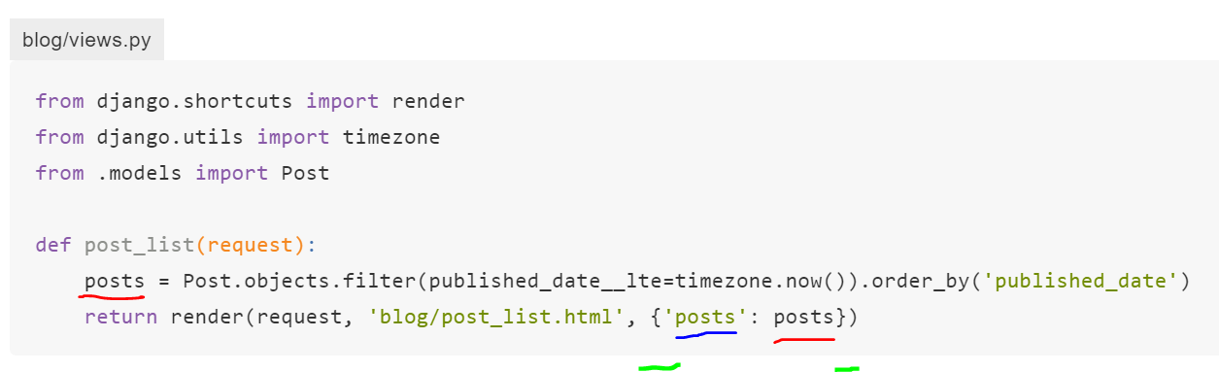

Red -= variable

Blue =

Green = {} used for

## Templates

Aim: to make posts appear in template – create template to link to posts details

|  |  |
| --- | --- |
| Blog/shoplistapp/blog/item_list.html | {{items}} |
|  |  |

|  |  |
| --- | --- |
|  |  |
| base.html 1 | {% block content %}  {% endblock %} |
| item_detail.html 3 | Meat of blog post or shopping list  Needs to be referenced in urls.py  Needs to be listed in views.py  If published – date  Title, text |
| item_edit.html |  |
| shop_list.html 2 | For post in posts %  Date, title  Link to detail page – item_detail |
| urgency.html | ?? implemented ?? |

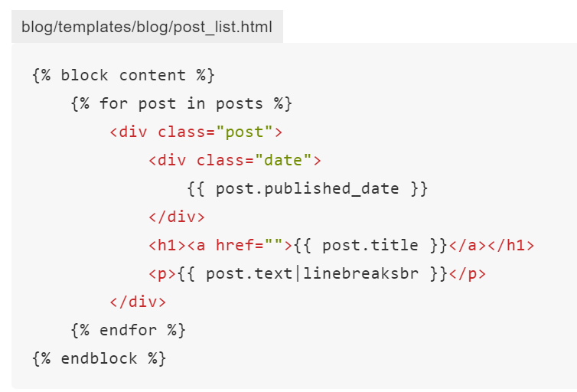 |linebreaksbr  pipes text to convert line-breaks to paragraphs.

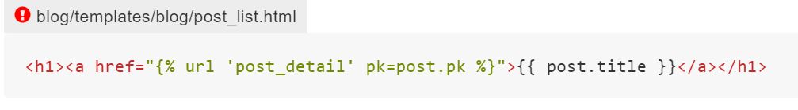

Link to detail page

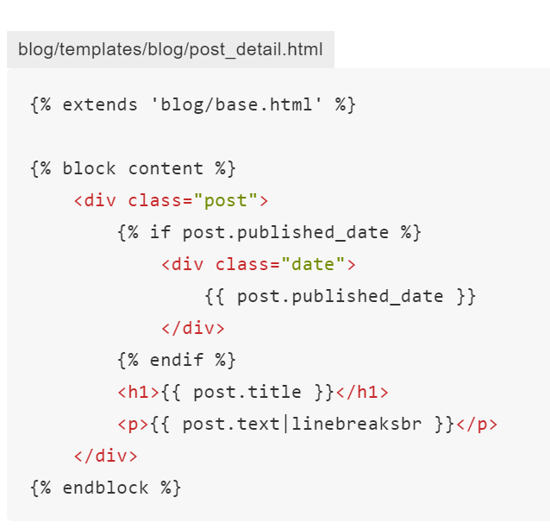

### Django forms

|  |  |
| --- | --- |
| Forms.py | Create class Listform |
| create   * a link to the page, * a URL, * a view * a template | In:   * Base.html * Urls.py * Views.py * Item_edit.html |

#### Link in base.html

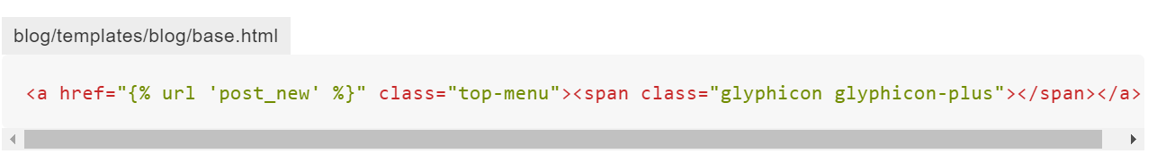

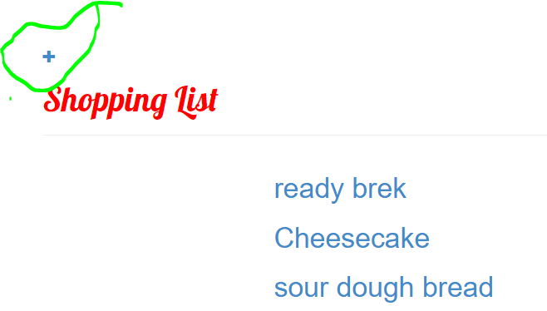 gives + at top

#### url

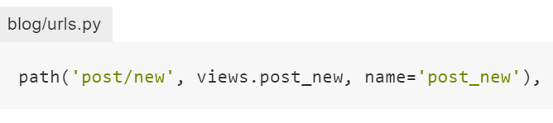

#### View

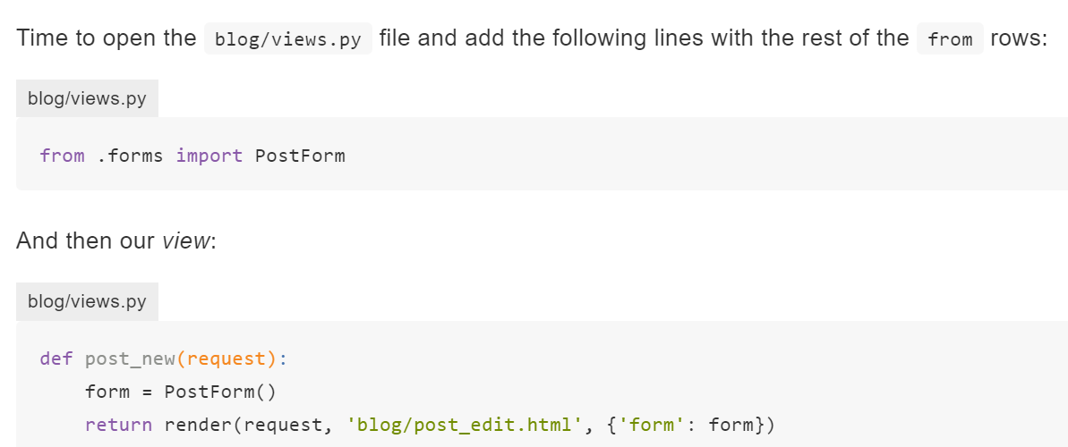

As written above it doesn’t save. Need to:

#### template

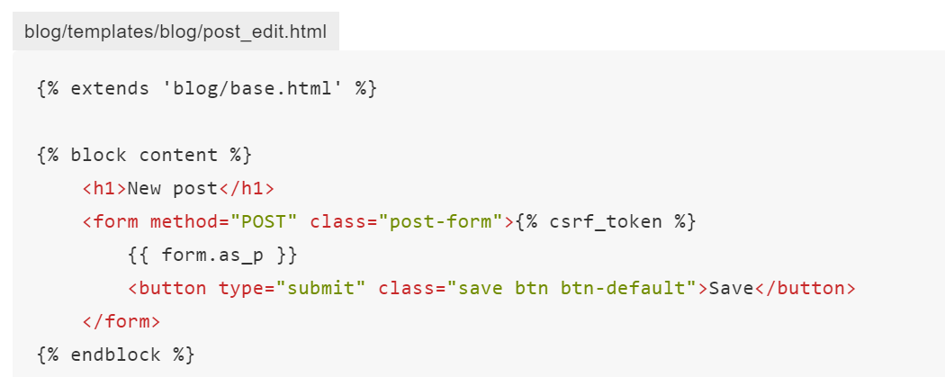

## Django passwords

From iphones notes – prob first blog

Django superuser

Username judit

Lqm e

PW vikin9jud