Consider the following schema for OrderDatabase:

**SALESMAN** (Salesman_id, Name, City, Commission)

**CUSTOMER** (Customer_id, Cust_Name, City, Grade,Salesman_id)

**ORDERS** (Ord_No, Purchase_Amt, Ord_Date, Customer_id,Salesman_id)    Write SQL queries to

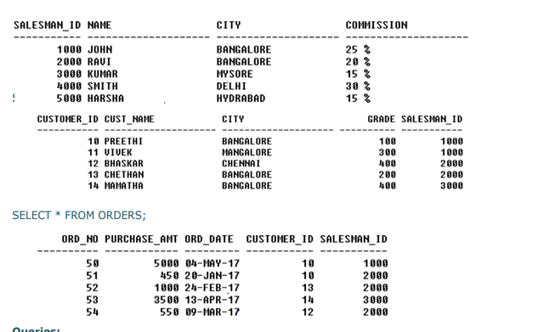

SQL> CREATE TABLE SALESMAN (Salesman_id INT NOT NULL PRIMARY KEY, Name VARCHAR (20), City VARCHAR (20), Commission number);

Table created.

SQL> INSERT INTO SALESMAN VALUES(1000,'JOHN','BANGALORE',25);

1 row created.

SQL> INSERT INTO SALESMAN VALUES(2000,'RAVI','BANGALORE',20);

1 row created.

SQL> INSERT INTO SALESMAN VALUES(3000,'KUMAR','MYSORE',15);

1 row created.

SQL> INSERT INTO SALESMAN VALUES(4000,'SMITH','DELHI',30);

1 row created.

SQL> INSERT INTO SALESMAN VALUES(5000,'HARSHA','HYDRABAD',15);

1 row created.

SQL> SELECT * FROM SALESMAN;

SALESMAN_ID NAME                 CITY                 COMMISSION

----------- -------------------- -------------------- ---------- ----------------------

1000 JOHN                 BANGALORE                    25

2000 RAVI                 BANGALORE                    20

3000 KUMAR             MYSORE                     15

4000 SMITH                DELHI                        30

5000 HARSHA            HYDRABAD                     15

SQL> CREATE TABLE CUSTOMER(Customer_id INT PRIMARY KEY, Cust_Name VARCHAR(20), City VARCHAR(20), Grade NUMBER,Salesman_id INT REFERENCES SALESMAN(SALESMAN_ID));

Table created.

SQL> INSERT INTO CUSTOMER VALUES(10,'PREETHI','BANGALORE',100,1000);

1 row created.

SQL> INSERT INTO CUSTOMER VALUES(11,'VIVEK','MANGALORE',300,1000);

1 row created.

SQL> INSERT INTO CUSTOMER VALUES(12,'BHASKAR','CHENNAI',400,2000);

1 row created.

SQL> INSERT INTO CUSTOMER VALUES(13,'CHETHAN','BANGALORE',200,2000);

1 row created.

SQL> INSERT INTO CUSTOMER VALUES(14,'MAMATHA','BANGALORE',400,3000);

1 row created.

SQL> SELECT * FROM CUSTOMER;

CUSTOMER_ID CUST_NAME           CITY              GRADE SALESMAN_ID

----------- -------------------- -------------------- ---------- ------------------ ---------------------

10 PREETHI              BANGALORE                100        1000

11 VIVEK                MANGALORE               300        1000

12 BHASKAR              CHENNAI                     400        2000

13 CHETHAN              BANGALORE                 200        2000

14 MAMATHA             BANGALORE                 400        3000

SQL> CREATE TABLE ORDERS(Ord_No NUMBER, Purchase_Amt NUMBER, Ord_Date DATE, Customer_id REFERENCES CUSTOMER(CUSTOMER_ID),Salesman_id REFERENCES SALESMAN(SALESMAN_ID));

Table created.

SQL> INSERT INTO ORDERS VALUES(50,5000,'04-MAY-17',10,1000);

1 row created.

SQL> INSERT INTO ORDERS VALUES(51,450,'20-JAN-17',10,2000);

1 row created.

SQL> INSERT INTO ORDERS VALUES(52,1000,'24-FEB-17',13,2000);

1 row created.

SQL> INSERT INTO ORDERS VALUES(53,3500,'13-APR-17',14,3000);

1 row created.

SQL> INSERT INTO ORDERS VALUES(54,550,'09-MAR-17',12,2000);

1 row created.

SQL> SELECT * FROM ORDERS;

ORD_NO PURCHASE_AMT ORD_DATE  CUSTOMER_ID SALESMAN_ID

---------- ------------ --------- ----------- ----------- ------------------------ ----------------------

        50         5000 04-MAY-17          10        1000

        51          450 20-JAN-17          10        2000

        52         1000 24-FEB-17          13        2000

        53         3500 13-APR-17          14        3000

        54          550 09-MAR-17          12        2000

**1. Count the customers with grades above Bangalore's Average.**

SQL> SELECT GRADE, COUNT (DISTINCT CUSTOMER_ID) FROM CUSTOMER GROUP BY GRADE HAVING GRADE > (SELECT AVG(GRADE) FROM CUSTOMER WHERE CITY='BANGALORE');

 GRADE COUNT(DISTINCTCUSTOMER_ID)

---------- --------------------------

       300                          1

       400                          2

**2. Find the name and numbers of all salesmen who had more than one customer**

SQL> SELECT SALESMAN_ID, NAME FROM SALESMAN A WHERE 1 < (SELECT COUNT (*) FROM CUSTOMER WHERE SALESMAN_ID=A.SALESMAN_ID);

SALESMAN_ID NAME

----------- --------------------

       1000 JOHN

       2000 RAVI

**3. List all salesmen and indicate those who have and don’t have   customers in their cities (Use UNIONoperation.)**

SQL> SELECT SALESMAN.SALESMAN_ID, NAME, CUST_NAME, COMMISSION FROM SALESMAN, CUSTOMER WHERE SALESMAN.CITY = CUSTOMER.CITY UNION SELECT SALESMAN_ID, NAME, 'NO MATCH', COMMISSION FROM SALESMAN WHERE NOT CITY = ANY (SELECT CITY FROM CUSTOMER) ORDER BY 2 DESC;

SALESMAN_ID NAME                 CUST_NAME            COMMISSION

----------- -------------------- -------------------- ----------------------------------------------

4000 SMITH                NO MATCH                     30

2000 RAVI                 CHETHAN                      20

2000 RAVI                 MAMATHA                      20

2000 RAVI                 PREETHI                      20

3000 KUMAR                NO MATCH                     15

1000 JOHN                 CHETHAN                      25

1000 JOHN                 MAMATHA                      25

1000 JOHN                 PREETHI                      25

5000 HARSHA               NO MATCH                     15

9 rows selected.

**4. Create a view that finds the salesman who has the customer with the highest order of the day.**

SQL> CREATE VIEW ELITSALESMAN AS SELECT B.ORD_DATE, A.SALESMAN_ID, A.NAME FROM SALESMAN A, ORDERS B  WHERE A.SALESMAN_ID = B.SALESMAN_ID AND B.PURCHASE_AMT=(SELECT MAX (PURCHASE_AMT) FROM ORDERS C WHERE C.ORD_DATE = B.ORD_DATE);

View created.

**5. Demonstrate the DELETE operation by removing salesmen with id   1000. All his orders must also be deleted.**

SQL> DELETE FROM SALESMAN WHERE SALESMAN_ID=1000;