AwtbiggestCourse Outcome 5 (CO5):
1.Program to find a maximum of three numbers using AWT.

package awtbiggest;
import java.awt.*;
import java.awt.event.*;
public class Awtbiggest implements ActionListener{
Frame f=new Frame();
Label l1=new Label("First Number");
Label l2=new Label("Second Number");
Label l3=new Label("Third Number");
Label l4=new Label("Largest Number");
TextField t1=new TextField();
TextField t2=new TextField();
TextField t3=new TextField();
TextField t4=new TextField();

Button b1=new Button("find");
Button b2=new Button("Cancel");

Awtbiggest()
{
l1.setBounds(50,100,100,20);
l2.setBounds(50,140,100,20);
l3.setBounds(50,180,100,20);
l4.setBounds(50,220,100,20);
t1.setBounds(200,100,100,20);
t2.setBounds(200,140,100,20);
t3.setBounds(200,180,100,20);
t4.setBounds(200,220,100,20);
b1.setBounds(50,250,50,20);
b2.setBounds(110,250,50,20);

f.add(l1);
f.add(l2);
f.add(l3);
f.add(l4);
f.add(t1);
f.add(t2);
f.add(t3);
f.add(t4);
f.add(b1);
f.add(b2);

b1.addActionListener(this);
b2.addActionListener(this);

f.setLayout(null);
f.setVisible(true);
f.setSize(400,350);

}

public void actionPerformed(ActionEvent e)
{
int n1=Integer.parseInt(t1.getText());
int n2=Integer.parseInt(t2.getText());
int n3=Integer.parseInt(t3.getText());
if(e.getSource()==b1)
{
if(n1>n2){
if(n1>n3){
t4.setText(String.valueOf(n1));

}
}
else if(n2>n3){
t4.setText(String.valueOf(n2));
}
else{
t4.setText(String.valueOf(n3));
}

}

if(e.getSource()==b2)
{
System.exit(0);
}
}

public static void main(String[] args) {

new Awtbiggest();

}

}

output:
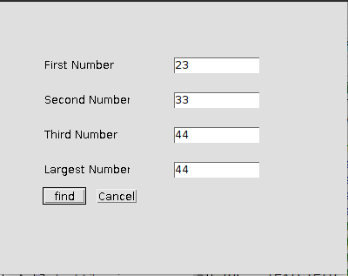

simple interest

package simpleinterest;
import java.awt.*;
import java.awt.event.*;

/**
*
* @author sjcet
*/
public class Simpleinterest implements ActionListener{
Frame f=new Frame();
Label l1=new Label("Principle");
Label l2=new Label("Number of years");
Label l3=new Label ("Rate");
Label l4=new Label("simpleinterest");
TextField t1= new TextField();
TextField t2=new TextField();
TextField t3=new TextField();
TextField t4=new TextField();
Button b1= new Button("calculate");
Simpleinterest()
{
l1.setBounds(50, 100, 100, 20);
l2.setBounds(50, 140, 100, 20);
l3.setBounds(50, 180, 100, 20);
l4.setBounds(50, 220, 100, 20);
t1.setBounds(200,100 , 100, 20);
t2.setBounds(200, 140, 100, 20);
t3.setBounds(200, 180, 100, 20);
t4.setBounds(200, 220, 100, 20);
b1.setBounds(50, 250, 50, 20);
f.add(l1);
f.add(l2);
f.add(l3);
f.add(l4);
f.add(t1);
f.add(t2);
f.add(t3);
f.add(t4);
f.add(b1);
b1.addActionListener(this);
f.setLayout(null);
f.setVisible(true);
f.setSize(600, 600);
}
public void actionPerformed(ActionEvent e)
{

int n1=Integer.parseInt(t1.getText());
int n2=Integer.parseInt(t2.getText());
int n3=Integer.parseInt(t3.getText());
if(e.getSource()==b1)
{

t4.setText(String.valueOf((n1*n2*n3)/100));
}

}
public static void main(String args[])
{
new Simpleinterest();
}

}

output:
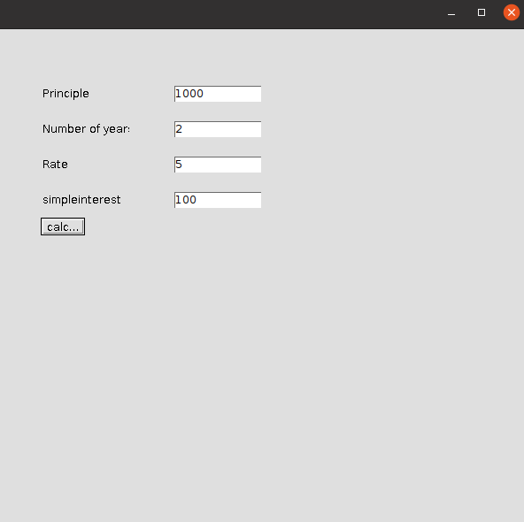

2.Implement a simple calculator using AWT components.
package awtcalculator;

/**
*
* @author sjcet
*/
import java.awt.*;
import java.awt.event.*;

class Awtcalculator implements ActionListener {

//Declaring Objects
Frame f=new Frame();
Label l1=new Label("First Number");
Label l2=new Label("Second Number");
Label l3=new Label("Result");
TextField t1=new TextField();
TextField t2=new TextField();
TextField t3=new TextField();
Button b1=new Button("Add");
Button b2=new Button("Sub");
Button b3=new Button("Mul");
Button b4=new Button("Div");
Button b5=new Button("Cancel");

Awtcalculator()
{
l1.setBounds(50,100,100,20);
l2.setBounds(50,140,100,20);
l3.setBounds(50,180,100,20);
t1.setBounds(200,100,100,20);
t2.setBounds(200,140,100,20);
t3.setBounds(200,180,100,20);
b1.setBounds(50,250,50,20);
b2.setBounds(110,250,50,20);
b3.setBounds(170,250,50,20);
b4.setBounds(230,250,50,20);
b5.setBounds(290,250,50,20);

f.add(l1);
f.add(l2);
f.add(l3);
f.add(t1);
f.add(t2);
f.add(t3);
f.add(b1);
f.add(b2);
f.add(b3);
f.add(b4);
f.add(b5);
b1.addActionListener(this);
b2.addActionListener(this);
b3.addActionListener(this);
b4.addActionListener(this);
b5.addActionListener(this);
f.setLayout(null);
f.setVisible(true);
f.setSize(400,350);

}

public void actionPerformed(ActionEvent e)
{
int n1=Integer.parseInt(t1.getText());
int n2=Integer.parseInt(t2.getText());
if(e.getSource()==b1)
{
t3.setText(String.valueOf(n1+n2));
}
if(e.getSource()==b2)
{
t3.setText(String.valueOf(n1-n2));
}
if(e.getSource()==b3)
{
t3.setText(String.valueOf(n1*n2));
}
if(e.getSource()==b4)
{
t3.setText(String.valueOf(n1/n2));
}
if(e.getSource()==b5)
{
System.exit(0);
}
}
public static void main(String[] args) {

new Awtcalculator();
}
}

output:
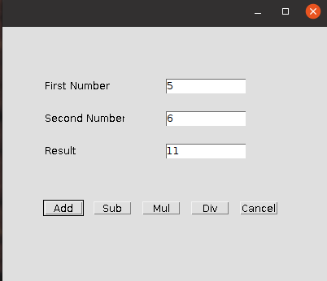

3. Develop a program to handle all mouse events and window events
package mouseevents;

/**
*
* @author sjcet
*/
import java.awt.*;
import java.awt.event.*;

public class Mouseevents extends Frame implements MouseListener {

Label l;
Mouseevents(){
addMouseListener(this);

l=new Label();
l.setBounds(20,50,100,20);
add(l);
setSize(300,300);
setLayout(null);
setVisible(true);
}
public void mouseClicked(MouseEvent e) {
l.setText("Mouse Clicked");
}
public void mouseEntered(MouseEvent e) {
l.setText("Mouse Entered");
}
public void mouseExited(MouseEvent e) {
l.setText("Mouse Exited");
}
public void mousePressed(MouseEvent e) {
l.setText("Mouse Pressed");
}
public void mouseReleased(MouseEvent e) {
l.setText("Mouse Released voi");
}

public static void main(String[] args) {
new Mouseevents();
}

}

output:

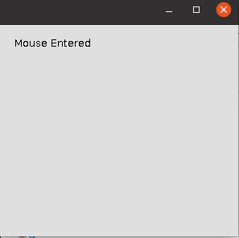

4. Develop a program to handle Key events.
package keyevents;

/**
* @author sjcet
*/
import java.awt.*;
import java.awt.event.*;

public class Keyevents extends Frame implements KeyListener {

Label l;
TextArea area;

Keyevents() {

l = new Label();

l.setBounds (20, 50, 100, 20);

area = new TextArea();

area.setBounds (20, 80, 300, 300);

area.addKeyListener(this);

add(l);
add(area);

setSize (400, 400);
setLayout (null);
setVisible (true);
}
public void keyPressed (KeyEvent e) {
l.setText ("Key Pressed");
}
public void keyReleased (KeyEvent e) {
l.setText ("Key Released");
}
public void keyTyped (KeyEvent e) {
l.setText ("Key Typed"); class MyException extends Exception
{
public MyException(String str)
{
System.out.println(str);
}
}class MyException extends Exception
{
public MyException(String str)
{
System.out.println(str);
}
}class MyException extends Exception
{
public MyException(String str)
{
System.out.println(str);
}
}
}

public static void main(String[] args)
{
new Keyevents();

}

output:
