Data Science Exercise 4 Report

Class: CSIE 4A

ID: 105502506

Name: 黃靖筌

According to the learning step consists in performing the SGD algorithm where for each known rating the biases and latent factors are updated as follows:

https://latex.codecogs.com/gif.latex?%5Cdpi%7B150%7D%20err%20%3D%20r%20-%20%5Chat%7Br%7D

https://latex.codecogs.com/gif.latex?%5Cdpi%7B150%7D%20%5Csmall%20bu_%7Bu%7D%20%3D%20bu_%7Bu%7D%20&plus;%20%5Calpha%20*%20%28err%20-%20%5Clambda%20*%20bu_%7Bu%7D%29

https://latex.codecogs.com/gif.latex?%5Cdpi%7B150%7D%20bi_%7Bi%7D%20%3D%20bi_%7Bi%7D%20&plus;%20%5Calpha%20*%20%28err%20-%20%5Clambda%20*%20bi_%7Bi%7D%29

https://latex.codecogs.com/gif.latex?%5Cdpi%7B150%7D%20P_%7Bu%2C%20f%7D%20%3D%20P_%7Bu%2C%20f%7D%20&plus;%20%5Calpha%20*%20%28err%20*%20Q_%7Bi%2C%20f%7D%20-%20%5Clambda%20*%20P_%7Bu%2C%20f%7D%29

https://latex.codecogs.com/gif.latex?%5Cdpi%7B150%7D%20Q_%7Bi%2C%20f%7D%20%3D%20Q_%7Bi%2C%20f%7D%20&plus;%20%5Calpha%20*%20%28err%20*%20P_%7Bu%2C%20f%7D%20-%20%5Clambda%20*%20Q_%7Bi%2C%20f%7D%29

where alpha is the learning rate and lambda is the regularization term.

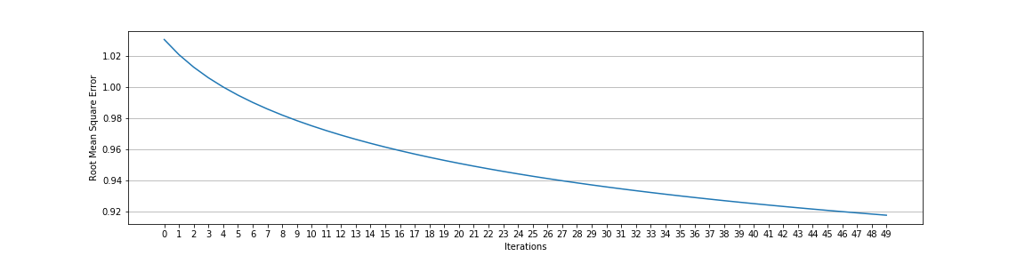Result:

Throughout iterations, it’s obvious to see that RMSE is heading downward more and more stably, which shows us the fitness condition of this model.