Spectrum of Female Fertility from a Mamdani Fuzzy Logic Perspective
Mamdani fuzzy System design and analyse
Judyta Dabek | P15238407 | 17/12/2018

ABSTRACT
This paper shows how fuzzy logic system can estimate the likelihood for women to get pregnant by predicting the chance of fertility on given day based on few conditions such as the Basal Body Temperature, Mucus Thickness and the Age of the woman. At the moment there are devices present on the market which come in handy for women trying to conceive, however they are still prone to failure as not all the essential factors could be taken into consideration while estimating the likelihood of fertility. This area is likely to expect some improvements to deliver more reliable products. Therefore, this paper shows a simplified way how – hopefully – a fuzzy logic system could be redesigned and evaluated to meet the expectations.

INTRODUCTION
First thing which comes to mind when we think “fuzzy logic” is a degree of uncertainty or certainty which could be estimated by introducing some set or laws (rules). Fuzzy logic is perfect in dealing with, among others, medical issues, where simple solution in strict mathematical way cannot be obtained due to a certain set of rules interfering and overlapping with each other. One of such issues - which was tried to be resolved by many scientists working across different scientific fields - was the degree of certainty when a woman is fertile or not on a given day. Especially natural methods of conception have drawn the attention of many great minds, whose works started in late 80s and whose final products are obtainable on the market for women who would like to understand and use their knowledge about their personal menstrual cycle in order to conceive or to prevent unwanted pregnancy. Due to many factors which have an impact on the human body the natural methods of conception are met with a huge critique – however, if appropriately understood and applied – it could be of a great help for any woman wishing to live with respect to natural laws. Many currently existing systems are still prone to errors and failures – as it can be seen in literature review section – and are said to still fail due to irregular menstrual cycles, incorrectly measured, the Basal Body Temperature (it should be measured right after awakening to avoid misinterpretation and confusion), avoiding acknowledgement of the age of the woman and others. The fuzzy system which is designed and implemented in this paper will propose one of the ways the likelihood of female fertility could be measured, tested, and evaluated; then critically reviewed.

LITERATURE REVIEW
Fuzzy logic is said to be one of the best methods to deal with incomplete information especially in the medical field. Fuzzy logic is, by definition, able to classify whether given information is true or false assuming with some level of certainty/uncertainty. This is well expressed by defining in what % a data sample belongs to the given membership. Fuzzy logic is handy wherever simple basic mathematical logic will not be enough. Therefore, fuzzy logic might be completely adopted to predict the chances of being fertile for a woman with respect to some upfront assumed factors. Speaking about female fertility, it can never be said that we possess all required information to state with 100% accuracy, that a given day is the best to get pregnant or that the other one might give 0% for conception, because female fertility depends on a few sets of factors and their dependencies which tend to be vague. Assessing these dependencies will allow us to predict the % of likelihood for a woman to get pregnant – and this is where fuzzy logic might be best to use [1].
Nevertheless, the idea for my fuzzy logic system predicting the likelihood of being fertile or not is not that original as I initially thought. After some research it appeared that similar systems were developed and getting improved over the last 10-20 years and today some of the devices using the fuzzy systems are in use, helping many women around the world to get pregnant or to avoid unwanted pregnancy without a need to undergo abortion if unplanned. One of the earliest papers I have found was published in 2002 in Slovenia. Natural methods caught the attention of scientists, who made an attempt to make use of three very important factors in order to define fertility on a given day during the cycle. The fertility information appliance was supposed to combine ovulation, symptom-thermal and LH hormone methods, which sound very reasonable, but also in my opinion was not too well defined [2] in order to predict with even higher accuracy probability of fertility on a specific day in the biological monthly cycle.
Very interesting system has been described in another scientific paper I encountered. The fuzzy logic system has been developed based on the Body Basal Temperature (BBT) which differs every day for a woman depending on the phase she is currently in [3]. In this paper a certain risk of failure was identified for women with irregular cycles. Therefore, the BBT and expected lutein hormone level might not be enough to achieve the greatest possible likelihood for fertility on the given day during the cycle. Regardless of that, the paper has proved that predicting the fertility with the use of a fuzzy logic system and Mamdani rules is possible – by adopting few more rules it could be even more accurate on a daily basis. The paper also presents simple devices (Arduino Mega 2560) currently in use benefiting from the developed systems. Its aim is to help women to understand their menstrual cycle. But is it enough to help to conceive? According to the confusion matrix for fuzzy ovulation, the maximum accuracy achieved by the system hit 71.43% in predicting the ovulation occurrence on a given day. What we would like to see is the probability of 80-100% and therefore we need more data to be introduced to the system to become even more accurate.
Among different factors while developing such system perhaps not only BBT or lutein phase should be taken into consideration, but also viability and longevity of sperm [4], post-ovulatory ageing of the oocyte [5], age of the woman [6], potential health issues [7]. For my modelling, as I lack sufficient real-life data to include all the factors in my fuzzy system, I will constraint myself to only 3 inputs, such as BBT, woman age, and ovulation mucus thickness [8].

THE SYSTEM

Overview
This system was designed to show how female fertility can be predicted by developing simple fuzzy logic system. It contains two subsystems. 2 inputs give intermediate output which serves as one of the inputs used for second subsystem. In total there are used 4 inputs and received 2 outputs. First subsystem calculates biological conditions and qualifies them into one of 5 groups. Second subsystem estimates based on these conditions and the age of the woman the likelihood of fertility. This system can be adopted to estimate general and daily likelihood of fertility which could be helpful in conceiving. In some circumstances it could be used also to predict when the conception will be very unlikely – however, these are only predictions, so the risk of unwanted pregnancy cannot be fully avoided. Generally, this system aims rather in estimating the likelihood of fertility than the likelihood of not getting pregnant on the given date.

subsystem I – biological conditions estimation
This part of the system estimates the biological conditions. The biological conditions play an important role in human fertility, therefore it should be estimated in order to obtain the proper picture of a general woman’s wellbeing (see Appendix 1).

INPUTS
In order to obtain the picture of general woman’s health and wellbeing, the following factors were used:
BBT – Basal Body Temperature - It is proven that the sudden rise of temperature (around 0.6 degree) during one cycle says that the likelihood of being fertile is rising. The temperature rises with the rising amount of one of the hormones (lutein-based). This hormone is responsible for creating the perfect biological conditions (including the mucus thickness factor) and introduces changes to the female body which could result in pregnancy. To be positive about increased likelihood of ovulation the temperature must rise to up to 0.6 degree more than the previous day. Temperature should be measured right after waking up in order to avoid data and conditional inconsistency. Because the normal body temperature for women is between 36.6-37.0 degrees, we can assume that the highest likelihood of ovulation will happen if the temperature will be in range of between 37.2-37.6 degrees. However, other circumstances should be taken into consideration, such as illnesses, or other anomalies when the basal body temperature might be lower for a given person. For these reasons the temperature ranges are segregated into 3 different groups. First group covers the range Too Low to conceive (lower than or equal to 36.2, membership grade rises with temperature drop). To present this range a function of trapezoid has been used due to some certain values which will indicate that fertility will not be possible. Second group covers Perfect temperature values in range of from 35.5 where potentially the likelihood of fertility could start growing with the membership degree equal to 1 for values in range of 36.5 – 37.3 and decreasing again till 37.7 degrees. This range has been also expressed by a trapezoid function due to certain values which will indicate higher likelihood of fertility. The last group is Too High range of values where the likelihood will start dropping again as the rise of the temperature value above 37.3 degrees might indicate some illness (flu, cold, influenza, etc.) – especially for temperature below 38.0 degrees - and creates worse conditions to conceive. This group has also been expressed by a trapezoid function due to some certainty in values and their impact on general fertility. There are two ranges of uncertainty – which can depend on personal conditioning, extraordinary circumstances and so on. These regions are the values overlapping between Too Low and Perfect sets (values 35.5 – 36.2) and Perfect and Too High sets (37.3 – 37.7)– where, if other conditions are met, they might not be a problem in conceiving and constitute rather presence of personal biological conditioning than real difficulties in conceiving.
Mucus Thickness (ml) – According to scientific research mucus thickness plays valid role in female fertility. The thicker the mucus is, the higher is the probability of conception. There are 3 ranges distinguished in this system: None, when lack of mucus leads to 0 chances of conception in nearly every possible case scenario (it is expressed by triangular function because there is only one value with membership degree equal to 1, and it is value of 0), Medium when fertility likelihood will start rising and might lead under some circumstances like personal conditioning or sperm condition (which is not considered in this paper) to conception (expressed by gaussian function; there is no specific value with membership degree of 1) and Very Thick which will definitely lead to conception when other conditions are met (expressed by trapezoid function, where membership degree of 1 will be obtained by any value higher than or equal to 0.3). There are two regions of uncertainty, but they do not play any vital role. The rules are simple – a lack of mucus will lead to being infertile, to conceive; mucus must be as thick as at least 0.3 ml, the thicker mucus is, the highest probability of conception is.

OUTPUT
Bio Conditions – the final output of this system is the estimation of the general biological conditions which will be used as input to another subsystem. There are 5 different ranges identified: Perfect, Pretty Good, Likely, Poor and Insufficient. All of these ranges are expressed by overlapping trapezoid functions, as under some circumstances fuzzy logic might indicate the output belonging to two different sets in the same time based on the input values. Rules for these ranges will be explained in another section.

RULES EXPLANATION
Literal notation of the rules applied to this subsystem – see Appendix 2.
MatLab code – base rules – see Appendix 3.
Fuzzy Logic Rules Table – see Appendix 4.
If the input 1 data belongs to the given range and the input 2 data belongs to another then these ranges are being compared and result in the form of a range for Biological Conditions is obtained. For example, if the Basal Body Temperature is 34 degrees (input 1 data), there is no mucus present (input 2 data), then input 1 data (look at graph above) is qualified to range Too Low for BBT input data and input 2 data is qualified to range None for Mucus Thickness input data and as a result for Bio Conditions the final set of data is qualified to Insufficient range – what means, that the likelihood of fertility on the given date is absolutely low what will have impact on final result obtained in second part of the system.

SUBSYSTEM ii – final fertility likelihood prediction
This part of the system predicts the chances of conception in form of qualifying obtained result to one of the ranges (see Appendix 5). Final calculation for all the system and output for Fertility is based on reusing output from Subsystem II and treating it as input 2 as overall Bio Conditions in comparison with input 1 in form of Age. The result is the output as one of the ranges (subranges) for Fertility category.

INPUTS
Age – according to scientists, the best age for conception is (according to different sources) until age of 25-27 years old. When woman hits the age of 27 years old, her fertility will begin to decrease until the age where the menopause period is over (max usually around 50 years old). Because of these findings, the following ranges have been identified: Young (membership degree of 1 until value of 24, then slowly decreasing till 28), which is the best age for conception and expressed by trapezoid function (due to specific values with membership degree of 1), Mature (24-36 years with a peak around 30) – here is the point where the likelihood of fertility starts to decrease – expressed by gaussian function, Middle (31 – 43), expressed by gaussian function with no specific values of membership degree of 1, Elder (36-54) again; expressed by gaussian function and without specific values with membership degree of 1 and Inactive (starting from 45 years old what means that the already small likelihood will keep decreasing until 50 years when there are no chances to get pregnant at all), expressed by trapezoid function with membership degree of 1 for values starting from 50, when fertility is impossible due to the ageing of organism.
Biological Conditions – this is exactly the same as output for Subsystem I but treated this time as input data. The data previously written to a xls file will be reread and reused to obtain final result. Results for biological conditions are obtained by following the rules created for the first subsystem.

OUTPUT
Fertility – 5 different ranges have been identified. The outcome is based on following the rules created specifically for this subsystem. Data might come into one of these categories: Very High (very high probability of getting pregnant), High, Medium, Less Likely, Infertile (basically 0 chances for conception). Unlikely the Biological Conditions input/output, these ranges have been diversified in order to test if specifying unusual ranges will make any difference and have impact on overall results. All the ranges are in form of a trapezoid function, with assumption that there might be more values than one falling into given sets with membership degree of more than 1. The Very High range has been reduced in comparison to other ranges due to the smaller likelihood of appearance, the Infertile range has been enlarged due to the higher likelihood of obtaining this result. There are some overlapping regions, because due to inputs belonging to more than 1 set; the final result might appear to be fuzzy and indicate belonging to more than 1 set as well.

RULES EXPLANATION
For Subsystem II following rules were identified – see Appendix 6.
MatLab code for base rules – see Appendix 7.
Fuzzy Logic Rules Table – see Appendix 8.
Rules work exactly the same as example shown for Rules Explanation for Subsystem I.
This means that if the input 1 data is the age of 22, the input data 2 is “Perfect”, then input 1 data falls into category of Young for Age input, input 2 data falls into category of Perfect for Bio Conditions 2 input and our Fertility result will be Very High.

EXPERIMENTAL DESIGN AND EVALUATION

test data
The test data have been produced in order to check the range values for inputs and outputs including those belonging to two different sets of data. The application read the data from the .xls file, then recorded output values for Biological Conditions, then re-read them again and recorded the values for Fertility outputs. The set of data covers 120 different possible combinations of input data (5 inputs for BBT (3 ranges plus 2 intermediate values belonging to more than 1 set) x 3 inputs for Mucus Thickness x 8 inputs for Age (5 in ranges and 3 intermediate belonging to more than 1 set) = 120, with omitting the ranges for Biological Conditions as this was already reused as output and input value based on the BBT and Mucus Thickness so no need for including the redundant data for this testing). This system has been evaluated with use of defuzzification methods such as bisector, centroid, LOM, SOM, MOM. The distribution of the values is as follows on MatLab website [12] (see Appendix 9).

first experiment
The system has been redesigned few times from its initial configuration. In first form, data were not overlapping too much because the aim was to achieve appropriate ranges for every method of defuzzification. However, every fuzzy system should assume some degree of uncertainty, so ranges for all sets have been improved. On the top of that; the final outcome ranges have been diversified and the decision was made not to adjust evenly spaced ranges, but more or less diversified in length by their likelihood of obtaining (based on rules and inputs ranges) in order to test the final results.

testing
Because the system consists of two subsystems, both must have been checked.

System I
For results of testing for this system – please see Appendix 10. Legend under the table is self-explanatory. It can be noticed that the closest to obtaining the expected results is the Centroid defuzzification method, especially when it comes to input values which belong to only one set. However, it can also be noticed, that for values belonging to more sets than 1 the obtained values are unexpected. After consideration it appears that system has learned and corrected the data in a logical way, which concluded to a precise result for fuzzy values. For example, BBT of 36 degrees with Mucus Thickness of 0.31 ml not necessarily needed to belong to Bio Conditions with the range of Perfect (as the temperature was far from Perfect) neither Insufficient (as Mucus Thickness was Very Thick). Therefore, the system has chosen the lowered subrange for the Bio Condition category, which appeared to be Pretty Good/Likely. It sounds completely reasonable and this example proved that fuzzy logic can be used to learn the system how to properly estimate the output based on given inputs and base rules. The same applies to the other 3 examples, where the resulted range was intermediary between the two expected ones.
Bisector and MOM methods of defuzzification appeared to work in similar way. Some output values were the same as those obtained from the centroid defuzzification method. The difference in this scenario was receiving output values based on fuzzy input values that were falling into at least one of the expected categories based on logical reasoning; following the base rules.
The most diversified output values have been obtained through using the LOM or SOM defuzzification methods. These might suit better if the ranges for input and output data would be changed. To summarize, the correct defuzzification method appeared to be centroid.

System II
The result of testing for this system – see Appendix 11.
The best defuzzification method for this system appears to be centroid, as all the values fell into expected categories. A bisector method also gave similar results, while only 2 samples did not fall into the exact same set. MOM and LOM appeared to result in very diversified values which only partially fit into expected ranges. The highest level of uncertainty was identified by using the SOM method of defuzzification – however values fell into one of the expected ranges, overall results were not that close to those expected and therefore this method would not be recommended as a suitable defuzzification for this system.

CRITICAL ANALYSIS
Overall this system appeared to be working quite well. Even in the event of obtaining the unexpected results, the new results appeared to be better adjusted while using the centroid method of defuzzification. However, there are things which could be improved in the future. First, the whole system could be compressed – instead of using 2 subsystems only 1 would be enough. This would require adding more data to the ‘.xls’ file for Biological Conditions and reconstructing the rules. Currently there are 34 rules for both systems. The compressed system would contain inputs such as BBT, Mucus Thickness and Age. In such an event where all the ranges would be left unchanged, the minimum of the 45 base rules should be applied (3 ranges for BBT times 3 ranges for Mucus Thickness times 5 ranges for Age). Therefore, there would be even more rules which could result in even better accuracy. Speed up the calculations by performing them on the fly instead of writing back the results into the ‘.xsl’ file and re-read them again and improve general performance.
It is noteworthy to re-think about the ranges for these categories. For the BBT set, the ranges could remain the same, maybe their values could be adjusted a little more. For the Mucus Thickness; in my opinion the ranges should remain unchanged – all 3 of them cover important data which have impact the result. The values should not be changed, as the most important; is the lack of thickness and the thickness equal to or greater than 0.3 ml, because these values participate greatly in obtaining not only the Bio Conditions result, but also the Fertility result itself. The mid values are important to record but they might or might not have impact on the total outcome. For the Bio Conditions set, frankly speaking, less ranges could have been identified – but more ranges guarantee more accurate results. For the Age set of data – the Middle and Elder ranges could have been compressed into one, but – the more ranges in this case are used, so that more accurate results can be obtained. The human body is still unpredictable, so, introducing so many ranges could only enhance any changes and important conditions which could lead to achieving even better results. Therefore, all these input ranges were thoroughly thought out and adopted to reflect any conditions for which the main output could be changed, including the values with a membership degree of 1 or below, based on a previously conducted literature review. There is still a field to improve this project, however.
The output set of data, the Fertility, has untypical ranges. This was concluded due to the experiment purposes which assumed to play with variables; other than standard values in order to compare the results obtained through the defuzzification methods. It is hard to say if these ranges should look more like the Bio Conditions set of data. For both systems the most appropriate defuzzification method appeared to be centroid, while SOM, LOM, and MOM did not achieve expected results. Possibly, the data range for the output, following the well-thought set of rules, does not have any impact on the final results – however, this should be re-tested by re-constructing these ranges and conducting testing anew, then comparing obtained results.
In order to apply this system into real life, as mentioned above, the system compression would be welcomed as the first change, which should allow for an optimize performance. For real life experiments more inputs could be identified, such as oocyte ageing factor, mental well-being, likelihood of suffering from diseases which could prevent a woman from getting pregnant. In this form however, the system could be used for a single user in a domestic environment to estimate roughly the likelihood of ovulation during the cycle and to get to know more about one’s body. The perfect device could use more AI concepts, be in a form of a simple device or even a mobile application; to record results daily. In a more expanded form with the use of more inputs which could be possessed through medical examination, such systems could easily be adopted into hospitals; treating patients with fertility problems. It is enough to say that infertility or problems in conceiving are becoming one of the biggest problems in modern society, so such fuzzy systems could potentially help a lot of couples who wish to become parents.
This system is built in a simplified way, there are things which should be improved, but for the unit of time contracted for my coursework and the requirements I would say it is well thought out and designed. Still, it could be done in a better way, like every other system, due to constant changes in technologies. The best way to find out if this system would need any improvements would be to test it in practice and find out how accurate it is on real life data.
The output data, equally for Biological Conditions like Fertility could be designed the other way round – that means, the Infertile range for output values should cover a range between 0 and 25, while Very High ranges should be between values of 80 and 100 and alike for Bio Conditions – Insufficient range could cover values between 0 and 25, while Perfect should take the place of the current Insufficient range.
The code for this system was derived from the one delivered on Blackboard. Appropriate parts of exemplary code were changed and modified to meet the needs for this project.

CONCLUSIONS
Overall this project went quite well. It contained the minimum inputs required to meet the coursework expectations. The testing proved that the rules were designed in a logical way and the reasoning pattern appears to be correct. For a real-life project; more inputs should be taken into consideration, as well as the compression the whole system in order to achieve better performance.
Through this exercise I have learned a lot about how to resolve real life problem using programming approaches, in this case scenario the fuzzy logic systems concepts. I have met different methods of data defuzzification, such as centroid, bisector and so on and adapted the way they work. Checking and comparing the expected and obtained output data helped me to learn to treat data with more care and greater attention. This project overall improved my data science and Artificial Intelligence knowledge and skills and allowed me to adapt theory into practice. I see a great area for future improvements for this project and within the AI field. This project was not easy to design and construct even after conducting the literature review, because the medical field itself is still like the universe – unknown, requiring specific data and possibly exploring the unknown factors working on human bodies. However, this project was simplified to meet the most specific scientific requirements. In the future I would like to expand this model to deliver unique tools which will work up to date with current medical knowledge and devices. That would require more inputs and subsystems to be constructed, but it is fun and could be extremely useful in solving the real problems in modern society.

BIBLIOGRAPHY
[1] P. Venkata Suba Reddy, “Generalized fuzzy logic for incomplete information”, 8 October 2013. [Online]. Available: https://bit.ly/2QHbnAk [Accessed 4 December 2018]
[2] L. Ngalamou, D. Rose, “Fertility information appliance”, Computer-Based Medical Systems: Proceedings of the Annual IEEE Symposium, 2002. [Online]. Available: https://bit.ly/2A3yfzj [Accessed 4 December 2018]
[3] M. Mohd Yazed, A. F. Zainodin and F. Mahmud, “Fuzzy Logic System for Menstrual Cycle Interpretation Based on BBT Data”, International Journal of Integrated Engineering, Vol.9 No. 4 (2017). [Online]. Available: http://penerbit.uthm.edu.my/ojs/index.php/ijie/article/view/2082/1326 [Accessed 4 December 2018]
[4] Wilcox A., Weinberg C. and Baird D., “Timing of Sexual Intercourse in Relation to Ovulation”, The New England Journal of Medicine, Vol. 333, No. 23, 7 December 1995
[5] Wilcox A, Weinberg C. and Baird D., “Post-ovulatory ageing of the human oocyte and embryo failure”, Human Reproduction, Vol. 13 no. 2 pp. 394-397, 1998
[6] Dunson, D., Colombo B. and Baird D., “Changes with age in the level and duration of fertility in the menstrual cycle”, Human Reproduction Vol. 17, No. 5, pp. 1399-1403, 2002.
[7] Chandra, A., Copen C. and Stephen E., “Infertility and Impaired Fecundity in the United States, 1982-2010: Data From the National Survey of Family Growth”, National Health Statistics Reports, No. 67, 14 August 2013
[8] M. Perkowski, S. Wang, W.K. Spiller, A. Legate, E. Pierzchata, “Ovulo-computer: application of image processing and recognition to mucus ferning patterns”, 1990. [Online]. Available: https://ieeexplore.ieee.org/document/109378 [Accessed 4 December 2018]
[9] E. Frank and R. White, “An Updated Basal Body Temperature Method”, Contraception, Vol. 54, Issue 5, November 1996, pp. 319-321. [Online]. Available: https://bit.ly/2EtRlC2 [Accessed 5 December 2018]
[10] L. Han, R. Taub and JT. Jensen, “Cervical mucus and contraception: what we know and what we don’t”, Contraception, Vol. 96, Issue 5, pp. 310-321, Nov 2017. [Online]. Available: https://bit.ly/2QYWYOX [Accessed 5 December 2018]
[11] D. Garcia, S. Brazal, A. Rodriguez, A. Prat and R. Vassena, „Knowledge of age-related fertility decline in women: A systematic review”, European Journal of Obstetrics & Gynecology and Reproductive Biology, Vol. 230, pp. 109-118, November 2018. [Online.] Available: https://bit.ly/2A2BnvB [Accessed 6 December 2018]
[12] MathWorks. 2018. Defuzzification Methods. [ONLINE] Available at: https://www.mathworks.com/help/fuzzy/examples/defuzzification-methods.html. [Accessed 27 December 2018].

APPENDICES

Appendix 1
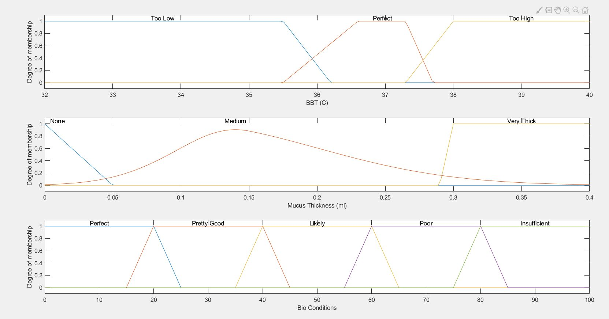

Appendix 2
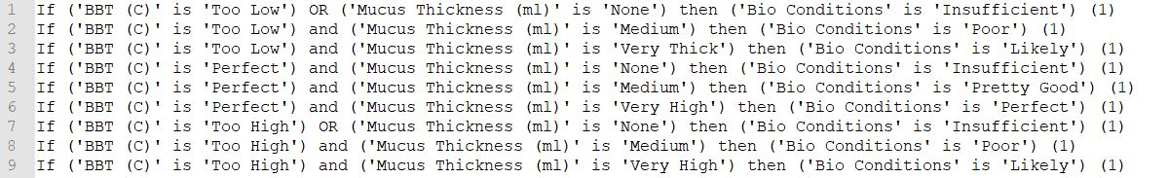

Appendix 3
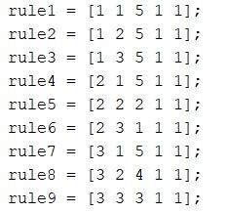

Appendix 4
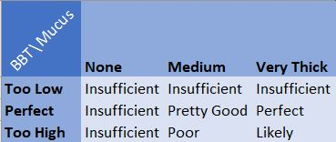

Appendix 5
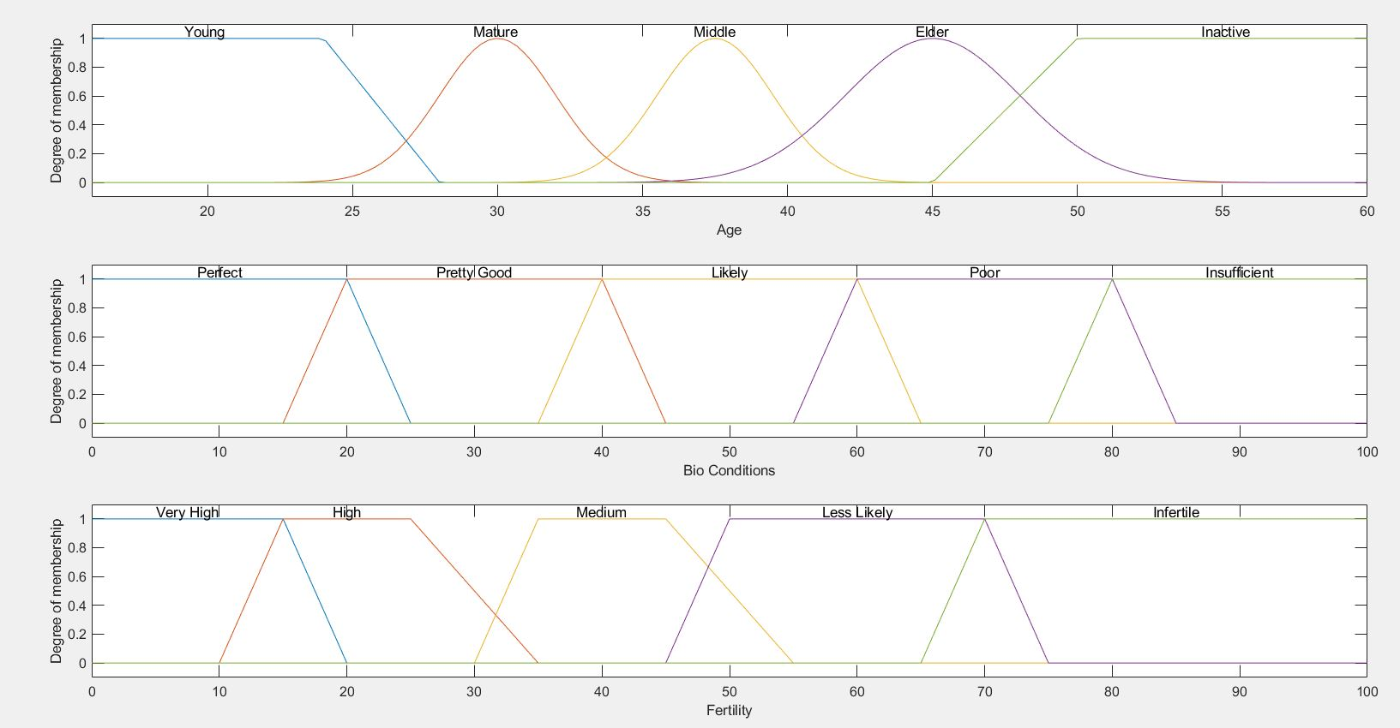

Appendix 6
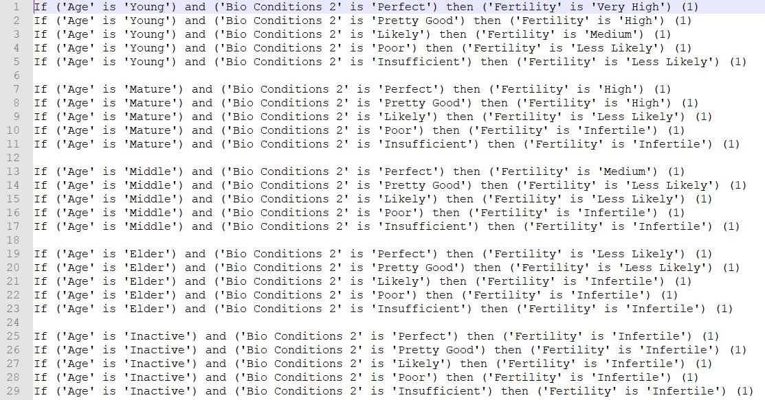

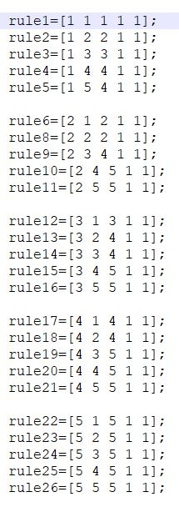
Appendix 7

Appendix 8
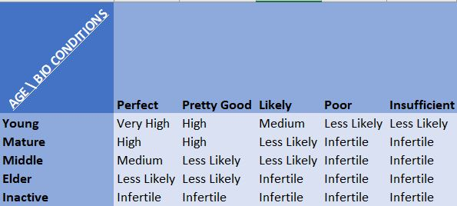

Appendix 9
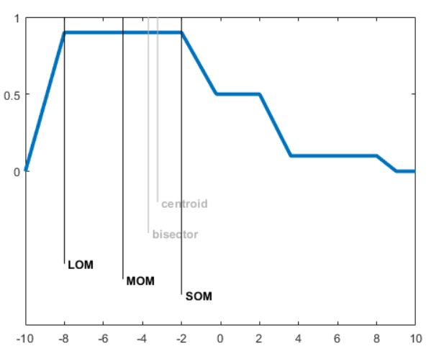

Appendix 10
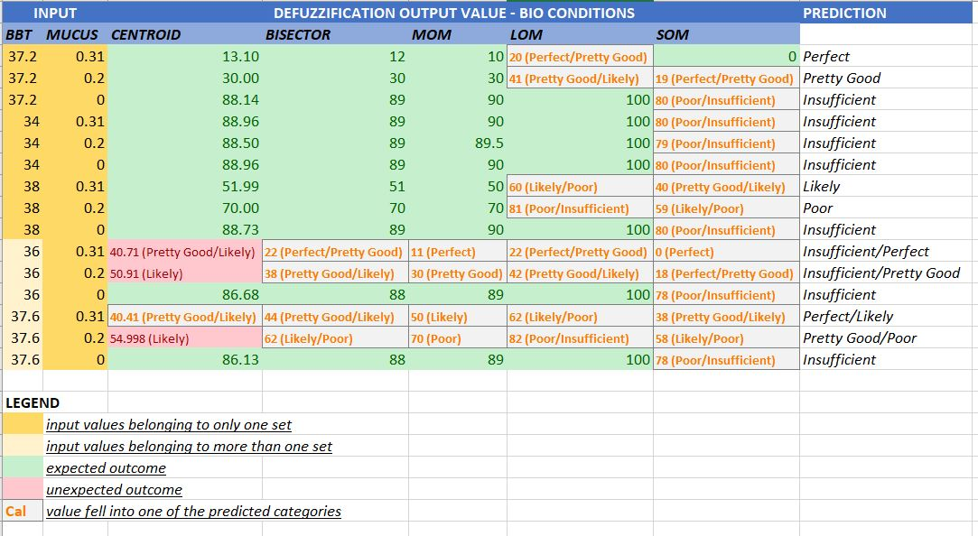

Appendix 11
