10/29 - Docker Documentation

Docker install

<https://docs.docker.com/docker-cloud/getting-started/deploy-app/2_set_up/>

\*\*Not sure about this part\*\*

Install docker on ec2 instance

<http://docs.aws.amazon.com/AmazonECS/latest/developerguide/docker-basics.html#docker_next_steps>

New User and attach AmazonEC2FullAccess policy to user

https://console.aws.amazon.com/iam/home#users

\*\*Hmmm\*\*

On aws, launch EC2 instance(type: t2.micro)

<https://us-west-2.console.aws.amazon.com/ec2/v2/home>

Link Docker to Amazon web Services account

<https://docs.docker.com/docker-cloud/infrastructure/link-aws/>

* Create dockercloud policy on aws following guide above to grant privileges to Docker Cloud

Create AWS IAM Role at <https://console.aws.amazon.com/iam/home#roles>

* Select Role for Cross-Account Access -> provide access to a 3rd party AWS account
* Account ID is for Docker cloud; external ID is personal docker account username
* Then copy role ARN and register on Docker-cloud in settings for Amazon Web Services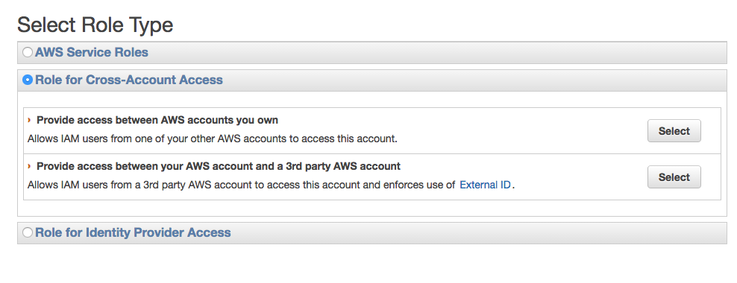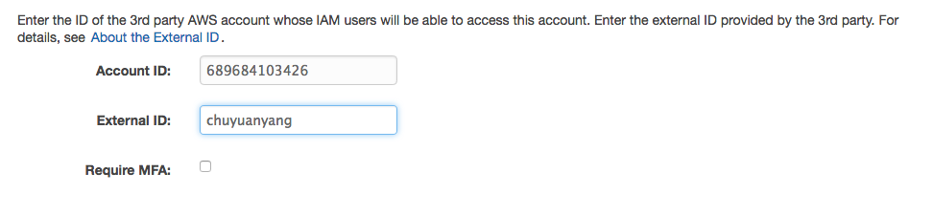

Deploy node on docker cloud

<https://docs.docker.com/docker-cloud/getting-started/your_first_node/>

—fill in ec2 instance info (type: t2.micro)

Deploy on Docker

<https://docs.docker.com/docker-cloud/getting-started/your_first_service/>

—instead of using a preexisting container, I pushed another generated image from local

|

| What I did. But not sure if I’m doing things right.

|

V

Open Docker Quickstart Terminal from Applications

Navigate to design/restlet/hello

make compile

./docker.sh

login (put in docker cloud login credentials)

build

push

Then you will see new repository on docker cloud/hub

It should run on the docker node that was created.

\*publish port