Zip Codes in Baltimore County

??? and ????

Econ 431

Abstract: For our project, we investigated the magnitude of a variety of factors that can affect home prices using homes from about 50 different zip codes in Baltimore county.

**Introduction:**

The saying goes that real estate is about “location, location, and location,” according to real estate professionals, but what about location makes real estate valuable? In our study, we attempt to determine the most important factors to real estate valuation. Homelight.com stated that “Comparable sales, location, and home size are the three main factors that are the most influential,” Finder.com also stated that “Property market performance, size, supply and demand, and renovation potential” are major factors. Inman.com suggested that the most important factors are “Neighborhood, nearby features, and size.” Some recurring themes in all of these websites are size of the home and nearby amenities. Square footage represents home size, while lot size represents and offers privacy and exclusivity. However larger more private lots will be less walkable. Walkability indicates nearby desirable amenities. An article by City Observatory states “that increased walkability was associated with higher home values across the country. On average, ... a one point increase in a house’s Walk Score was associated with a $3,000 increase in the house’s market value.” One of the most important amenities to many homebuyers is schools, and many families move for the sole purpose of living in an area with a good school district. Schools play a big factor in a child's development because they spend most of their time there. We compiled a list to see how they affect home prices by picking the most recurring factors from our research online. Our regression included factors such as Square footage, lot size, average school rating, walkability score, and average income.

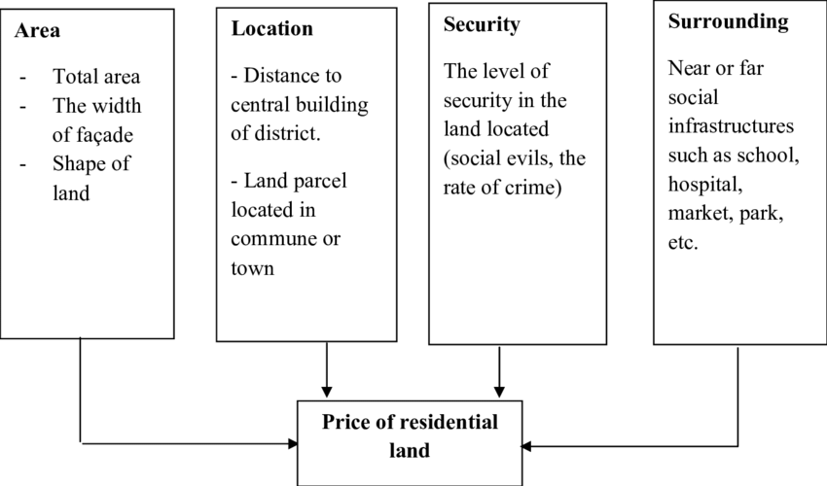

**Data Summary:**

To get an idea of how various factors impact home pricing we examined data from zip codes in Baltimore county with recent sales. For each zip we collected the average sale price, square footage, and lot size from a bright multiple list system, or MLS for short. We also collected information pertaining to school systems, walkability, and average income from each zip code.

We used greatschools.org to evaluate the education system in each zip code. Great Schools grades schools by test scores and other factors. By taking the average score of each zip code we get a general picture of how good the schools are in each district. We anticipate that areas with better schools will have higher home prices, as any parents of young children or those expecting to be parents will usually prioritize giving their kid(s) a good, and affordable education. We also included a walkability score, which we obtained from walkscore.com, to see how the convenience of walking to stores and restaurants nearby compares to the exclusivity and privacy of spread out neighborhoods that require a car. Lastly, income of residents likely correlates with home value, but it’s difficult to say if the wealth of potential neighbors makes homes more appealing and therefore more valuable, or if the value of the homes necessarily only draws residents who can afford them. This would imply the relationship is reversed, and that home price affects average income, but more likely a little of both is the case.

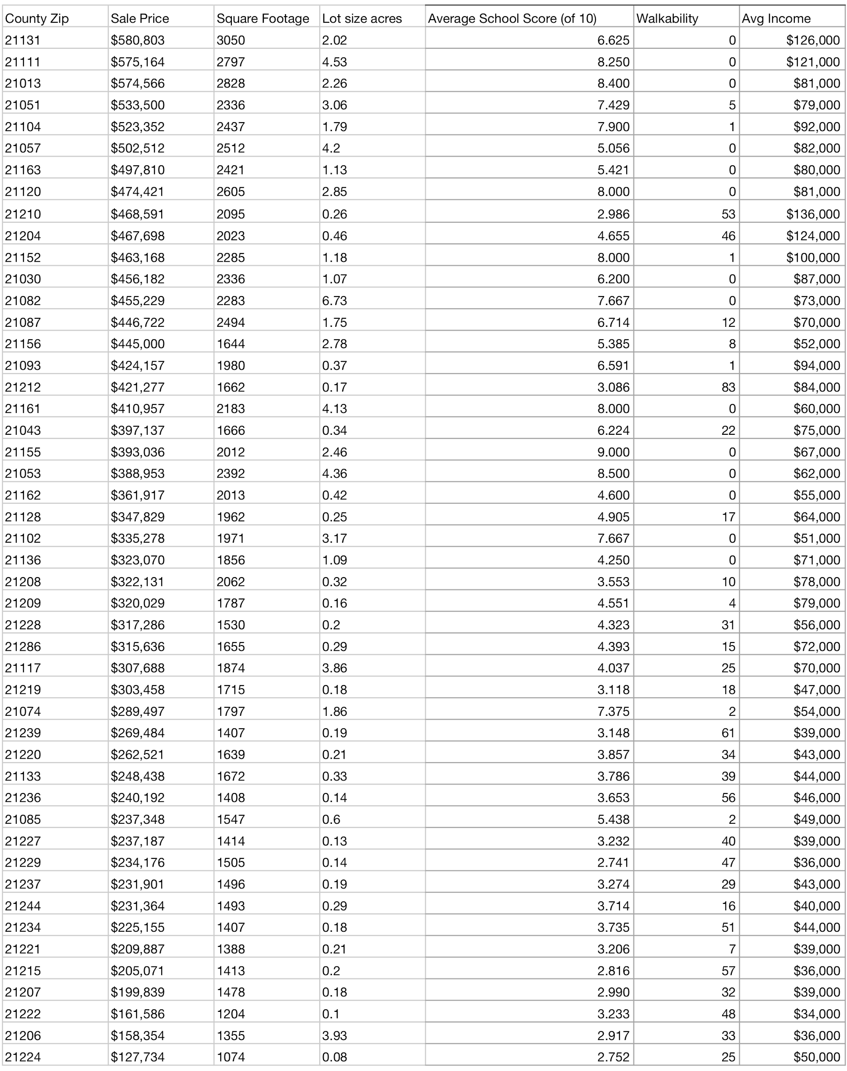

After removing some zip codes with no recent sales, we had a collection of around 50 zip codes making up Baltimore County to give us an idea of trends here. Average sale prices ranged from $127,000 to $580,000, with a mean of $352,589. The average square footage of the homes is 1,899 ft2. The lot size averaged 1.39 acres, ranging from 0.08 acres to 6.73 acres. The average income ranged from $34,000 to $136,000, with a mean of $66,250, which is about 17% greater than the national average. Lastly, walk score ranged from 0 to 83, with an average of 19.39. For context, less than 50 is considered car dependent, while over 70 is considered very walkable.

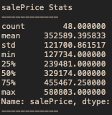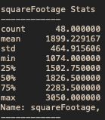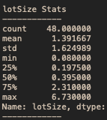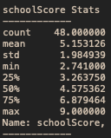

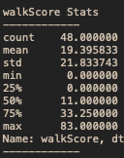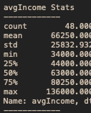

By plotting each of our independent variables against our dependent variable, in this case sale price, we can try to spot the correlation visually before our regression. Average income appears loosely but positively correlated, while walkability seems negatively, and likely insignificantly correlated. Comparing lot size to sales price reveals a very loose but positive correlation as well as price to school score. The most clearly correlated variable is square feet, indicating that size does matter in home valuation. (See Below)A close up of a map

**Regression and Analysis**

We will be testing the model:

Using an algorithm we ran our regression with sale price as the dependent variable and square footage, lot size, school score, walk score, and average income for independent variables. With an r2 of .987, most of the variation in price is clearly caused by our selected variables. Taking a look at the P-values reveals only 2 significant correlations - square footage and income. The coefficient tells us that for every additional square foot, homes go up an average of $99. For each additional dollar in zip code average income, home values go up $1.90. Standard error is very high for lot size and school score, further indicating their unreliability in approximating home price.

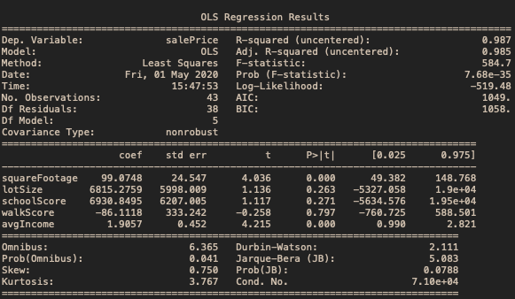

**Results:**

Our results show that square footage and income are highly correlated to sale price and could be used as predictors. School scores and lot size were surprisingly not significant factors, while we expected walk score could very well be insignificant from the start. Interestingly square footage and income don’t have much to do with location, possibly disproving the adage, “location, location, and location.” Our more locational factors such as walkability and schools weren’t significant enough to draw a conclusion. Instead, intrinsic factors determined the price according to our study.

**Reference:**

“6 Factors That Influence a Home's Value.” *Inman*, www.inman.com/2017/08/07/6-factors-that-influence-a-homes-value/.

Bartsch, Christine, et al. “10 Factors Large and Small That Influence Real Estate Property Values.” *HomeLight Blog*, 26 Feb. 2020, www.homelight.com/blog/real-estate-property-value/.

“The Economic Value of Walkability: New Evidence.” *City Observatory*, 29 Aug. 2016, cityobservatory.org/the-economic-value-of-walkability-new-evidence/.

Whitten, Richard, and Richard. “What Factors Influence a Property's Market Value?: Finder.” *Finder.com.au*, 21 Jan. 2020, www.finder.com.au/what-influences-a-propertys-value.