Name: _______________________________________ Date: ________________

**1.1 Game Coding: Getting Started**

**Introduction**

How are video games made? Why it’s in computer of code of course! In this lesson you will learn how to program in Scratch.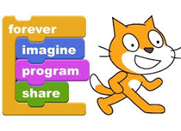

**Equipment**

✦ Computer with Internet

✦ Scratch™ create an account

**Procedure**

Scratch is a web based programing language. In this lesson you will sign up for a Scratch Account and then learn the basics of Scratch through a tutorial.

## 1. Scratch Account Creation

To create an account, go to the [front page](http://scratch.mit.edu) and click "Join Scratch" in the top right hand corner. If you already have an account, it will first ask you if you want to retrieve your password. When you get to the signup page, enter the following data:

**Username**: Use one that reflects you in some way, but does not give away any personal information like your full name or address. Do not use an inappropriate username either. If you do, your account might be blocked.

**Password**: A secure password should have both letters and numbers. To make it stronger, you may use symbols or a upper-lowercase combination, but make sure you can remember it! Always write your password down somewhere safe in case you forget it. But make sure not to leave a piece of paper with your password just lying around! Also remember not to write 'Scratch password' or similar on it, as that would be risky. To change the password after you've logged in, visit the [Account Settings](http://wiki.scratch.mit.edu/wiki/Account_Settings) page.

**Other data**: Some of this data is optional, although your birthday, email, gender, and country are still required in order to create a Scratch account.

Then click Sign Up. You are now ready to post [projects](http://wiki.scratch.mit.edu/wiki/Project), [comments](http://wiki.scratch.mit.edu/wiki/Comment_%28website_feature%29), and use the [forums](http://wiki.scratch.mit.edu/wiki/Scratch_Forums).

2. Launch a Web browser and navigate to the Scratch website at

<http://scratch.mit.edu/projects/editor/?tip_bar=getStarted>

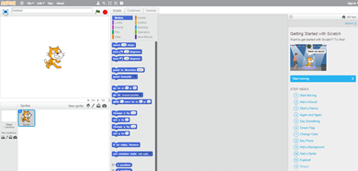

3. Work with a partner to complete the tutorial.